f



**Government of the People’s Republic of Bangladesh**

**Bangladesh Water Development Board (BWDB)**



**Coastal Embankment Improvement Project**

**Consultancy Services for Feasibility Studies and Preparation of Detailed Design for the Following Phase (CEIP-2)**

**Coastal Embankment Improvement Project II**

**Modelling Assessment: Part A: Embankment Crest Levels**

**Final Report**

**December 2022**

**Myanmar Integrated Water Resources Management**

**,**

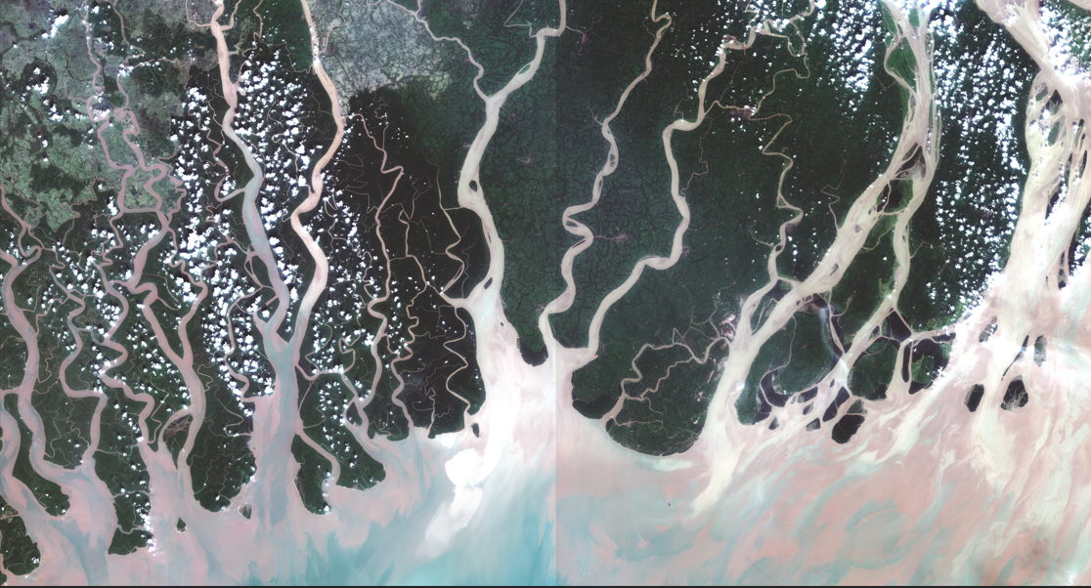

Satellite Image from: ESA, taken at 04:28:29+6



Table of contents

[Table of contents 2](#_Toc123970421)

[List of Tables 5](#_Toc123970422)

[List of Figures Main Report 6](#_Toc123970423)

[Abbreviations, Acronyms and Units 8](#_Toc123970424)

[1 Introduction 14](#_Toc123970425)

[Project Description 14](#_Toc123970426)

[Purpose and Scope of this Report 17](#_Toc123970427)

[Outline of this Report 17](#_Toc123970428)

[2 Overview of the Hydraulic Loads Considered 18](#_Toc123970429)

[3 Selected Design Scenarios for CEIP-2 22](#_Toc123970430)

[4 Climate Change Assessment 25](#_Toc123970431)

[5 Subsidence 30](#_Toc123970432)

[What is Subsidence 30](#_Toc123970433)

[Studies on Subsidence in Bangladesh 30](#_Toc123970434)

[Recommended Subsidence Rates for CEIP-2 34](#_Toc123970435)

[6 Overview of Modelling Approach 35](#_Toc123970436)

[Outline of Modelling Methodology 35](#_Toc123970437)

[Notes on Data Availability and Limitations 35](#_Toc123970438)

[7 Storm Surge and Wave Analysis 36](#_Toc123970439)

[Hydrodynamic Model 36](#_Toc123970440)

[Cyclone Induced Storm Surge Model 38](#_Toc123970441)

[7.1.1 Approach and Methodology 38](#_Toc123970442)

[Wave Model Development 42](#_Toc123970443)

[Calibration and Validation of the Models 43](#_Toc123970444)

[7.1.2 Hydrodynamic Model 43](#_Toc123970445)

[7.1.3 Cyclone Induced Storm Surge Model 48](#_Toc123970446)

[7.1.4 WAVE Model 55](#_Toc123970447)

[Hydrodynamic, Storm Surge and Wave Model Simulations 58](#_Toc123970448)

[Freeboard Calculation 58](#_Toc123970449)

[Storm Surge and Wave Model Results 60](#_Toc123970450)

[7.1.5 Analysis of Storm Surge Level 60](#_Toc123970451)

[7.1.6 Analysis of Significant Wave Height 62](#_Toc123970452)

[Summary of Storm Surge Assessment Results 63](#_Toc123970453)

[8 Monsoon Flooding with Regional Model 65](#_Toc123970454)

[Regional Model Development 65](#_Toc123970455)

[8.1.1 Software Package 65](#_Toc123970456)

[8.1.2 Approach of the Model 65](#_Toc123970457)

[8.1.3 Updating of the 1D Regional Model 66](#_Toc123970458)

[8.1.4 Model Domain 67](#_Toc123970459)

[8.1.5 Model Input Data 70](#_Toc123970460)

[8.1.6 Model Schematization 70](#_Toc123970461)

[8.1.7 Boundary Condition 72](#_Toc123970462)

[8.1.1 Model Simulation 73](#_Toc123970463)

[8.1.2 Model Calibration and Validation 73](#_Toc123970464)

[Wave Height and Overtopping Calculations 82](#_Toc123970465)

[8.1.3 Wind Speed 82](#_Toc123970466)

[8.1.4 Wave Height and Overtopping Calculations 87](#_Toc123970467)

[Summary of Regional Assessment Results 88](#_Toc123970468)

[9 Summary of Recommended Design Parameters 90](#_Toc123970469)

|  |  |
| --- | --- |
| **Appendix A1** | **Future Climate Change Analysis** |
| **Appendix A2** | **Data from LTM** |
| **Appendix A3** | **Comparison of the CEIP-1 and CEIP-2 Storm Surge Modelling Approach** |
| **Appendix A4** | **Cyclone Track** |

List of Tables

[Table 1‑1: Selected 13 Polders for Next Phase of CEIP (CEIP-2) 14](#_Toc123970470)

[Table 3‑1: Design standards of other flood mitigation structures around the world. 23](#_Toc123970471)

[Table 4‑1: Comparison of climate change scenarios considered under various projects. 26](#_Toc123970472)

[Table 4‑2: Summary of climate change considerations for this study. Results are taken from IPCC, unless otherwise noted. 27](#_Toc123970473)

[Table 7‑1: Statistical performance of the Bay of Bengal model for Calibration at Hiron Point, Khepupara and Coxs Bazar 45](#_Toc123970474)

[Table 7‑2: Statistical performance of the Bay of Bengal model for Validation at Hiron Point, Khepupara and Coxs Bazar 47](#_Toc123970475)

[Table 7‑3: Statistical performance of the Storm Surge Model 50](#_Toc123970476)

[Table 7‑4: Statistical performance of the CEIP-2 model, compared to the CEIP-1 model. 53](#_Toc123970477)

[Table 7‑5: Results of the comparison between the CEIP-1 and CEIP-2 wind results. 54](#_Toc123970478)

[Table 7‑6: Statistical performance of the Wave Model 57](#_Toc123970479)

[Table 7‑7: Hydrodynamic, Storm Surge and Wave Model model simulations. 58](#_Toc123970480)

[Table 7‑8: Storm Surge Depth (in meters) for Different Return Period for Both Base and Climate Change Scenarios 61](#_Toc123970481)

[Table 7‑9: Significant Wave Height (in meters) for Different Return Period for Climate Change Scnearios 62](#_Toc123970482)

[*Table 7‑10: Overview of recommended crest elevations based on the storm surge analysis; results include climate change* 63](#_Toc123970483)

[Table 8‑1: List of Polders and their respective Regional Models 66](#_Toc123970484)

[Table 8‑2: Major River Systems Incorporated within the Model Domain 67](#_Toc123970485)

[Table 8‑3: Data Requirements for 1D Hydrodynamic Modeling 70](#_Toc123970486)

[Table 8‑4: Specified Boundary Conditions 72](#_Toc123970487)

[Table 8‑5: Simulation of the 1D Regional Model 73](#_Toc123970488)

[Table 8‑6: Calibration and Validation Locations 74](#_Toc123970489)

[Table 8‑7: Annual maximum Monsoon Wind Speed (m/s) at Patuakhali for different year 82](#_Toc123970490)

[Table 8‑8: Monsoon wind speed for different return period 84](#_Toc123970491)

[Table 8‑9: Annual maximum monsoon wind speed at Patuakhali for different years 84](#_Toc123970492)

[Table 8‑10: Monsoon Wind Speed (m/s) for different return period (Shatkhira) 87](#_Toc123970493)

[Table 8‑11: Results of the monsoon model; results include climate change 88](#_Toc123970494)

[Table 9‑1: Summary of recommended crest elevations; results include climate change 90](#_Toc123970495)

List of Figures Main Report

[*Figure 1‑1: Six selected Polders for CEIP-2 in the Southwestern Zone.* 15](#_Toc123970496)

[*Figure 1‑2: Seven selected Polders for CEIP-2 in the Southern Zone.* 16](#_Toc123970497)

[*Figure 2‑1: Tidal range in the study area. The red lines indicate the Pussur and Sibsa river system. Image from the LTM.* 19](#_Toc123970498)

[*Figure 2‑2: Annaul peak discharges and associated return period in the Bramaputra and Ganges Rivers.* 20](#_Toc123970499)

[*Figure 2‑3: Hydraulic loads that must be considered for embankment design.* 21](#_Toc123970500)

[*Figure 3‑1: Design conditions for CEIP-2 structures.* 22](#_Toc123970501)

[*Figure 3‑2: Aggregate probability of exceedance for the embankments to fail during their design lifetime. An embankment with a 50-year design life designed to protect against a 25-year water level, has an 87% chance of failing during its lifetime.* 24](#_Toc123970502)

[*Figure 5‑1: Reported subsidence rate over 50 years from previous studies* *as reported by the LTM Interim Report on Subsidence. (Ranges are presented as the maximum value.)* 31](#_Toc123970503)

[*Figure 5‑2: Maximum subsidence rates expected over the contemporary period, based on Becker et al..* 32](#_Toc123970504)

[*Figure 5‑3: Map of Ganges-Brahmaputra Delta from Grall et al., showing average subsidence* 33](#_Toc123970505)

[*Figure 5‑4: Subsidence rates measured by the latest results of the LTM study at the time of writing this, November 2021. Font size is proportional to the length of the time series and reliability. (From communications with the LTM team.)* 33](#_Toc123970506)

[*Figure 7‑1: Grid size distribution in the model domain.* 37](#_Toc123970507)

[*Figure 7‑2: Bay of Bengal model domain and boundaries.* 38](#_Toc123970508)

[*Figure 7‑3: Delft3D Dashboard Interface* 40](#_Toc123970509)

[*Figure 7‑4: Extraction points for the water level and wave height data.* 41](#_Toc123970510)

[*Figure 7‑5: Schematic of computed results for one extraction point over the duration of one cyclone storm.* 41](#_Toc123970511)

[*Figure 7‑6: Bathymetry and Grid of Wave Model* 42](#_Toc123970512)

[*Figure 7‑7: Hydrodynamic Model Calibration and Validation Location* 43](#_Toc123970513)

[*Figure 7‑8: C*alibration of Water Level at Hiron Point 44](#_Toc123970514)

[*Figure 7‑9: C*alibration of Water Level at Khepupara 45](#_Toc123970515)

[*Figure 7‑10: C*alibration of Water Level at Coxsbazar 45](#_Toc123970516)

[*Figure 7‑11: V*alidation of Water Level at Hiron Point 46](#_Toc123970517)

[*Figure 7‑12: V*alidation of Water Level at Khepupara 47](#_Toc123970518)

[*Figure 7‑13: V*alidation of Water Level at Coxsbazar 47](#_Toc123970519)

[*Figure 7‑14: Cyclone Induced Storm Surge Model Calibration and Validation Location* 48](#_Toc123970520)

[*Figure 7‑15: Calibration* of Water Level at Khepupara for SIDR (Storm Surge Model) 49](#_Toc123970521)

[*Figure 7‑16: Calibration* of Water Level at Charchenga for SIDR (Storm Surge Model) 50](#_Toc123970522)

[*Figure 7‑17: Validation* of Water Level at Hidron Point for Aila (Storm Surge Model) 50](#_Toc123970523)

[*Figure 7‑18: Comparison points between the CEIP-1 model and the CEIP-2 model.* 52](#_Toc123970524)

[*Figure 7‑19: Comparison of water level at various points in the model. The CEIP-1 model is shown with the black line and the CEIP-2 model is shown with the blue line.* 53](#_Toc123970525)

[*Figure 7‑20: Comparison points for the wind speeds.* 54](#_Toc123970526)

[*Figure 7‑21: Calibration and Validation Location of Wave Model* 56](#_Toc123970527)

[*Figure 7‑22: Calibration* of Significant Wave Height at Location-2 for SIDR 57](#_Toc123970528)

[*Figure 7‑23: Validation* of Significant Wave Height at Location-1 for Aila 57](#_Toc123970529)

[*Figure 8‑1: Domain for combined and separated models* 68](#_Toc123970530)

[*Figure 8‑2: Major river systems within model domains* 69](#_Toc123970531)

[*Figure 8‑3: Model Schematization within SOBEK NETTER GIS Interface* 71](#_Toc123970532)

[*Figure 8‑4: Water Level Calibration at Protapnagar (SW26)* 74](#_Toc123970533)

[*Figure 8‑5: Water Level Calibration at Khulna (SW241)* 75](#_Toc123970534)

[*Figure 8‑6: Water Level Calibration at Kaikhali (SW130)* 75](#_Toc123970535)

[*Figure 8‑7: Water Level Calibration at Kobadak Forest Office (SW165)* 76](#_Toc123970536)

[*Figure 8‑8: Water Level Calibration at Mongla (SW140)* 76](#_Toc123970537)

[*Figure 8‑9: Water Level Calibration at Patharghata (SW39)* 77](#_Toc123970538)

[*Figure 8‑10: Water Level Calibration at Mirjaganj (SW19)* 77](#_Toc123970539)

[*Figure 8‑11: Water Level Validation at Mongla (SW244)* 78](#_Toc123970540)

[*Figure 8‑12: Water Level Validation at Pathatghata (SW39)* 78](#_Toc123970541)

[*Figure 8‑13: Water Level Validation at Protapnagar (SW26)* 79](#_Toc123970542)

[*Figure 8‑14: Water Level Validation at Kaikhali (SW130)* 79](#_Toc123970543)

[*Figure 8‑15: Water Level Validation at Protapnagar (SW26)* 80](#_Toc123970544)

[*Figure 8‑16: Water Level Validation at Khulna (SW241)* 80](#_Toc123970545)

[*Figure 8‑17: Water Level Validation at Patharghata (SW39)* 81](#_Toc123970546)

[*Figure 8‑18: Water Level Validation at Mirjaganj (SW39)* 81](#_Toc123970547)

[*Figure 8‑19: Wind Rose Diagram of Patuakhali* 83](#_Toc123970548)

[*Figure 8‑20: Wind Class Frequency Distribution of Patuakhali* 84](#_Toc123970549)

[*Figure 8‑21: Wind Rose Diagram of Shatkhira* 86](#_Toc123970550)

[*Figure 8‑22: Wind Class Frequency Distribution of Shatkhira* 86](#_Toc123970551)

[*Figure 8‑23: Number of incidences of storm events in the North Indian Ocean.* 88](#_Toc123970552)

Abbreviations, Acronyms and Units

AED Average Annual Expected Damage

ACL Authorized Crest Level

ADCP Acoustic Doppler Current Profiler

AHP Analytical Hierarchy Process

ARIPA Acquisition and Requisition of Immovable Property Act

ARIPO Acquisition and Requisition of Immovable Property Ordinance

AsDB Asian Development Bank

BADC Bangladesh Agriculture Development Corporation

BARI Bangladesh Agriculture Research Institute

BBS Bangladesh Bureau of Statistics

BIWTA Bangladesh Inland Water Transport Authority

BMD Bangladesh Meteorological Department

BoB Bay of Bengal

BoB SAL Bay of Bengal Salinity

BoQ Bill of Quantities

BRRI Bangladesh Rice Research Institute

BTM Bangladesh Transverse Mercator

BWDB Bangladesh Water Development Board

BM Bench Mark

BoBM Bay of Bengal Model

CBA Cost-Benefit Analysis

CC Climate Change

CCL Cash Compensation Under Law

CDPo Coastal Development Policy

CDMP Comprehensive Disaster Management Program

CDS Coastal Development Strategy

CDSP Char Development and Settlement Project

CEGIS Center for Environmental and Geographic Information Services

CEIP Coastal Embankment Improvement Program / Project

CEIP-1 Coastal Embankment Improvement Program / Project – Phase 1

CEIP-2 Coastal Embankment Improvement Program / Project – Phase 2

CEP Coastal Embankment Project

CERP Coastal Embankment Rehabilitation Project

CES Coastal Embankment System

CPP- I Cyclone Protection Project - I

CPP- II Cyclone Protection Project - II

CZ Coastal Zone

CZE Coastal Zone Embankment

CZPo Coastal Zone Policy

CZWMP Coastal Zone Water Management Program

CSPS Cyclone Shelter Preparatory Study

DAE Department of Agriculture Extension

DCF Discounted Cash Flow

D&CSC Design & Construction Supervision Consultants

DDC Development Design Consultants

DEM Digital Elevation Model

DHI Danish Hydraulic Institute Denmark

DISREP Distribution Sector Recovery Program

DGPS Differential Global Positioning System

DLR Director Land Records

DoE Department of Environment

DoF Department of Fisheries

DPM Design Planning & Management

DSM Digital Surface Model

DTM Digital Terrain Model

EA Environmental Assessment

EAP Environmental Action Plan

ECA Environmental Conservation Act

ECR Environmental Conservation Rules

ECRRP Emergency Cyclone Recovery and Restoration Project

ED Executive Director

EDP Estuary Development Program

EEWS Early Erosion Warning System

EHS Environmental, Health, and Safety

EIA Environmental Impact Assessment

EMA External Monitoring Agency

EMP Environmental Management Plan

EMF Environmental Management Framework

EPG Embankment Protection Group

EPs Entitled Persons

ES Embankment Settlers

ESS2 Environmental and Social Standard 2

ESCP Environmental & Social Commitment Plan

ESF Environmental and Social Framework

ESS Environmental Social Standards

FAO Food and Agricultural Organization

FAP-7 Flood Action Plan-7

FCD Flood Control & Drainage

FCDI Flood Control Drainage & Irrigation

FGD Focus Group Discussion

FFG Foreshore Forestry Group

FM Flood Management

FO Field Office

FREMIP Flood and Riverbank Erosion Risk Management Investment Program

FWOP Future-Without-Project

FWIP Future‐With‐Project

GBV Gender Bases Violence

GCC General Conditions of Contract

GCPs Ground control points

GDP Gross Domestic Product

GeoDASH Geospatial Data Sharing Portfolio

GIS Geographic Information Systems

GOB Government of Bangladesh

GO Government Organization

GPP Guidelines for People's Participation

GPS Global Positioning System

GRM Grievance Redress Mechanism

GRRP Gorai River Restoration Project

IA Implementing Agency

IBRD International Bank for Reconstruction & Development

ICB International Competitive Bidding

ICZM Integrated Coastal Zone Management

ICZMP Integrated Coastal Zone Management Plan

ICZMP Integrated Coastal Zone Management Program

IDA International Development Agency

IESCs Important Environmental and Social Components

IPC & WMPs Infection Prevention Control and Waste Management Plans

IRR Internal Rate of Return

INROS Inros Lackner

IoL Inventory of losses

IPCC Intergovernmental Panel on Climate Change

IPSWAM Integrated Planning For Sustainable Water Management

ITC Information and Communication Technologies

IUCN International Union for Conservation of Nature

IWM Institute of Water Modelling

IEE Initial Environmental Examination

KJDRP Khulna Jessore Drainage Rehabilitation Project

KII Key Informant Interview

KMC Knowledge Management Consultants

LAPs Land Acquisition Plans

LGED Local Government Engineering Department

LGI Local Government Institution

LMP Labour Management Procedure

LRP Land Reclamation Project

MCA Multi-Criteria Analysis

M&E Monitoring and Evaluation

MES Meghna Estuary Studies

MIS Management information systems

MoEF Ministry of Environment and Forest

MoFDF Ministry of Food and Disaster Management

MOWR Ministry of Water Resources

MoL Ministry of Land

MSL Mean Sea Level

NCB National Competitive Bidding

NEP National Environmental Policy

NEMAP National Environment Management Action Plan

NGO Non Government Organization

NHC Northwest Hydraulics Consultans

NWMP National Water Management Plan

OCC One-stop Crisis Cell

O&M Operation and Maintenance

OP Operation Policies

PSC Project Steering Committee (PSC)

RAP Resettlement Action Plan

REA Rapid Environmental Assessment

RMS Root Mean square

RPF Resettlement Policy Framework

RTK Real Time Kinematic

PAP Project Affected People

PAVC Property Assessment and Valuation Committee

PBM Permanent Bench Marks

PD Project Director

PDC Polder Development Committee

PIU Project Implementation Unit

PMU Project Management unit

POM Project Operations Manual

PPCR Pilot Programme for Climate Resilience

PPR Project Progress Report

PMIS Polder Management Information System

PVS Property Valuation Survey

PWD Public Works Department

PRA Participatory Rapid Assessment

JV Joint Venture RHDHV-NHC-INROS

RAP Resettlement Action Plan

RRA Rapid Rural Appraisal

RCC Reinforced Cement Concrete

RHDHV Royal HaskoningDHV

RoR Record of Rights

SA Social Assessment

SCM Stakeholders Consultation Meeting

SEP Stakeholder Engagement Plan

SIA Social Impact Assessment

SLR Sea Level Rise

SMRPFW Social Management and Resettlement Policy Framework

SPARSO Space Research & Remote Sensing Organization

SPMC Strategic Planning and Management Consultants

SRP System Rehabilitation Project

SRDI Soil Resource Development Institute

SSHSMP Site-Specific Health and Safety Management Plan

SWMC Surface Water Modelling Centre

SWZ South Western Zone

SZ Southern Zone

SOB Survey of Bangladesh

SWRM South West Region Model

SEA Strategic Environmental Assessment

SEAA Sexual Exploitation and Assault

SMRPF Social Management & Resettlement Policy Framework

SWRSAL South West Region Salinity

TRM Tidal River Management

TBM Temporary Bench Mark

ToR Terms of Reference

WARPO Water Resources Planning Organization

WB World Bank

WMA Water Management Association

WMIP Water Management Improvement Project

WRS Water Retention Structures

WSIP Water Sector Improvement Project

WUA Water Users Association

MWh Megawatt hour

m Metre

cm Centimetre

ha Hectare

l Litre

mm Millimetre

m3/s Cubic metres per second

m3 Cubic metres

km Kilometre

km2 Square kilometres

Mt Mega ton (109 kilogram)

# Introduction

## Project Description

The intent of the Coastal Embankment Improvement Project –2 (CEIP-2) is to reduce the flood disaster risk of the Polders within the coastal area of Bangladesh, bringing increased flood security to the communities who live within the Polders. The Polders of Bangladesh are embanked islands surrounded by a complex network of interconnected tidal rivers. The Polders are vulnerable to flooding, which can be caused by irregular cyclone tropical storms. water-logging and annual monsoon flooding. During CEIP-2, flood risk management structures will be designed and constructed, which will mitigate all three types of flooding within the selected Polders.

The following 13 Polders have been selected for flood risk mitigation infrastructure improvement under CEIP-2 (the associated Thana and District has been listed as well, respectively):

Table 1‑1: Selected 13 Polders for Next Phase of CEIP (CEIP-2)

| **Sl. No.** | **Polder No.** | **Name of Thana** | **District** |
| --- | --- | --- | --- |
| 1 | P-7/1 | Assasuni, Shyamnagar | Satkhira |
| 2 | P-7/2 | Assasuni | Satkhira |
| 3 | P-13-14/2 | Koyra | Khulna |
| 4 | P-39/1B | Motbaria | Pirojpur |
| 5 | P-41/5 | Barguna Sadar | Barguna |
| 6 | P-45 | Taitoli | Barguna |
| 7 | P-47/1 | Kalapara | Patuakhali |
| 8 | P-5 | Kaliganj, Shyamnagar | Satkhira |
| 9 | P-4 | Assasuni | Satkhira |
| 10 | P-10-12 | Koyra, Paikgacha | Khulna |
| 11 | P-39/1C | Motbaria | Pirojpur |
| 12 | P-50-51 | Rangabali | Patuakhali |
| 13 | P-55/2D | Dashmina | Patuakhali |

The Polders are situated in two distinct zones: the Shatkira or Southwestern Zone (SW) and the Barguna or Southern/Southcentral Zone (SC). The selected Polders are shown in *Figure 1‑1* and *Figure 1‑2*, as well as the Polders that were the focus of the first phase of this project, CEIP-1.

|  |
| --- |
| . |
| *Figure 1‑1: Six selected Polders for CEIP-2 in the Southwestern Zone.* |

|  |
| --- |
|  |
| *Figure 1‑2: Seven selected Polders for CEIP-2 in the Southern Zone.* |

## Purpose and Scope of this Report

This report, along with the Morphological Assessment Report and the Modelling Assessment: Part B Drainage Infrastructure report, is *Deliverable 4: Modelling Reports (Storm Surge Modelling and Polder Morphological Analysis and Polder Drainage Modelling) for max. 13 Polders*. This Deliverable meets *Task 2.1 (c) hydraulic/hydrological analysis/modelling*.

This report is intended to detail the modelling study of monsoon and cyclone flooding and summarize the results. The modelling study of monsoon and cyclone flooding comprises of two main components. First, the storm surge model has been used to simulate the effect of cyclone storms on the study region. To generate wind generated waves and swells in the offshore and coastal areas the Wave Model has been developed. Second, the 1D regional model has been used to simulate the effect of monsoon flooding on the study region. The intent of the modelling study is to determine the design parameters for the design of the flood risk management structures to be constructed during CEIP-2. Specifically, this report provides the recommended embankment crest level, considering monsoon flooding and cyclone storms. Additionally, this report will provide a recommended allowance for subsidence of the embankments.

## Outline of this Report

In this report, first an overview of the hydraulic loads considered in the modelling assessment is provided. Next, the selected design scenarios for CEIP-2 are described. The climate change assessment is explained in Section 4, followed by the subsidence analysis. Subsequently, an overview of the modelling approach is detailed in Section 6. In Section 7, the storm surge analysis is presented. And in Section 8, the monsoon flooding analysis is described. Finally, Section 9 presents a summary of the recommended design parameters.

# Overview of the Hydraulic Loads Considered

The following section summarizes the hydraulic loads that have been considered for the design of the flood mitigation structures.

Nearly every year a cyclone hits Bangladesh's coastal region and on average a severe cyclone strikes the country every three years. Cyclones are low pressure storms, caused by warm ocean temperatures and the Coriolis effect[[1]](#footnote-2). When cyclones make landfall, they can cause high winds, heavy rainfall, storm surges and large waves. Storm surges are caused by low pressures creating the Inverse Barometer Rise effect, wind set up and, to a lesser extent, wave set up. A storm surge can be visualized as a raised dome of water moving with the cyclone, centred to the right of its path1. The severity of a cyclone is dependent on the magnitude of the cyclone, the landfall location and the time of landfall relative to the tides.

Bangladesh is particularly vulnerable to severe cyclone storms; the 1970 and 1991 cyclones are considered two of the deadliest natural disasters of the 20th century. The severity of the cyclones is caused by a number of factors. The triangular shape of the Bay of Bengal funnels sea water pushed by the wind towards the coast, causing surge amplification. Additionally, the wide, shallow continental shelf in the Bay of Bengal creates a large tidal range, especially in the eastern part of the country[[2]](#footnote-3). Typically, when a cyclone makes landfall at high tide, the potential for storm surge flooding is greater. For example, the 1991 cyclone had much greater inundation extents and a higher death toll than the May 1997 cyclone, despite the two cyclones making landfall at similar locations along the Noakhali-Chittagong coastline and the 1991 cyclone having lower maximum wind speeds (225 km/hr compared to 275 km/hr). The difference between these cyclones was the time of landfall[[3]](#footnote-4). The 1997 cyclone made landfall at low tide, while the 1991 cyclone made landfall at high tide. The Meghna-estuarine region is vulnerable to some of the highest surge amplifications in the country because of the large tidal range in this area. Finally, low lying topography, high population densities and poor coastal protection systems exacerbates the situation.

The tides along the Bangladesh coast are semi-diurnal. Tidal effects extend approximately 150 km inland (*Figure 2‑1*). While tides can impact the intensity of cyclone floods, pure tidal flooding has been largely eliminated since the original construction of the Polders in the 1960s.

|  |
| --- |
|  |
| *Figure 2‑1: Tidal range in the study area. The red lines indicate the Pussur and Sibsa river system. Image from the LTM[[4]](#footnote-5).* |

The study area is within the Ganges-Brahmaputra-Meghna basin. The large rivers of the basin carry large volumes of water and sediment through the delta, before debouching into the Bay of Bengal. During the monsoon season (June to October), these rivers can spill their banks, and cause severe fluvial flooding. A 100-year flood in the Brahmaputra is ~100,000 m3/s, while the Ganges is ~70,000 m3/s (*Figure 2‑2*). Typically, the Brahmaputra’s dual flood peaks occur earlier than the Ganges single peak. Flows in the Upper Meghna are relatively insignificant compared to the Brahmaputra and Ganges, contributing less than 10% of the total upstream flow[[5]](#footnote-6). The Kabadak, Bhairab, Gorai and Arial Khan Rivers are four river that carry flows from the Ganges and Padma[[6]](#footnote-7) Rivers to the Southwest and Southern areas.

|  |
| --- |
|  |
| *Figure 2‑2: Annaul peak discharges and associated return period in the Bramaputra and Ganges Rivers.* |

Cyclones typically occur in the pre-monsoon (April - May) or post-monsoon (October - November)[[7]](#footnote-8). Therefore, monsoon floods do not typically coincide with large cyclones. So, depending on the Polder location, embankment crest levels will be determined by *either* monsoon or cyclone water levels, whichever is greater. Cyclone surges decrease in severity as they move inland because once the cyclones make landfall, they lose energy and the storm surge height decreases. Closer to the coast (Southern Zone), flood levels are typically governed by cyclones, while further inland (Southwestern Zone) they are governed by fluvial flooding. These two different flooding mechanisms have been modelled separately (Section 7 and 8, respectively).

As mentioned above, the embankments are designed to prevent flooding from both monsoon flooding and cyclone storms. The crest elevation of the embankments is determined from the water level caused by either of these phenomena, termed the still water level (SWL) (*Figure 2‑3*). Additionally, a freeboard is added to the crest elevations to prevent excessive overtopping from wave run up[[8]](#footnote-9). Globally, 50% of earthen dam failures are caused by overtopping[[9]](#footnote-10). The river- or sea-side embankment slope is determined by location of the embankment (sea or river embankment), geotechnical considerations, and the wave run up criteria. The SWL and wave height have been determined using numerical models. Using these results, the required freeboard considering overtopping has been calculated using analytical calculations. Additionally, over the embankments’ design life subsidence will decrease the crest height of the embankment and therefore, recommended crest heights must also consider subsidence.

|  |
| --- |
|  |
| *Figure 2‑3: Hydraulic loads that must be considered for embankment design.* |

In addition, watertight embankments, such as the ones that will be constructed for CEIP-2, can cause waterlogging if inadequate drainage systems are installed. Heavy rainfalls occur in the Southern and Southwestern Zone of Bangladesh. If the water from these rainstorms is not drained sufficiently quickly, water logging starts to occur and can cause health problems and damage livelihood. Required Polder drainage rates are dependent on rainfall intensity and duration, as well as the topography and the drainage infrastructure. If gravity drainage no longer works, pumps are required. Furthermore, the drainage structures not only need to be able to have enough capacity to adequately drain the Polder, but they must also be able to withstand the typical head difference and pass peak discharges. The drainage structures and peak discharges were determined from the drainage models. The drainage modelling assessment is not included in this report, but rather the Modelling Assessment Part B report.

# Selected Design Scenarios for CEIP-2

The typical existing embankment crest levels within the study area provide protection to 5- to 10-year water levels (with 2% wave overtopping)[[10]](#footnote-11). This design standard will be increased during CEIP-2.

The following conditions are assumed to be the design criteria pertaining to the crest level analysis (*Figure 3‑1)*:

* Embankments will protect against a 25-year cyclone storm event, including waves generated by cyclone wind velocities
* Embankments will protect against a 25-year river flood event, including waves corresponding to a 25-year monsoon wind velocity
* An overtopping rate of 5 L/m/s is allowed
* Embankments will be designed for a 50-year lifetime
* Embankment design will consider subsidence and river aggradation
* The design of the embankments will consider projected climatic changes over the structures’ lifetime

|  |  |
| --- | --- |
|  |  |
| *Figure 3‑1: Design conditions for CEIP-2 structures.* | |

For comparison, Table 3‑1 summarizes design standards for several similar large scale infrastructure projects around the world. When compared to design standards around the world, the embankments of CEIP-2 have a relatively low standard of safety. The lifetime probability of exceedance for the embankments is 87% (*Figure 3‑2*). This means that during the embankments’ lifetime, the structures have an 87% chance of overtopping beyond the allowable 5 L/m/s. Because of this, other risk mitigation measures should be maintained, such as early cyclone warning systems and use of cyclone shelters.

Table 3‑1: Design standards of other flood mitigation structures around the world.

| Country | Infrastructure | Design Standard |
| --- | --- | --- |
| Bangladesh[[11]](#footnote-12) | Inland embankments on the Jamuna River built during the Flood and Riverbank Erosion Risk Management Investment Program (FRERMIP) | 200-year flood without climate change or 100-year flood with climate change  Plus 1.5 m of freeboard  30-year design life |
| River training works at the Padma River Bridge | 500-year flood  100-year design life |
| Coastal embankments for CEIP-1 | 25-year return period |
| Coastal embankments for CEIP-2 | 25-year return period  50-year design life |
| The Netherlands and Germany[[12]](#footnote-13) | Inland embankments on the Rhine River within Germany | 200-year to 500-year flood |
| Coastal embankments on the Rhine River in the Netherlands | 1,250-year flood |
| Australia[[13]](#footnote-14) [[14]](#footnote-15) | Embankments | 100-year flood  100-year design life |
| America[[15]](#footnote-16) [[16]](#footnote-17) | Inland embankments on the Mississippi River (in St. Louis) | 500-year flood for urban centers  50-year flood for rural areas |
| Coastal embankments at the Mississippi River delta | 100-year storm event with 0.3 m of freeboard |

|  |
| --- |
|  |
| *Figure 3‑2: Aggregate probability of exceedance for the embankments to fail during their design lifetime. An embankment with a 50-year design life designed to protect against a 25-year water level, has an 87% chance of failing during its lifetime.* |

# Climate Change Assessment

Anthropogenic warming of the earth is expected to have significant impacts on the coastal processes of Bangladesh. The designs of CEIP-2 must accommodate the possible changes in future climate conditions, to the best extent possible. There is a high degree of certainty that the average air temperatures will increase in the future; however, the magnitude of this change is uncertain. Furthermore, how increased global temperatures impact specific features of the environment also is uncertain. Additionally, other future anthropogenic changes will also impact the environment. For example, the future Nation River Linking Project, which will connect 44 rivers has been predicted to reduce the Brahmaputra’s water and sediment load by 6% and 9-25%, respectively[[17]](#footnote-18). This may counteract future increases in discharges predicted in climate projections. Therefore, all aspects of climate change impact projections are subject to considerable uncertainty.

The most recent climate change predictions published in the sixth Intergovernmental Panel on Climate Change (IPCC)[[18]](#footnote-19) has projected how various aspects of the environment will respond to increased greenhouse gases emissions. A multinational team of economists, climate scientists, and energy system modelers has developed a number of new "pathways" that look at how society, economy, and demographics may change over the course of the next century. They are referred to as "Shared Socioeconomic Pathways" as a whole (SSPs). The new SSPs present five possible directions for the planet. These scenarios provide a more comprehensive depiction of a "business as usual" world without future climate policies, with global warming ranging from 3.10C to 5.10C above pre-industrial levels in 2100.

For the purposes of design, this assessment has considered a high emissions scenario, SSP5-8.5[[19]](#footnote-20) 8.5, projected to 2080 (approximately the end of the 50-year design lifetime). The climate change assessment scenario used in this study has been compared to what has been used in other studies within Bangladesh in Table 4‑1. Within this report, the climate change scenario refers to this scenario (SSP5-8.5). Additional climate projections have been assessed; however, these results are contained within the Appendices and are identified as such.

Table 4‑1: Comparison of climate change scenarios considered under various projects.

| Project | Climate Change Scenario Assessed |
| --- | --- |
| CEIP-1[[20]](#footnote-21) | RCP 8.5 Emissions Scenario  Taken from the IPCC 6th assessment report |
| Long Term Monitoring Plan (LTM)[[21]](#footnote-22) [[22]](#footnote-23) | Assessed three periods:  Reference period (1951-2005)  RCP 4.5 Emission Scenario (2006 – 2099)  RCP 8.5 Emissions Scenario (2006-2099)  Taken from IPCC 6th assessment report |
| Delta Plan[[23]](#footnote-24) | Assessed two different climate projections:  Business as usual (RCP 4.5)  Extreme scenario (RCP 8.5) |
| FRERMIP[[24]](#footnote-25) | RCP 8.5 Emissions Scenario (2040 and 2100) |
| LGT Small Scale Projects[[25]](#footnote-26) | RCP 4.5 (2020-2039)  RCP 8.5 (2020-2039) |

A summary of how the parameters used in this study vary considering future climate change is presented in Table 4‑2. Details on the climate change assessment, including how the values in Table 4‑2 were determined, can be found in Appendix A1.

Table 4‑2: Summary of climate change considerations for this study. Results are taken from IPCC[[26]](#footnote-27), unless otherwise noted.

| Parameter | Remarks | Parameter Variation SSP5-8.5 Scenario in 2080 |
| --- | --- | --- |
| Average Temperature | Monthly average temperatures are expected to increase. | Average monthly temperature increase varies throughout the year, with a maximum increase in averaged temperatures in December - February of 4.63oC and 4.95oC in the South central and South western region, respectively. Similarly, the annual average temperature will rise by 4 and 4.2oC in the South central and South western region, respectively. |
| Tropical cyclone wind speed | Tropical cyclone intensity is expected to increase with rising sea temperatures. Due to the increase in intensity, surface winds are expected to increase[[27]](#footnote-28). | Historic rates increased by 10% |
| Tropical cyclone size and duration | Tropical cyclones are not projected to increase in size nor duration [[28]](#footnote-29). | Unchanged |
| Sea level rise | The sea level is expected to rise due to, primarily, thermal expansion of the oceans and glacial ice caps melting. The projections are for the global mean sea level rise. This study has assumed that the global mean sea level rise will equal the local sea level rise along the Bangladesh coastline. | Historic sea level increased by 0.65 m (SSP5-8.5, 2080) |
| Tidal amplitude and asymmetry | Tidal amplitudes and asymmetries could increase or decrease because of sea level rise. However, other factors, such as loss of intertidal area, can also change tidal characteristics[[29]](#footnote-30). According to a study by Pickering et al.[[30]](#footnote-31), there are negligible changes in tidal amplitude at the location of the model boundaries. The storm surge model boundaries lie beyond the edge of the Bengal shelf (where the ocean bed levels are significantly shallower), changes in tidal amplitude around the Polders due to sea level rise will inherently be included in the model. In the deep sea, tidal amplitudes are less than in the shallow sections. That being said, anthropogenic or morphologic changes can also impact tidal amplitudes. However, these are difficult to predict and therefore are not included in the model. Therefore, changes in tidal characteristics will in part be included in the modelling results; however, some effects, like bed roughness changes, will not be included. | Unchanged |
| Rainfall intensity | Extremes in rainfall are expected to increase; this indicates that rainfall events will become more severe. | Monsoon rainfall increased by 11%, and 15% in the South central and Southwestern Zone, respectively |
| River discharge | With increased rainfall, river discharges are expected to increase. | The expected percent increase in discharge for the Ganges, Brahmaputra, and Upper Meghna is 55%, 29% and 18% respectively |
| Salinity | As sea levels rise, salinity extents could increase in the dry season. | Not considered in the analysis |
| Sediment Flux | With increased rainfall and river discharges, sediment fluxes will increase, however, future sediment fluxes may decrease due to basin wide dynamics[[31]](#footnote-32). | Qualitatively considered |

# Subsidence

## What is Subsidence

Subsidence is the gradual, continuous lowering or sinking of the land due to compaction and isostasy[[32]](#footnote-33). In the Bengal delta, subsidence rates are countered by the accretion of the sediment supply transported from the Himalayan mountains by the rivers and redispersed in the coastal area through tidal forces[[33]](#footnote-34). Data analysis from 101 water level gauges across the delta reveals that the rate of water level changes in the delta (~3 mm/year) is higher than that of the global mean sea level (~2 mm/year)[[34]](#footnote-35). In areas without human intervention, such as the Sundarbans, most of the land surface is above the average high tide level during neap tide and below the average high tide level during spring tide[[35]](#footnote-36). However, after construction of the Polder embankments, the land is no longer flooded and replenished with new sediment supply. Therefore, subsidence has and will continue to gradually lower the land elevation within the Polders. Subsidence must be accounted for when determining the crest levels of the embankments. After Hurricane Katrina hit New Orleans, USA in 2005, local land levels were discovered to have subsided more than 1 m since the embankments were upgraded in the 1960s[[36]](#footnote-37).

Annual subsidence rates vary spatially and temporally across the delta. Along with natural physical processes (glacial or sedimentary isostatic adjustment, tectonics, sediment compaction, sediment load, etc), human-induced processes (land use, withdrawal of groundwater/gas, resources mining, and reduced sediment availability due to interventions upstream, etc) effect the subsidence rates in the Bengal delta. For example, sandier regions typically have lower shallow subsidence rates than muddier regions, in part because of dewatering and decay of organic matter. Likewise, areas around the major cities with significant groundwater extraction can have higher subsidence rates.

## Studies on Subsidence in Bangladesh

A number of studies have examined subsidence rates within the Bangladesh delta. The studies have used various methods of estimating subsidence rates, such as measuring historic landmark settlement, studying satellite imagery, or water level data analysis. Reported rates vary substantially, in part due to natural variability of the rates spatially, as well as differences in measurement techniques (including length of time considered) and inconsistencies in defining subsidence rates (for example, discrepancies in compensation for sedimentation rates and local sea-level rise). A detailed literature review of previous studies on subsidence in the Bengal delta is provided by Akter et al.[[37]](#footnote-38), Becker et al.[[38]](#footnote-39), and LTM[[39]](#footnote-40). *Figure 5‑1* shows the variability in subsidence rates reported by various studies. The values show how the reported subsidence rate would correlate to the necessary increase in crest level for an embankment with a 50-year design life.

|  |
| --- |
|  |
| *Figure 5‑1: Reported subsidence rate over 50 years from previous studies* *as reported by the LTM Interim Report on Subsidence*39*. (Ranges are presented as the maximum value.)* |

*Figure 5‑2* shows the variation of subsidence rates in different studies and recommendations made by Becker et al.38. The solid-coloured bars correspond to the significant subsidence rates obtained in that study. They were not able to provide reliable information about the subsidence in the Chattogram region. According to their team, the maximum rate of subsidence for the Southwestern and Southern Zones would not be more than 2.5 mm/year and 7 mm/year respectively.

Grall et al.[[40]](#footnote-41) (*Figure 5‑3*) showed a spatial variation of land subsidence showing average subsidence rates over the Holocene (last 10,000 years) derived from radiocarbon dates samples of a suite of over 400 tube wells. The study made an effort to distinguish between components brought on by subsidence, rising sea levels, and sedimentation. The located samples that were impacted by this "river cut" effect and deleted them. Results showed that subsidence rates varied consistently throughout the delta. According to the study, the subsidence rates increase southeast from the Hinge Zone to a maximum of ~4.5 mm/yr. The spatial variation map clearly depicts that at the location of study polders of Southwest Region the land subsidence rate ranges from 3.0–3.5 mm/y. On the other hand, in the South-Central region the study shows a land subsidence rate of 5.0-6.0mm/y.

The ongoing study under the LTM project has expanded upon earlier research studies. Their study, although not complete[[41]](#footnote-42), has found subsidence values between 4-8 mm/year inside the muddy Sundarbans. Outside the Sundarbans, the rates are around 4-6 mm/year (*Figure 5‑4*).

|  |
| --- |
|  |
| *Figure 5‑2: Maximum subsidence rates expected over the contemporary period, based on Becker et al.[[42]](#footnote-43).* |

|  |
| --- |
| ** |
| *Figure 5‑3: Map of Ganges-Brahmaputra Delta from Grall et al., showing average subsidence*  *rates over the Holocene (last 10,000 years) derived from radiocarbon dates samples of a*  *suite of over 400 tube wells and a very high resolution seismic line along the Jamuna*  *River (thick black line)* |
|  |
| *Figure 5‑4: Subsidence rates measured by the latest results of the LTM study at the time of writing this, November 2021. Font size is proportional to the length of the time series and reliability. (From communications with the LTM team.)* |

Steckler et al[[43]](#footnote-44), (2018) compiled may measurements, which varied in collection technique, around Polder 32. Polder 32 is situated in the south-west region and close to P10-12, P13-14/2. The study discovered long-term subsidence of 2.4–3.2 mm/y.

## Recommended Subsidence Rates for CEIP-2

The subsidence rates of CEIP-1 have been refined considering the findings of both historic studies, as well as the most recent findings. The recommended rates also account for compaction of land due to the embankment construction methodology and the lack of recent sediment at the embankment sites, which both cause higher compaction rates in the upper layers of sediment, and therefore lower subsidence rates. Areas with recently deposited sediment typically have a high shallow compaction rates[[44]](#footnote-45). It should be noted that subsidence rates over the embankments’ lifetime may be impacted by future land-use change, which is difficult to predict.

The embankments constructed during CEIP-1 considered a subsidence rate of 10 mm/year. For CEIP-2, the Consultant recommends considering a subsidence rate of 3 mm/year for the Polders located in the Southwestern Zone and 6 mm/year for the Polders located in the Southern Zone. Over the 50-year embankment lifetime, the subsidence allowance will be 15 and 30 cm for the Southwestern and Southern Zones, respectively.

# Overview of Modelling Approach

## Outline of Modelling Methodology

The modelling assessment consists of three major components:

1. Cyclone Storm Assessment (Section 7)

*Intent of the assessment:* Determine the required embankment crest elevations due to cyclone storms, as well as inundation extents

*What the assessment is:* Hindcasting historic storm surge water levels and waves

*Models used:* Storm Surge Model and SWAN[[45]](#footnote-46) Model

1. Monsoon Flooding Assessment (Section 8)

*Intent of the assessment:* To find the required embankment crest elevations due to monsoon flooding

*What the assessment is:* Monsoon flood levels in the peripheral rivers will be determine by modelling the design flood

*Models used:* South West and South-Central Regional Models

1. Drainage Model Assessment (in Modelling Report Part B)

*Intent of the assessment:* The results will be used for design of the drainage infrastructure

*What the assessment is:* Drainage models for each Polders will be used to calculate drainage patterns and flow rates within each Polder

*Models used:* South West and South-Central Regional Model and local Polder drainage models (one per Polder)

## Notes on Data Availability and Limitations

An extensive data collection exercise was undertaken during CEIP-2. This included collecting both existing and new data. In addition to the data collected during CEIP-2, data has been collected from CEIP-1, the LTM, BWDB, the Bangladesh Meteorological Department (BMD), as well as from CEGIS’s own database. A summary of the majority of the LTM data available for this study is detailed in Appendix A2.

A number of surveys will not be collected due to project scheduling and bureaucratic hurtles. These include the Ichamati-Kalindi Indian boarder river and the rivers within the Sundarbans. CEGIS has used the surveyed data which has been collected during 2000. CEGIS worked on the old cross sections and made necessary adjustment based on widths and sinosities, observed from satellite image, as well as slopes taken from Digital Elevation Model (DEM). This will add inaccuracies in the results; however, it is difficult to quantify the additional uncertainty this lack of data introduces to the results.

# Storm Surge and Wave Analysis

## Hydrodynamic Model

***Model Overview****:* The 2D hydrodynamic model, known as Bay of Bengal Model, was created using Delft3D Version 4. The Bay of Bengal model has already been used by CEGIS in several government and private projects. In 2017, The model was used to assess the impact of Sea Level Rise in three sectors: water, agriculture and infrastructure of coastal areas of Bangladesh. The study was initiated by Department of Environment (DoE). During 2019, the model was applied to assess the combined effect of sea level rise and storm surge on National and Regional Highways of Chattogram Coastal Zone of Bangladesh. This project was initiated by Roads and Highways Department (RHD) of Bangladesh. In the year of 2021, the model was further simulated to assist in preparation of Water Development Plan (WDP) at Maheshkhali-Matabari Area (MIDI) of Coxsbazar. The model domain contains the entire coastal area of Bangladesh, including approximately 500 m of the Bay of Bengal (*Figure 7-1*). For a realistic simulation of floods in the coastal area and inundation, the Delft3D modelling system contains dynamic simulations of flooding and drying processes. The terrain topography employed in the model also depicts the crest elevations of the existing embankments. The model simulated:

* Upstream river discharges
* Tides
* Storm surges (both pressure and wind set up)
* Predicted future impacts of climate change by raising the sea level by 0.65m and increasing the cyclone wind speeds by 10%
* Wave characteristics generated by cyclone winds (this is modelled by the coupled SWAN model, Version 3)
  + wave refraction over a bottom of variable depth and/or a spatially varying ambient current, depth and current-induced shoaling, wave generation by wind, dissipation by white capping, dissipation by depth-induced breaking, dissipation due to bottom friction, nonlinear wave-wave interactions, wave blocking by flow, transmission through, blockage by or reflection against obstacles and diffraction; details can be found in the Delft3D SWAN Manual[[46]](#footnote-47).

The model did not simulate:

* Sediment transport
* Swells
* Wave overtopping
* Salinity

***Generated Grids:***The model consisted of variable grid sizes varying from 750-1500 m in the deep sea and 150-200 m in and adjacent to the coastal region. The curvilinear grid contained 864 grid cells in M-direction and 1241 grid cells in N-direction, respectively. The total number of grid elements was 896,603. The maximum aspect ratio of the grid wass 1.56 which is within the allowable limit specified by 2.0 by Delft3D Manual. On the contrary, orthogonality of the generated grid was 0.05 which is also within allowable limit (0.6) suggested by Delft3D Manual. Therefore, the mesh had adequate aspect ratios and orthogonality.

***Open Boundaries:*** There were four open boundaries in the model: three upstream boundaries and one downstream boundary. The upstream boundaries were located on the Ganges, Jamuna and Upper Meghna rivers. The upstream boundary was assigned a time series discharge at the Ganges, Jamuna and the Upper Meghna Rivers. The upstream discharges were collected from the BWDB daily discharge gauges. The downstream boundary contained timeseries tidal water level data from TPXO 8.0 Global Inverse Tide Model generated using Delft3D Dashboard When considering the effects of sea level rise due to climate change, the downstream water levels was shifted up accordingly. Figure 7-2 shows the boundary location of the model.

***Bathymetry and Topography:*** Surveys collected from CEIP-1, the LTM project, CEGIS internal data sets, as well as those collected during CEIP-2 have been used to create the bathymetry and topography of the rivers and Polders. The bathymetry of the deep sea portion of the Bay of Bengal has been generated using the Open Access General Bathymetric Chart of the Oceans dataset (GEBCO 22). This bathymetry data was from the year 2020 (CEGIS Survey Data) and 2022 (Survey conducted for CEIP II).

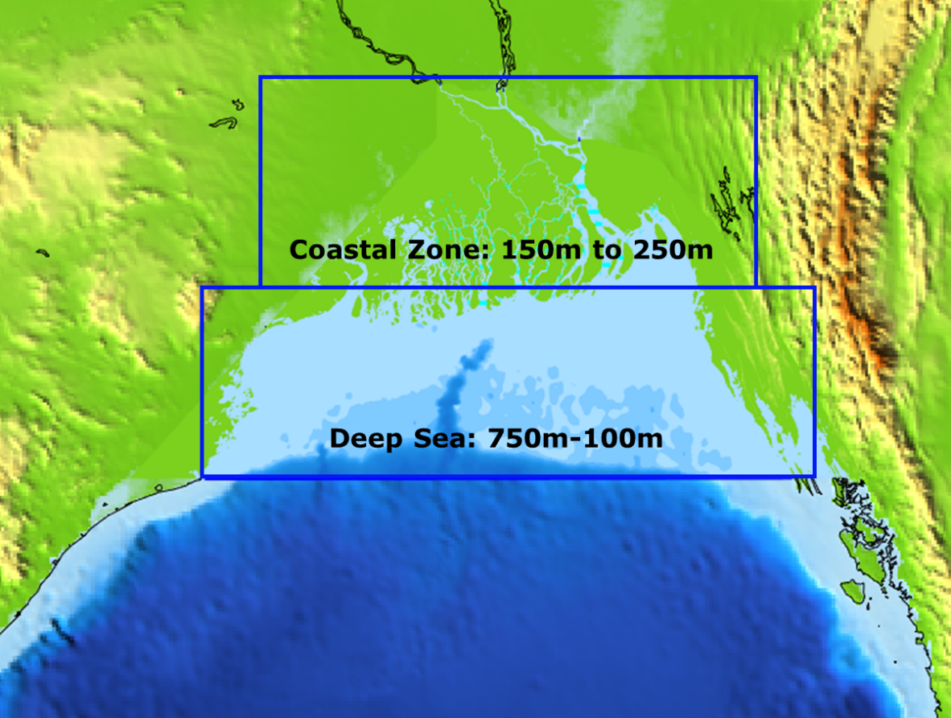

*Figure 7‑1: Grid size distribution in the model domain.*

|  |
| --- |
| C:\Users\GRA\Downloads\Coastal Zone_DEM (1).jpg  **Bay of Bengal Sea Boundary – Water Level**  **Jamuna Discharge**  **Upper Meghna Discharge**  **Ganges Discharge** |
| *Figure 7‑2: Bay of Bengal model domain and boundaries.* |

## Cyclone Induced Storm Surge Model

### Approach and Methodology

The existing Bay of Bengal Model has been applied in this study for storm surge modelling. Cyclone and hydrodynamic models are combined to create the storm surge model. Bay of Bengal model based on Delft3D hydrodynamic modelling system has been used to simulate cyclone, cyclone induced storm surge, related flooding and storm surge analysis. The storm surge analysis will determine the water levels at the Polder boundaries due to tides, storm surges and waves. Additionally, inundation extents by overtopping have been determined for the design cyclone storm event. The following methodology has been followed:

1. ***Data Collection:*** Cyclone data was collected for the period of 1960-2021 (61 years). Every year, on average five to six cyclones form in the Bay of Bengal[[47]](#footnote-48). Major cyclones which made impact at Bay of Bengal Coast have been selected for the analysis. These cyclones are all *severe cyclonic storms* or *super cyclonic storms*, according to the scale of the India Meteorological Department. In total, 33 cyclones have been selected. Characteristic of the selected cyclones are summarized in Appendix A4. The models have simulated the landfall of the cyclone in conjunction historic tide levels. The historic cyclones have been simulated both with and without climate change.
2. ***Model Input Parameters:*** Holland Single Vortex theory has been used to create the wind field. Delft3D Dashboard was used to generate spiderweb for the historical cyclones (Figure 7-3) The following facts and information are required by the cyclone model for the description of the wind field and pressure field.

* Cyclone Track (Including direction)
* Maximum Wind Speed (Vmax)
* Central Pressure (Pc)
* Ambientl Pressure (Pn)
* Radius of Maximum Winds (Rmax)
* Holland Parameter, B= 2.0-(Pc-90)/160
* Vmax-Pc relation

1. ***Defining Extraction Points:*** A number of extraction points have been identified over the study area (*Figure 7‑4*). There are approximately 2-3 points per Polder. After running the Storm Surge model for each of the 33 historic cyclones, at each of the extraction points the water levels over the duration of the storm were extracted (the SWL).
2. ***Storm Surge Model Simulation:*** The storm surge model was simulated for all the 33 cyclones for both base condition and climate change scenario (SSP8.5-2080). The cyclone induced storm surge model was calibrated and validated against water level at specified location where observed data is available during cyclone (Detailed in Section 7.4.2)
3. ***Wave Simulation:*** To simulate the evolution of wind-generated waves in coastal waters (which may include estuaries, tidal inlets, barrier islands with tidal flats, channels etc.) the third-generation SWAN model has been used. This model will be used to hindcast waves generated during historic cyclones to derive time series wave data across the project area. This model will be run *in parallel* to the cyclone model.
4. ***Result Extraction***: At each extraction point, the surge height, significant wave heights, wave period during the entire duration of the storm were extracted.
5. ***Calculating Free Board Requirement***: The freeboard requirement due to wave run up has been calculated analytically for the entire time series for each storm, at each extraction point. If the value was below the minimum freeboard stipulated by BWDB (0.9 m), the minimum freeboard was added.
6. ***Joint Probabilistic Analysis:*** The time series of the SWL and freeboard at each point for each cyclone were added together. This created a time series of the *required crest height* over the duration of each storm. Then, the maximum required crest level was extracted for each time series and a frequency analysis was performed using these maximum required crest elevations. In this way, the assessment considers the joint probability of tides, storm surges and wave effects influencing water levels simultaneously using a continuous simulation approach. *Figure 7‑5* shows a schematic of the approach. The assessment accounts for the fact that peak storm surge levels, wave heights and high tides do not always occur simultaneously; if they are assumed to be so, the protection level of embankments will be in fact much higher than the design requirements. As well, the analysis considers how storm surge severity is spatially variable by analysing each extraction point separately.
7. ***Determining Design Crest Elevation:*** Finally, the 25-year crest elevation was determined from the frequency analysis at each point across the study area.

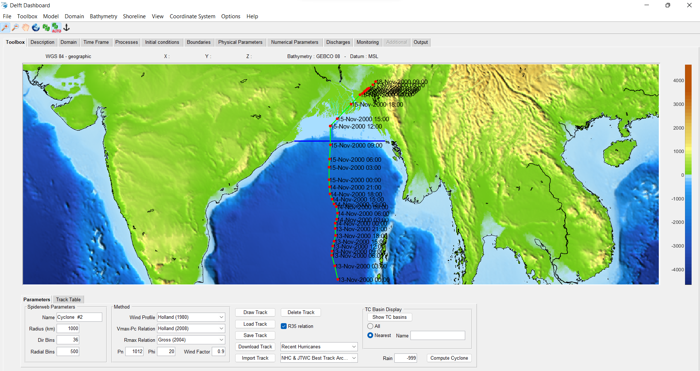

*Figure 7‑3: Delft3D Dashboard Interface*

The methodology of CEIP-2 varies from that of CEIP-1. Appendix A3 summarizes the differences between the two methodologies.

|  |
| --- |
|  |
| *Figure 7‑4: Extraction points for the water level and wave height data.* |

|  |
| --- |
|  |
| *Figure 7‑5: Schematic of computed results for one extraction point over the duration of one cyclone storm.* |

## Wave Model Development

The Delft3D-WAVE model (*Figure 7‑6*) has been developed to simulate how wind-generated waves change over time in coastal seas. In waters of deep, intermediate, and finite depth, the wave module of Delft3D computes wave propagation, wave generation by wind, nonlinear wave-wave interactions, and dissipation for a given bottom topography, wind field, water level, and current field. Delft3D-WAVE model uses third-generation SWAN model. The stationary second-generation HISWA model was replaced by this SWAN model. The SWAN model is superior to HISWA in a number of ways, and it also substantially outperforms its drawbacks. Some of the notable advantages of SWAN model are: 1) Modern formulations are used to explicitly represent the physics in SWAN, 2) The SWAN model is fully spectral in both directions and frequencies (0 to 360), 3) The fully implicit techniques that have been implemented ensure that the wave computations in SWAN are invariant, 4) The computational grid in SWAN has not to be oriented in the mean wave direction and so the grid can handle all wave directions, 5) SWAN can perform computations on a curvilinear grid (if the FLOW module of Delft3D uses this grid, the coupling between SWAN and FLOW is enabled).

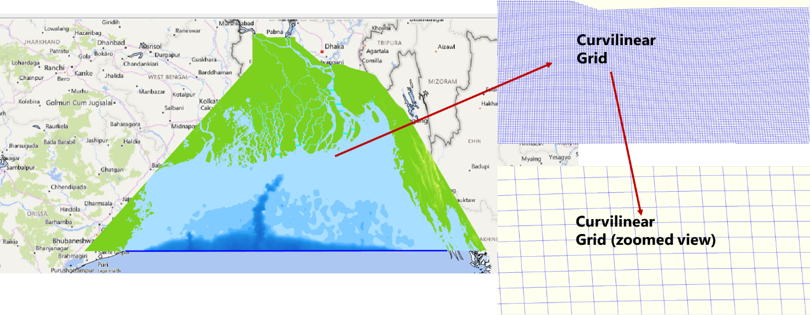

*Figure 7‑6: Bathymetry and Grid of Wave Model*

SWAN calculates the evolution of arbitrary, short-crested waves in shallow, middle, and deep water along coasts. The SWAN model takes into consideration (refractive) propagation due to current and depth and explicitly models non-linear wave-wave interactions (both quadruplets and triads) generated by wind, dissipation due to white capping, bottom friction, and depth-induced wave breaking

CEGIS has wave model developed by Delft3D modelling system to estimate the main wave parameters and some hydrodynamic features. The WAVE module of Deflft3D was used with an online coupling with the FLOW module. Through a two-way wave-current interaction, the two modules in this coupled simulation are dynamically connected. This connection of modules takes into account both the impact of waves on current and the impact of flow on waves.

Three additional boundary conditions along with those used in hydrodynamic and cyclone induced storm surge model: time-varying significant wave height, wave direction and wave period were provided at the southern boundary in Bay of Bengal, from European Centre for Medium-Range Weather Forecasts (ECMWF). Wind speed data were collected from ECMWF as well, at one-degree interval across the whole computational grid.

## Calibration and Validation of the Models

### Hydrodynamic Model

The updated hydrodynamic model has been calibrated at validated at three locations: Coxsbazar, Khepupara and Hiron Point. Calibration was done for the year 2018 and validation was done for the year 2020. In cased of both calibration and validation, efforts have been made to match the simulated water level with observed water level at the mentioned three locations. *Figure 7‑7* shows the geographical location of calibration and validation of hydrodynamic model:

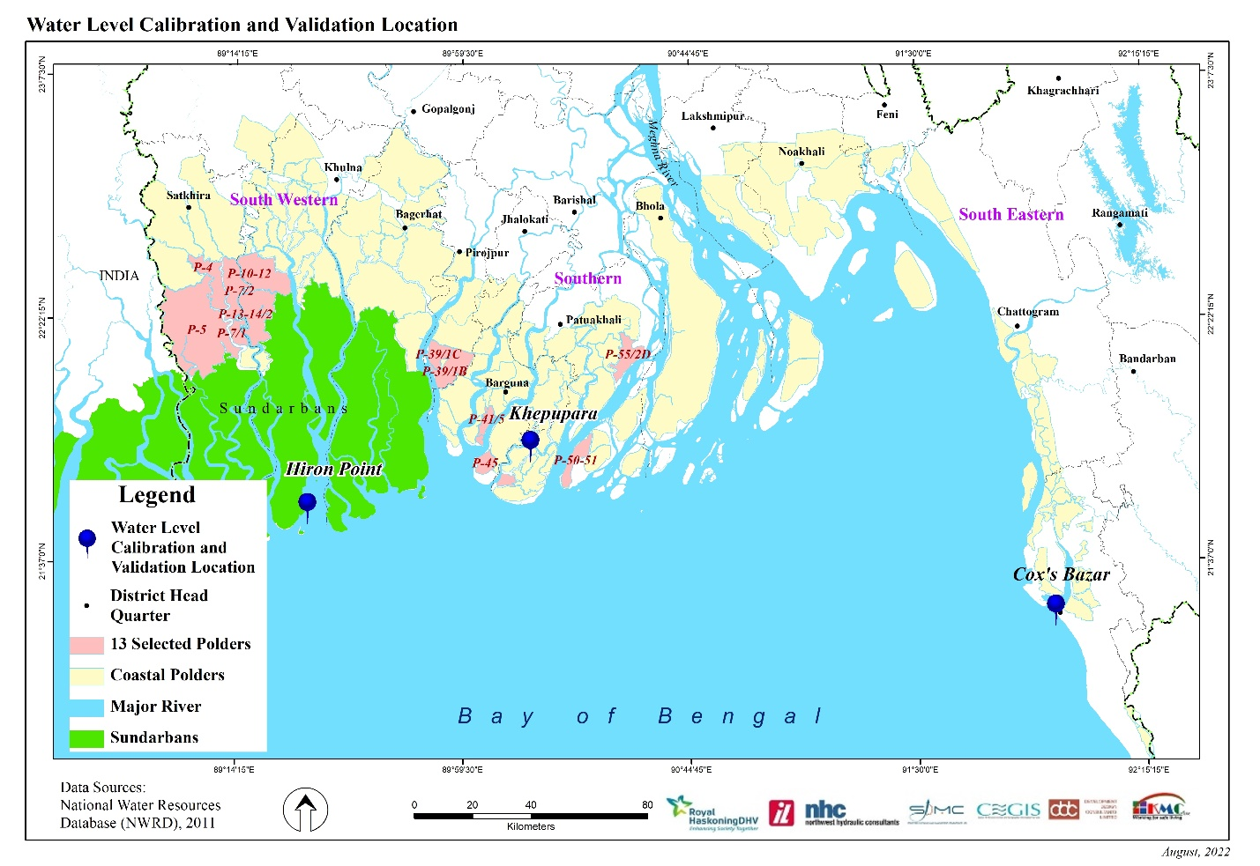

*Figure 7‑7: Hydrodynamic Model Calibration and Validation Location*

Calibration of the Model

The performance of the hydrodynamic model has been evaluated in two ways, (i) visual comparison of observed and simulated water level, and (ii) statistical performance evaluation of results. Statistical performance of the model has been analysed utilising the following parameters: Nash-Sutcliffe Efficiency (NSE), percent Bias (PBIAS), ratio of RMSE and observed data standard deviation (RSR), Pearson’s correlation coefficient (r) and coefficient of determination (R2). In order to achieve satisfactory model performance, the updated and enhanced two-dimensional hydrodynamic model of the Bay of Bengal has been calibrated against water level (simulated and measured) and water flow at various places. The year 2018 has been chosen as the calibration year. The locations of the measured and anticipated data that were used for calibration are depicted in *Figure 7‑8* to *Figure 7‑10*. From the visual interpretation it has been observed that the model captures the peak water levels well. The result of statistical analysis also shows that the model shows satisfactory performance for all the parameters (see Table 7‑1).

|  |
| --- |
|  |
| *Figure 7‑8: C*alibration of Water Level at Hiron Point |
|  |
| *Figure 7‑9: C*alibration of Water Level at Khepupara |
|  |
| *Figure 7‑10: C*alibration of Water Level at Coxsbazar |

Table 7‑1: Statistical performance of the Bay of Bengal model for Calibration at Hiron Point, Khepupara and Coxs Bazar

| **Station Name** | **Parameter** | **Value** | **Status** |
| --- | --- | --- | --- |
| Coxsbazar | NSE | 0.97 | Very Good |
| PBIAS | 2.10 | Very Good |
| RSR | 0.16 | Very Good |
| R2 | 0.98 | Very Good |
| Khepupara | NSE | 0.91 | Very Good |
| PBIAS | 0.54 | Very Good |
| RSR | 0.31 | Very Good |
| R2 | 0.91 | Very Good |
| Hiron Point | NSE | 0.91 | Very Good |
| PBIAS | -0.22 | Very Good |
| RSR | 0.30 | Very Good |
| R2 | 0.91 | Very Good |

Validation of the Model

To validate the model, other sets of data from different years but at the same locations were compared to the data used in the calibration. Three locations have validated the model for the year 2020. *Figure 7‑7* displays the locations for the validations. The results of the validation are displayed from *Figure 7‑11* to *Figure 7‑13*. From the visual interpretation, it has been observed that, model captures the peak water levels well. The result of statistical analysis also shows that the model shows satisfactory performance for all the parameters (see Table 7-2).

|  |
| --- |
|  |
| *Figure 7‑11: V*alidation of Water Level at Hiron Point |
|  |
| *Figure 7‑12: V*alidation of Water Level at Khepupara |
|  |
| *Figure 7‑13: V*alidation of Water Level at Coxsbazar |

Table 7‑2: Statistical performance of the Bay of Bengal model for Validation at Hiron Point, Khepupara and Coxs Bazar

| **Station Name** | **Parameter** | **Value** | **Status** |
| --- | --- | --- | --- |
| Coxsbazar | NSE | 0.86 | Very Good |
| PBIAS | 3.96 | Very Good |
| RSR | 0.37 | Very Good |
| R2 | 0.89 | Very Good |
| Khepupara | NSE | 0.87 | Very Good |
| PBIAS | 2.79 | Very Good |
| RSR | 0.36 | Very Good |
| R2 | 0.89 | Very Good |
| Hiron Point | NSE | 0.92 | Very Good |
| PBIAS | 4.25 | Very Good |
| RSR | 0.28 | Very Good |
| R2 | 0.94 | Very Good |

### Cyclone Induced Storm Surge Model

The updated storm surge model has been calibrated at validated at three location: CHarchenga, Khepupara and Hiron Point. The location has been selected such way so that storm surge level due to cyclone is available for a particular cyclone. In cased of both calibration and validation, efforts have been made to match the simulated water level with observed water level at the mentioned three locations. *Figure 7‑14* shows the geographical location of calibration and validation of Cyclone Induced Storm Surge Model.

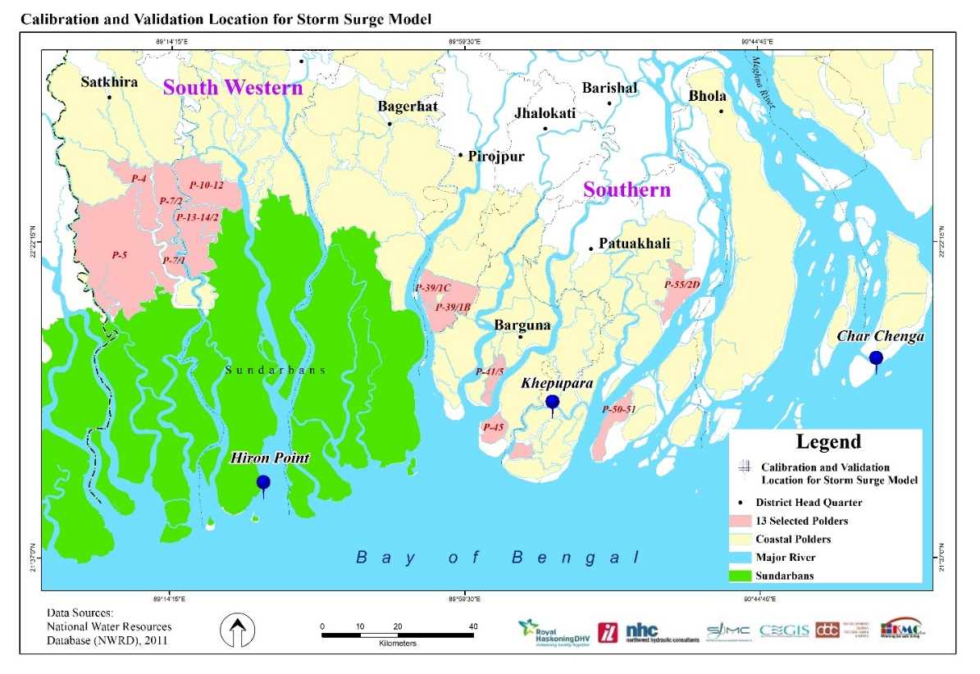

*Figure 7‑14: Cyclone Induced Storm Surge Model Calibration and Validation Location*

The performance of the storm surge model has been evaluated in two ways, (i) visual comparison of observed and simulated water level of a historic cyclone, and (ii) statistical performance evaluation of results. Statistical performance of the model has been analysed utilising the following parameters: Nash-Sutcliffe Efficiency (NSE), percent Bias (PBIAS), ratio of RMSE and observed data standard deviation (RSR), Pearson’s correlation coefficient (r) and coefficient of determination (R2). Calibration has been done by comparing o observed and simulated water level of tropical cyclone Sidr at Khepuppara. Validation has been done by comparing observed and simulated water level of tropical cyclone Sidr at Charchenga and Aila at Hiron Point. *Figure 7‑15* to *Figure 7‑17*, shows the result of calibration and validation for all the three stations. The model captures the peak water levels well. The result of statistical analysis also shows that the model shows satisfactory performance for all the parameters (see Table 7‑3).

|  |
| --- |
|  |
| *Figure 7‑15: Calibration* of Water Level at Khepupara for SIDR (Storm Surge Model) |
|  |
| *Figure 7‑16: Calibration* of Water Level at Charchenga for SIDR (Storm Surge Model) |
|  |
| *Figure 7‑17: Validation* of Water Level at Hidron Point for Aila (Storm Surge Model) |

Table 7‑3: Statistical performance of the Storm Surge Model

| **Station Name** | **Parameter** | **Value** | **Status** |
| --- | --- | --- | --- |
| Khepupara | NSE | 0.86 | Very Good |
| PBIAS | -0.28 | Very Good |
| RSR | 0.38 | Very Good |
| R2 | 0.86 | Very Good |
| Charchenga | NSE | 0.75 | Very Good |
| PBIAS | 0.28 | Very Good |
| RSR | 0.50 | Very Good |
| R2 | 0.68 | Good |
| Hiron Point | NSE | 0.75 | Very Good |
| PBIAS | 0.28 | Very Good |
| RSR | 0.50 | Very Good |
| R2 | 0.68 | Very Good |

Comparison to CEIP-1 Results

Because of limited historic data available, the CEIP-2 storm surge model has also been compared to the model results of CEIP-1. In the absence of historic data, confidence in model results can be gained if two separate models create comparable results. Results have been extracted at the same locations as the extracted points for CEIP-1 (*Figure 7‑18*). A total of 103 locations have been identified. Three major cyclones have been used for the validation: the 1991 cyclone (landfall at Chattogram Coastal Plain), cyclone SIDR (landfall at Meghna Deltaic Zone) and cyclone AILA (landfall at West Bengal but effected the Ganges Deltaic Plan). The results can be seen in *Figure 7‑19* and *Table 7‑4*. The results shows that the CEIP-2 model performs well for all the three cyclones both statistically and visually. The CEIP-2 model underestimating the CEIP-1 model outcomes at few locations, see *Figure 7‑19*, *(ii)*. Here, the CEIP-1 model shows higher water levels during low tide, compared to those at high tide. Additionally, wind velocities at the points shown in *Figure 7‑20* are shown in Table 7-4. There is good agreement between the model velocities.

|  |
| --- |
|  |
| *Figure 7‑18: Comparison points between the CEIP-1 model and the CEIP-2 model.* |

|  |  |  |  |
| --- | --- | --- | --- |
|  |  | | |
| *(i) 1991 Cyclone (High Tide)* | *(ii) 1991 Cyclone (Low Tide)* | | |
|  | |  | |
| *(iii) SIDR Cyclone (High Tide)* | | *(iv) SIDR Cyclone (Low Tide)* | |
|  |  | |
| *(v) AILA Cyclone (High Tide)* | *(vi) AILA Cyclone (Low Tide)* | |
| *Figure 7‑19: Comparison of water level at various points in the model. The CEIP-1 model is shown with the black line and the CEIP-2 model is shown with the blue line.* | | | |

Table 7‑4: Statistical performance of the CEIP-2 model, compared to the CEIP-1 model.

| **Cyclone** | **Parameters** | **Value (HT)** | **Status** | **Value (LT)** | **Status** |
| --- | --- | --- | --- | --- | --- |
| 1991 | NSE | 0.80 | Very Good | 0.57 | Satisfactory |
| PBIAS | 3.50 | Very Good | 11.26 | Good |
| RSR | 0.35 | Very Good | 0.65 | Satisfactory |
| R2 | 0.90 | Very Good | 0.75 | Very Good |
| SIDR  (2007) | NSE | 0.97 | Very Good | 0.91 | Very Good |
| PBIAS | -0.91 | Very Good | 5.49 | Very Good |
| RSR | 0.17 | Very Good | 0.31 | Very Good |
| R2 | 0.98 | Very Good | 0.94 | Very Good |
| AILA  (2009) | NSE | 0.88 | Very Good | 0.63 | Satisfactory |
| PBIAS | -0.42 | Very Good | 9.29 | Very Good |
| RSR | 0.35 | Very Good | 0.61 | Satisfactory |
| R2 | 0.89 | Very Good | 0.84 | Very Good |

|  |
| --- |
|  |
| *Figure 7‑20: Comparison points for the wind speeds.* |

Table 7‑5: Results of the comparison between the CEIP-1 and CEIP-2 wind results.

| **Point** | **SIDR (CEIP-1)** | **SIDR (CEIP-2)** | **AILA (CEIP-1)** | **AILA (CEIP-2)** |
| --- | --- | --- | --- | --- |
| 1 | 40.56 | 40.2 | 23.94 | 24.22 |
| 2 | 38.79 | 37.1 | 24.29 | 24.12 |
| 3 | 39.38 | 38.47 | 23.78 | 23.55 |
| 8 | 31.52 | 31.22 | 22.86 | 22.98 |
| 9 | 30.54 | 31.04 | 22.74 | 22.65 |
| 10 | 29.45 | 29.12 | 21.52 | 21.45 |
| 11 | 30.42 | 30.33 | 21.68 | 21.56 |
| 12 | 31.94 | 32.23 | 22.37 | 22.65 |
| 13 | 33.52 | 33.65 | 22.00 | 22.34 |
| 24 | 33.65 | 33.76 | 19.45 | 19.22 |
| 118 | 42.80 | 42.99 | 24.13 | 24.39 |
| 119 | 41.57 | 41.94 | 22.95 | 22.75 |
| 120 | 40.37 | 40.67 | 22.82 | 22.65 |
| 121 | 32.46 | 32.31 | 21.91 | 21.55 |
| 122 | 33.52 | 33.08 | 22 | 21.89 |
| 123 | 32.97 | 32.52 | 22.44 | 22.48 |
| 124 | 31.94 | 31.75 | 22.37 | 22.31 |
| 125 | 31.94 | 31.50 | 22.37 | 22.25 |
| 126 | 34.27 | 33.79 | 18.79 | 19.10 |

### WAVE Model

The performance of the wave model has been evaluated in two ways, (i) visual comparison of observed and simulated significant wave height and (ii) statistical performance evaluation of results. The ERA5 atmospheric reanalysis, which covers the period from January 1950 to the present, is the fifth generation of the ECMWF. The Copernicus Climate Change Service (C3S) at ECMWF creates ERA5. A significant number of atmospheric, land, and oceanic climate variables are provided hourly estimates by ERA5. ERA5 replaces the ERA-Interim reanalysis. Reanalysis combines model data with observations from across the world into a globally complete and consistent dataset using the laws of physics. Reanalysis does not have the constraint of issuing timely forecasts, so there is more time to collect observations, and when going further back in time, to allow for the ingestion of improved versions of the original observations, which all benefit the quality of the reanalysis product.

ERA5 provides hourly estimates for a large number of atmospheric, ocean-wave and land-surface quantities. An uncertainty estimate is sampled by an underlying 10-member ensemble at three-hourly intervals. ERA5 is updated daily with a latency of about 5 days. In case of serious flaws are detected in this early release (called ERA5T), this data could be different from the final release 2 to 3 months later. In case that this occurs, users are notified.

The data set presented here is a regridded subset of the full ERA5 data set on native resolution. Data has been regridded to a regular lat-lon grid of 0.25 degrees for the reanalysis and 0.5 degrees for the uncertainty estimate (0.5 and 1 degree respectively for ocean waves). There are four main sub sets: hourly and monthly products, both on pressure levels (upper air fields) and single levels (atmospheric, ocean-wave and land surface quantities).

The WAVE model was calibrated against two locations where the data from ERA5 is available. One location is located at Sibsa River close to Hiorn Point (defined as Location-1) and another is located at Bishkhali River close to Charduani (defined as Location-2). Calibration was done at at Bishkhali River close to Charduani against the observed significant wave height for SIDR cyclone and validation was done at Sibsa River close to Hiorn Point for Amphan Cyclone. *Figure 7‑21* illustrates the location of Calibration and Validation location graphically. *Figure 7‑22* and *Figure 7‑23* shows the calibration and validation location of the Wave Model. Statistical performance of the model has been analysed utilising the following parameters: Nash-Sutcliffe Efficiency (NSE), percent Bias (PBIAS), ratio of RMSE and observed data standard deviation (RSR), Pearson’s correlation coefficient (r) and coefficient of determination (R2).

The model captures the peak wave heights well. The result of statistical analysis also shows that the model shows satisfactory performance for all the parameters (see Table 7-6).

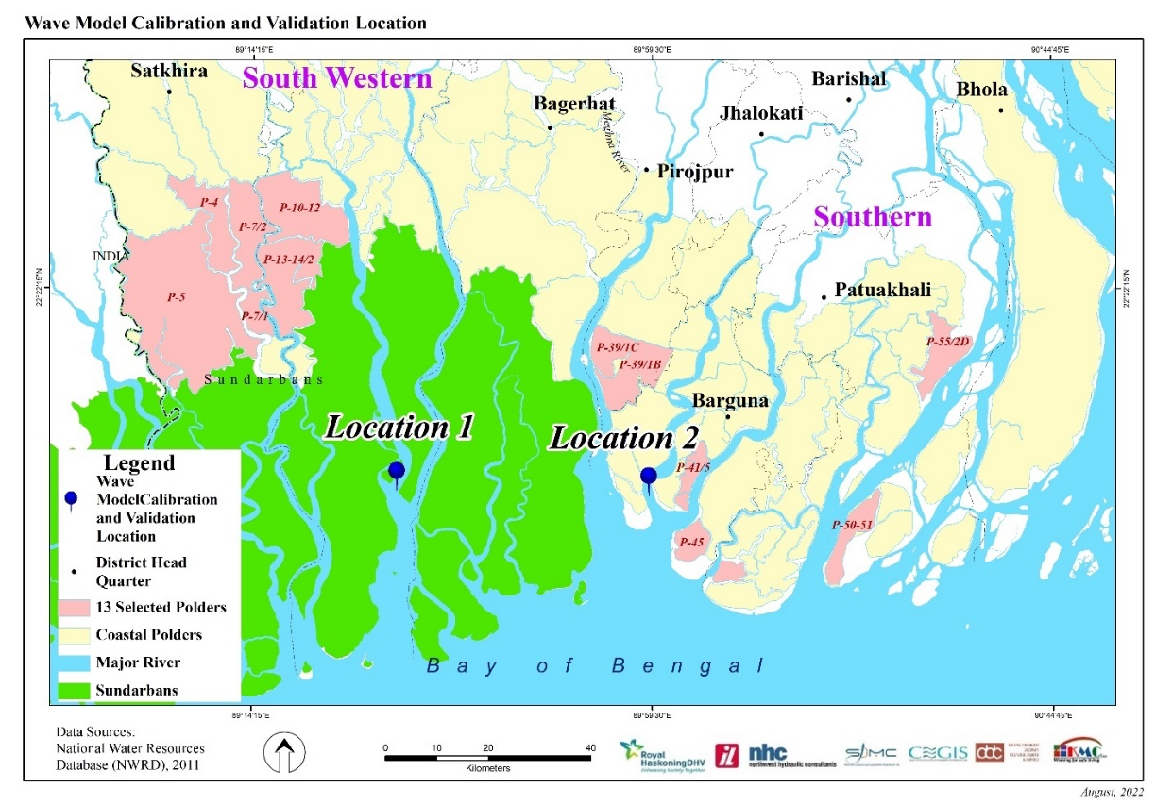

*Figure 7‑21: Calibration and Validation Location of Wave Model*

|  |
| --- |
|  |
| *Figure 7‑22: Calibration* of Significant Wave Height at Location-2 for SIDR |
|  |
| *Figure 7‑23: Validation* of Significant Wave Height at Location-1 for Aila |

Table 7‑6: Statistical performance of the Wave Model

| **Station Name** | **Parameter** | **Value** | **Status** |
| --- | --- | --- | --- |
| Location-1 | NSE | 0.87 | Very Good |
| PBIAS | 12.98 | Good |
| RSR | 0.36 | Very Good |
| R2 | 0.95 | Very Good |
| Location-2 | NSE | 0.89 | Very Good |
| PBIAS | 11.22 | Good |
| RSR | 0.34 | Very Good |
| R2 | 0.92 | Very Good |

## Hydrodynamic, Storm Surge and Wave Model Simulations

Table 7‑7 summarizes the simulation runs of the Storm Surge and Wave Model.

Table 7‑7: Hydrodynamic, Storm Surge and Wave Model model simulations.

| Type of Model | Upstream boundary | Downstream Boundary | | Cyclone Winds | Cyclone Track | No. of  Runs | Remarks |
| --- | --- | --- | --- | --- | --- | --- | --- |
| Sea Level | Astronomical Tides |
| Hydrodynamic | Time Series Unsteady Discharge Hydrograph | N/A | Histroic tidal levels | N/A | N/A | 1 | Model Calibration and Validation |
| Cyclone Induced Storm Surge Coupled with Wave | Time Series Unsteady Discharge Hydrograph | Present day sea level | Histroic tidal levels during cyclone | Historic winds during cyclones | Historic Track | 33 |  |
| Cyclone Induced Storm Surge Coupled with Wave | Time Series Unsteady Discharge Hydrograph | Present day sea level plus 0.65 m due to climate change | Histroic tidal levels during cyclone | Historic winds plus 10% to account for climate change | Historic Track | 33 |  |
|  |  |  |  |  | Total | **67** |  |

## Freeboard Calculation

Wave run-up will cause overtopping of the embankment. A small amount of overtopping will not cause damage to the embankments; however, excessive overtopping may cause flooding and erosion of the embankment slopes. Overtopping rates from wave run-up will vary spatially and temporally, depending on both the wave and embankment characteristics. The embankments of CEIP-2 will include a freeboard which will limit the average overtopping rate to 5 L/m/s for the design event. Wind effects are neglected in the wave run up calculations as per Eurotop[[48]](#footnote-49) recommendations.

The methodology for determining overtopping is based on the analytical methodology outlined in Eurotop48. The 2018 Eurotop manual updates the overtopping equations presented in the 2007 manual[[49]](#footnote-50). The required freeboard, *Rc,* has been determined by the following equation:

$$\frac{q}{\sqrt{gH_{m0}^{3}}}= \frac{0.026}{\sqrt{tanα}} γ_{b }ξ_{m-1,0} exp\left[-{\left(2.5 \frac{R_{c}}{H_{m0}{ γ}_{b }ξ_{m-1,0 }γ_{f }γ_{β} γ_{v}}\right)}^{1.3}\right]$$

with a maximum of, $$\frac{q}{\sqrt{gH_{m0}^{3}}}= 0.1035 exp\left[-{\left(1.35 \frac{R_{c}}{H_{m0} γ_{f }γ_{β }γ_{* } }\right)}^{1.3}\right]$$

where,

| Variable | | Value | Units | Note |
| --- | --- | --- | --- | --- |
| $$R_{c}$$ | Embankmenk crest freeboard | variable | [m] | Calculated |
| *q* | average wave overtopping discharge | 5 | [l/m/s] | BWDB design guidelines |
| *g* | acceleration due to gravity | 9.81 | [m/s2] | Constant |
| *Hm0* | Estimated significant wave height from spectral analysis at the toe of the dike | variable | [m] | Output from model |
| $$γ_{b }$$ | Correction factor for a berm | 1 | [-] | Embankment outer slopes are simple slopes - assume no berm |
| $$γ_{f }$$ | Correction factor for the permeability and roughness of or on the slope | 0.8/1.0 | [-] | Both a rough (armoured) and smooth (grass slopes) embankment slope have been considered in the calculations. Friction factors of $γ_{f}=0.8$ and $γ_{f}=1.0$, respectively, have been used. |
| $$γ_{v}$$ | Correction factor far a vertical wall on the slope | 1 | [-] | There is no floodwall on the embankment |
| $$γ_{* }$$ | Factor for storm wall or promenade | 1 | [-] | No prominent prominade or storm wall |
| $$α$$ | Angle between overall structure slope and horizontal | variable | [o] | 1V:5H – Riverside Embankment  1V:7H – Sea Embankment |
| $$γ_{β}$$ | Correction factor for oblique wave attack |  | [-] | Wave attack has conservatively been assumed to be normal to the embankment, $β=0$ |
|  | For wave overtopping |  |  | , |
|  | For wave run up |  |  | ,  , |
|  | Breaker parameter based on so |  | [-] |  |
|  | $ξ_{m-1,0}=\frac{tanα}{\sqrt{H_{mo}/L_{m-1,0}}}$ |  |  |  |
|  | where Lm-1,0 = deep water wave length, $L_{m-1,0}=\frac{gT_{m-1,0}^{2}}{2π}$ |  |  |  |
|  | where T2m-1,0 is the average wave period |  |  |  |

These equations are recommended for design and include a safety factor in the results (one standard deviation). However, the BWDB embankment design manual recommends a minimum freeboard of 0.9 m. If the calculated freeboard based on the overtopping calculations is lower than 0.9 m, then the minimum value of 0.9 m is recommended. The required freeboard has been calculated at every point, over the duration of each cyclone.

## Storm Surge and Wave Model Results

### Analysis of Storm Surge Level

In order to assess the effectiveness of the current coastal embankment, frequency analysis has been used to determine the storm surge level for various return periods along the embankment. Under the present study, time series storm surge levels in the peripheral rivers of coastal polders at different locations have been generated from simulation results. These surge level values are analyzed to determine the different return period for all the locations. Statistical analysis of surge level is carried out using Extreme Value Analysis (EVA). The return period analysis was conducted for both base period and climate change scenario (65cm SLR and 10% increase in cyclone intensity). Table 7-8 shows the storm surge elevation for different return period for both base and climate change scenarios.

Table 7‑8: Storm Surge Depth (in meters) for Different Return Period for Both Base and Climate Change Scenarios

| **Location (CEIP-2)** | **Sidr** | **Aila** | **Amphan** | **Return Period (Years) Without Climate Change** | | | | **Return Period (Years) With Climate Change** | | | | **Polder**  **No** |
| --- | --- | --- | --- | --- | --- | --- | --- | --- | --- | --- | --- | --- |
| **10** | **25** | **50** | **100** | **10** | **25** | **50** | **100** |
| 1 | 2.12 | 3.45 | 3.80 | 2.66 | 3.13 | 3.47 | 3.81 | 3.23 | 3.58 | 3.80 | 4.00 | 5 |
| 2 | 2.17 | 3.15 | 3.55 | 2.43 | 2.89 | 3.23 | 3.57 | 2.93 | 3.38 | 3.71 | 4.03 | 5 |
| 3 | 2.16 | 2.83 | 3.52 | 2.46 | 3.00 | 3.41 | 3.85 | 2.92 | 3.40 | 3.76 | 4.12 | 4,5 |
| 4 | 2.14 | 3.13 | 3.62 | 2.57 | 3.04 | 3.39 | 3.73 | 3.07 | 3.51 | 3.83 | 4.14 | 4,5 |
| 5 | 2.12 | 3.18 | 3.78 | 2.68 | 3.20 | 3.59 | 3.99 | 3.32 | 3.88 | 4.30 | 4.71 | 7/1, 5 |
| 6 | 2.08 | 3.15 | 3.82 | 2.79 | 3.23 | 3.56 | 3.89 | 3.25 | 3.69 | 4.01 | 4.31 | 7/1, 5 |
| 7 | 2.00 | 3.22 | 3.95 | 2.85 | 3.35 | 3.72 | 4.10 | 3.31 | 3.75 | 4.06 | 4.37 | 5 |
| 8 | 2.36 | 3.22 | 3.67 | 3.06 | 3.63 | 4.05 | 4.46 | 3.30 | 3.88 | 4.25 | 4.77 | 5 |
| 9 | 2.25 | 3.07 | 3.55 | 2.75 | 3.16 | 3.45 | 3.74 | 3.17 | 3.55 | 3.82 | 4.20 | 7/2, 13-14/2 |
| 11 | 2.20 | 2.77 | 3.35 | 2.59 | 2.85 | 3.02 | 3.17 | 3.00 | 3.28 | 3.46 | 3.61 | 7/2, 10-12 |
| 12 | 2.18 | 2.97 | 3.15 | 2.86 | 3.41 | 3.82 | 4.22 | 3.26 | 3.78 | 4.17 | 4.56 | 10-12 |
| 13 | 2.29 | 3.10 | 3.30 | 2.96 | 3.52 | 3.94 | 4.36 | 3.35 | 3.90 | 4.31 | 4.71 | 10-12 |
| 14 | 3.80 | 2.10 | 2.83 | 3.06 | 3.43 | 3.67 | 3.89 | 3.46 | 3.83 | 4.06 | 4.67 | 55/2D |
| 15 | 3.70 | 1.85 | 2.45 | 2.45 | 2.76 | 2.95 | 3.13 | 3.01 | 3.38 | 3.61 | 3.83 | 55/2D |
| 17 | 5.48 | 2.65 | 3.34 | 3.55 | 4.47 | 5.23 | 6.08 | 4.21 | 5.62 | 6.67 | 7.77 | 50-51 |
| 18 | 4.05 | 2.16 | 3.03 | 2.73 | 3.74 | 4.21 | 4.70 | 3.85 | 4.56 | 5.13 | 5.72 | 50-51 |
| 19 | 4.02 | 2.13 | 3.15 | 2.90 | 3.74 | 4.21 | 4.70 | 3.85 | 4.56 | 5.13 | 5.72 | 54 |
| 20 | 3.93 | 2.18 | 3.05 | 2.83 | 3.29 | 3.62 | 4.01 | 3.10 | 3.86 | 4.19 | 4.49 | 54 |
| 21 | 3.82 | 2.82 | 3.17 | 3.00 | 3.62 | 4.18 | 4.72 | 3.58 | 4.35 | 4.88 | 5.12 | 47/1 |
| 22 | 4.42 | 3.08 | 3.47 | 3.35 | 3.95 | 4.39 | 4.83 | 4.01 | 4.70 | 5.21 | 5.72 | 47/1 |
| 23 | 4.66 | 3.00 | 3.55 | 3.39 | 4.00 | 4.45 | 4.90 | 4.06 | 4.96 | 5.27 | 5.78 | 45 |
| 24 | 4.12 | 2.77 | 3.35 | 3.15 | 3.70 | 4.11 | 4.51 | 3.77 | 4.55 | 4.95 | 5.22 | 45 |
| 25 | 4.11 | 2.74 | 3.33 | 3.15 | 3.70 | 4.11 | 4.51 | 3.77 | 4.55 | 4.95 | 5.22 | 41/5 |
| 26 | 3.45 | 2.13 | 2.65 | 2.77 | 3.24 | 3.58 | 3.92 | 3.39 | 3.90 | 4.28 | 4.66 | 41/5 |
| 27 | 4.51 | 2.75 | 3.22 | 3.28 | 3.90 | 4.37 | 4.82 | 3.89 | 4.54 | 5.02 | 5.49 | 39/1B |
| 28 | 4.28 | 2.65 | 3.01 | 3.08 | 3.64 | 4.06 | 4.55 | 3.63 | 4.22 | 4.66 | 5.10 | 39/1B, 39/1C |
| 29 | 3.74 | 2.55 | 2.63 | 2.84 | 3.35 | 3.72 | 4.30 | 3.45 | 4.01 | 4.43 | 4.85 | 39/1C |
| 30 | 2.40 | 1.89 | 1.80 | 2.20 | 2.49 | 2.69 | 2.89 | 2.68 | 2.95 | 3.14 | 3.32 | 41/7 |
| 31 | 2.85 | 2.17 | 2.00 | 2.44 | 2.82 | 3.10 | 3.38 | 2.96 | 3.25 | 3.44 | 3.62 | 41/7 |
| 35 | 3.52 | 2.60 | 3.05 | 2.92 | 3.42 | 3.79 | 4.16 | 3.45 | 3.96 | 4.35 | 4.73 | 39/1B, 39/1C |
| 36 | 3.65 | 2.13 | 2.56 | 2.86 | 3.35 | 3.71 | 4.07 | 3.41 | 3.89 | 4.25 | 4.61 | 41/5 |
| 41 | 2.15 | 3.30 | 3.73 | 2.54 | 2.85 | 3.05 | 3.23 | 2.74 | 3.06 | 3.26 | 3.45 | 5 |

### Analysis of Significant Wave Height

Significant wave height extracted from wave model was analysed to obtain the 10-, 25-, 50- and 100-years return period significant wave height. Statistical analysis of significant wave height is carried out using Extreme Value Analysis (EVA). Table 7-9 contains the significant wave height for different return period under climate change scenario.

Table 7‑9: Significant Wave Height (in meters) for Different Return Period for Climate Change Scnearios

| Location | Aila | Amphan | Sidr | Return Period (CC) | | | |
| --- | --- | --- | --- | --- | --- | --- | --- |
| 10 | 25 | 50 | 100 |
| 1 | 1.83 | 2.07 | 0.68 | 1.1 | 1.2 | 1.8 | 2.2 |
| 2 | 1.4 | 1.67 | 0.64 | 0.88 | 0.94 | 1.48 | 1.81 |
| 3 | 1.48 | 1.61 | 0.63 | 0.86 | 0.95 | 1.52 | 1.89 |
| 4 | 1.55 | 1.66 | 0.6 | 0.88 | 0.95 | 1.50 | 1.85 |
| 5 | 1.57 | 1.7 | 0.6 | 0.95 | 1.07 | 1.67 | 2.06 |
| 6 | 1.61 | 1.82 | 0.68 | 1.03 | 1.17 | 1.77 | 2.17 |
| 7 | 1.63 | 1.91 | 0.7 | 1.06 | 1.18 | 1.76 | 2.14 |
| 8 | 1.63 | 1.85 | 0.7 | 1.07 | 1.21 | 1.81 | 2.22 |
| 9 | 1.29 | 1.7 | 0.69 | 0.97 | 1.09 | 1.68 | 2.06 |
| 11 | 1.15 | 1.6 | 0.69 | 0.90 | 0.97 | 1.51 | 1.85 |
| 12 | 1.1 | 0.95 | 0.43 | 0.93 | 1.07 | 1.68 | 2.09 |
| 13 | 1.35 | 0.95 | 0.68 | 1.03 | 1.18 | 1.80 | 2.23 |
| 14 | 1.03 | 0.94 | 2.4 | 1.98 | 2.61 | 3.15 | 3.75 |
| 15 | 0.83 | 0.89 | 2.2 | 1.80 | 2.37 | 2.86 | 3.42 |
| 17 | 2.3 | 1.01 | 4.45 | 3.38 | 4.34 | 5.04 | 5.75 |
| 18 | 2.05 | 0.94 | 4.2 | 3.13 | 4.03 | 4.70 | 5.37 |
| 19 | 2.05 | 0.94 | 4.2 | 3.13 | 4.03 | 4.70 | 5.37 |
| 20 | 0.79 | 0.88 | 2.38 | 1.82 | 2.45 | 3.02 | 3.68 |
| 21 | 1.21 | 1.34 | 1.6 | 1.77 | 1.93 | 2.05 | 2.16 |
| 22 | 1.6 | 1.47 | 2.05 | 3.16 | 3.97 | 4.58 | 5.18 |
| 23 | 2.46 | 1.88 | 3.95 | 3.1 | 3.9 | 4.5 | 5.1 |
| 24 | 2.21 | 1.51 | 3.7 | 2.85 | 3.60 | 4.16 | 4.72 |
| 25 | 2.21 | 1.51 | 3.7 | 2.85 | 3.60 | 4.16 | 4.72 |
| 26 | 2.01 | 0.98 | 3.5 | 2.63 | 3.35 | 3.88 | 4.40 |
| 27 | 1.5 | 1.43 | 2.6 | 2.48 | 3.12 | 3.60 | 4.07 |
| 28 | 1.05 | 1.09 | 2.15 | 1.80 | 2.47 | 3.09 | 3.81 |
| 29 | 1.65 | 1.08 | 1.95 | 1.81 | 2.12 | 2.32 | 2.50 |
| 30 | 1.61 | 0.72 | 3.1 | 1.93 | 2.55 | 3.05 | 3.59 |
| 31 | 1.81 | 0.87 | 3.3 | 2.43 | 3.10 | 3.60 | 4.10 |
| 35 | 1.05 | 0.89 | 2.15 | 1.79 | 2.48 | 3.12 | 3.89 |
| 36 | 0.87 | 0.97 | 2 | 1.87 | 2.10 | 2.27 | 2.44 |
| 41 | 1.2 | 1.75 | 0.6 | 0.93 | 1.01 | 1.56 | 1.91 |

## Summary of Storm Surge Assessment Results

Table 7-10 shows the results of the storm surge assessment.

*Table 7‑10: Overview of recommended crest elevations based on the storm surge analysis; results include climate change*

| Polder | Point | Recommended slope1  (1V:XH) | 25-year crest level – rough2  (mPWD) | 25-year crest level – smooth2  (mPWD) |
| --- | --- | --- | --- | --- |
| 4 | 3 | 2 | 4.0 | 4.4 |
| 4 | 3 | 4.0 | 4.5 |
| 10 | Not extracted from cyclone model3 | | |
| 37 | Not extracted from cyclone model3 | | |
| 5 | 1 | 3 | 4.9 | 5.4 |
| 2 | 3 | 4.2 | 4.6 |
| 3 | 2 | 4.0 | 4.4 |
| 4 | 3 | 4.0 | 4.5 |
| 5 | 3 | 4.1 | 4.5 |
| 7 | 3 | 4.4 | 4.8 |
| 41 | 3 | 4.6 | 5.1 |
| 7/1 | 5 | 3 | 4.1 | 4.5 |
| 6 | 3 | 4.3 | 4.8 |
| 7/2 | 4 | 3 | 4.0 | 4.5 |
| 9 | 3 | 4.1 | 4.7 |
| 10 | Not extracted from cyclone model3 | | |
| 11 | 2 | 3.3 | 3.7 |
| 10-12 | 9 | 3 | 4.1 | 4.7 |
| 11 | 2 | 3.3 | 3.7 |
| 12 | 3 | 4.1 | 4.3 |
| 13 | 3 | 4.4 | 4.7 |
| 42 | Not extracted from cyclone model3 | | |
| 13-14/2 | 8 | 3 | 4.5 | 4.9 |
| 9 | 3 | 4.1 | 4.7 |
| 39/1B | 27 | 5 | 5.5 | 6.0 |
| 28 | 5 | 5.1 | 5.7 |
| 35 | 2 | 4.6 | 5.0 |
| 39/1C | 28 | 5 | 5.1 | 5.7 |
| 29 | 5 | 4.9 | 5.3 |
| 35 | 2 | 4.6 | 5.0 |
| 38 | 2 | 4.1 | 4.5 |
| 41/5 | 25 | 7 | 5.8 | 6.3 |
| 26 | 5 | 5.1 | 5.6 |
| 36 | 2 | 4.5 | 5.0 |
| 47/1 | 21 | 5 | 4.9 | 5.1 |
| 22 | 7 | 6.2 | 6.7 |
| 45 | 23 | 7 | 6.2 | 6.7 |
| 24 | 7 | 5.8 | 6.3 |
| 50-51 | 17 | 7 | 6.4 | 6.9 |
| 18 | 7 | 5.6 | 6.3 |
| 55/2D | 14 | 3 | 5.2 | 5.8 |
| 15 | 3 | 4.8 | 5.2 |
| 32 | 2 | 3.8 | 4.2 |
| 40 | 2 | 3.6 | 4.0 |

**Notes:**

1Riverside slope

2 Includes the required freeboard, calculated from wave run up

3 Crest elevations will be governed by monsoon water levels

# Monsoon Flooding with Regional Model

## Regional Model Development

*Model Overview*: CEGIS has updated the existing Regional Model for the South-west and South-central hydrological regions. SOBEK was used to develop the 1-dimensional regional model. The model simulated:

* river discharges
* tidal forcing
* future impacts of climate change by raising the sea level and increasing the river discharges

The model did not simulate:

* Cyclone forcing
* Sediment transport
* Waves (including wave overtopping)
* Salinity
* Storm surges (both pressure set up and wind set up)

### Software Package

For simulating flow within the South-west and South-central region, the ‘SOBEK’ modelling suite developed by Deltares of the Netherlands is being utilized in this study. SOBEK is an integrated software package for river, urban or rural water management. SOBEK is an implicit, finite difference model for computation of unsteady flows, where advanced computational modules are included for description of flow. Specifically, coupling of three modules of SOBEK model can be used to assess both hydrologic and hydraulic phenomena of the study area, including rainfall-runoff, flooding and drainage condition. The three modules are: SOBEK-Rural 1D Flow, SOBEK-RR and SOBEK Overland Flow (2D). SOBEK-RR module estimates surface runoff for design storm event. SOBEK-Rural 1D, simulates the dynamics of flow in channels, drains or rivers. SOBEK Overland Flow (2D) module generates flood depth and extent maps. All the modules are necessary for flood and drainage modelling.

The 1D and 2D modules are implicitly coupled and solved simultaneously based on momentum balance and mass conservancy between separate computational layers while both layers use finite difference formula based on a staggered grid approach. The RR, 1D and 2D modules can be run either simultaneously or separately. For this particular study, the 1D module of SOBEK is being used to simulate flow, water levels and salinity concentrations within the different major river systems within the SW and SC regions.

### Approach of the Model

A multi-model approach was taken to produce the crest level for the concerned polders of the study. The 13 polders that are considered in the study are spread across both the Southwest and Southcentral Hydrological Regions of Bangladesh. Table 8-1 presents the region-wise divided list of polders, which is also illustrated in*Figure 8‑1*. Given the complexity of incorporating each and every peripheral river bordering the polders, separate models for the SW and SC regions are required. But this again gives rise to the necessity of assigning boundaries at appropriate locations along the mid portion of both the regions. Four (4) locations adjacent to tidal meeting points were identified for these downstream water level boundary locations. For assigning time-series boundary data for the locations, a combined regional model was developed for the SW-SC regions and was calibrated and validated at key locations.

Table 8‑1: List of Polders and their respective Regional Models

| **Sl** | **Name** | **Upazila** | **Area (sqkm)** | **Hydrological Region** |
| --- | --- | --- | --- | --- |
| 1 | Polder-10-12 | Koyra, Paikgacha | 0.0147 | SW |
| 2 | Polder-13-14/2 | Koyra | 0.013604 | SW |
| 3 | Polder-4 | Assasuni | 0.009045 | SW |
| 4 | Polder-41/5 | Barguna Sadar | 0.003273 | SC |
| 5 | Polder-41/7 | Mirganj | 0.006459 | SC |
| 6 | Polder-45 | Amtali | 0.003473 | SC |
| 7 | Polder-47/1 | Kalapara | 0.001818 | SC |
| 8 | Polder-5 | Kaloganj, Shayamnagar | 0.047904 | SW |
| 9 | Polder-50-51 | Galachipa | 0.003897 | SC |
| 10 | Polder-54 | Kalapara, Amtali, Galachipa | 0.008755 | SC |
| 11 | Polder-55/2D | Dashmania | 0.006922 | SC |
| 12 | Polder-7/1 | Assasuni, Shaymnagar | 0.003171 | SW |
| 13 | Polder-7/2 | Assasuni | 0.009608 | SW |
| 14 | Polder-39/1B | Patharghata, Mathbaria, Bamna | 0.009155 | SC |
| 15 | Polder-39/1C | Mathbaria | 0.004525 | SC |

Since the separate models are to be simulated for at least 30 years duration, the combined model has been simulated for 31 years, from 1990-2020, to generate 30 years boundary data for the separate models and these models, fully schematized with polder adjacent rivers, were each simulated for three separate scenarios (Base, SSP5-8.5(2080)), 31 years each from 1990 to 2020 to generate water levels for the peripheral rivers, from which, yearly maximum water level values were extracted. These levels represent the Still Water Level (SWL), phased year-wise from 1990-2020 and used both directly for designing embankment, as well as for calculating crest height of embankment. Yearly maximum water depth values were also extracted and used for calculating appropriate freeboard for calculating crest levels.

### Updating of the 1D Regional Model

A combined one dimensional (1-D) hydrodynamic model has been developed for the SW-SC regions and has been calibrated and validated for the rivers of the South-west and South-central regions of Bangladesh. As mentioned before, this model has been used to calculate boundary data for four (4) specific locations along the mid-portion of the regions (*Figure 8‑1*). Upon calibration and validation, this model has been detached to produce separate models for South-west and South-central regions. This has been done to both increase model accuracy in generating design parameter values, and significantly reduce simulation times. Boundary at split channel points has been generated using combined model.

The regional models have been updated using both historic cross section data, specifically for the Raimangal system, as well as pertinent latest data from CEGIS database, the Long-term Monitoring (LTM) and most importantly the ongoing survey for CEIP-II. As mentioned, this update includes cross-section data and water level data of selected river systems. Since survey was not possible for the westernmost system i.e., the Raimangal System adjacent to the Sundarbans and Bangladesh-India border; and also given the fact that recent data is not available for this system, historic cross-section data from CEGIS’s archives. Model upstream and downstream boundaries have been updated with latest discharge and water level data. The models have been calibrated and validated using latest water level data.

For fixing the crest level for polders, the separated regional models have been simulated both for base and with climate change (CC) considerations. Three separate scenarios were thus generated; a base scenario for representing current conditions, and a scenario for SSP5-8.5(2080) for representing a 50-year climate change impact. This means that both in upstream discharge boundaries and downstream water level boundaries, influence of futuristic climate chance implications has been factored in. For the upstream boundaries, changes in discharge due to climate change implications have been used. For downstream boundaries, the effect of sea level rise (SLR) due to climate change has been factored in. The SSP5-8.5 high emissions scenario (2080) is considered as CC impacted water levels, assuming a 50-year design life for polders.

### Model Domain

The models encompass the extent of the Southwest (SW) and Southcentral (SC) hydrological regions. The models have been schematized, preliminarily simulated and has been calibrated & validated for key locations. The models include the following river systems presented in Table 8‑2. *Figure 8‑1* illustrates the model domains and *Figure 8‑2* presents the schematic of major river systems within the models.

Table 8‑2: Major River Systems Incorporated within the Model Domain

| Major River System | Region |
| --- | --- |
| Gorai-Modhumati  Hishna-Mathabanga  Chandana-Barasia  Rupsa-Sibsa-Passur  Malancha-Arpangasia etc. | Southwest |
| Arial Khan  Tentulia  Bishkhali  Barisal-Buriswar  Baleswar  Lower Meghna etc. | Southcentral |

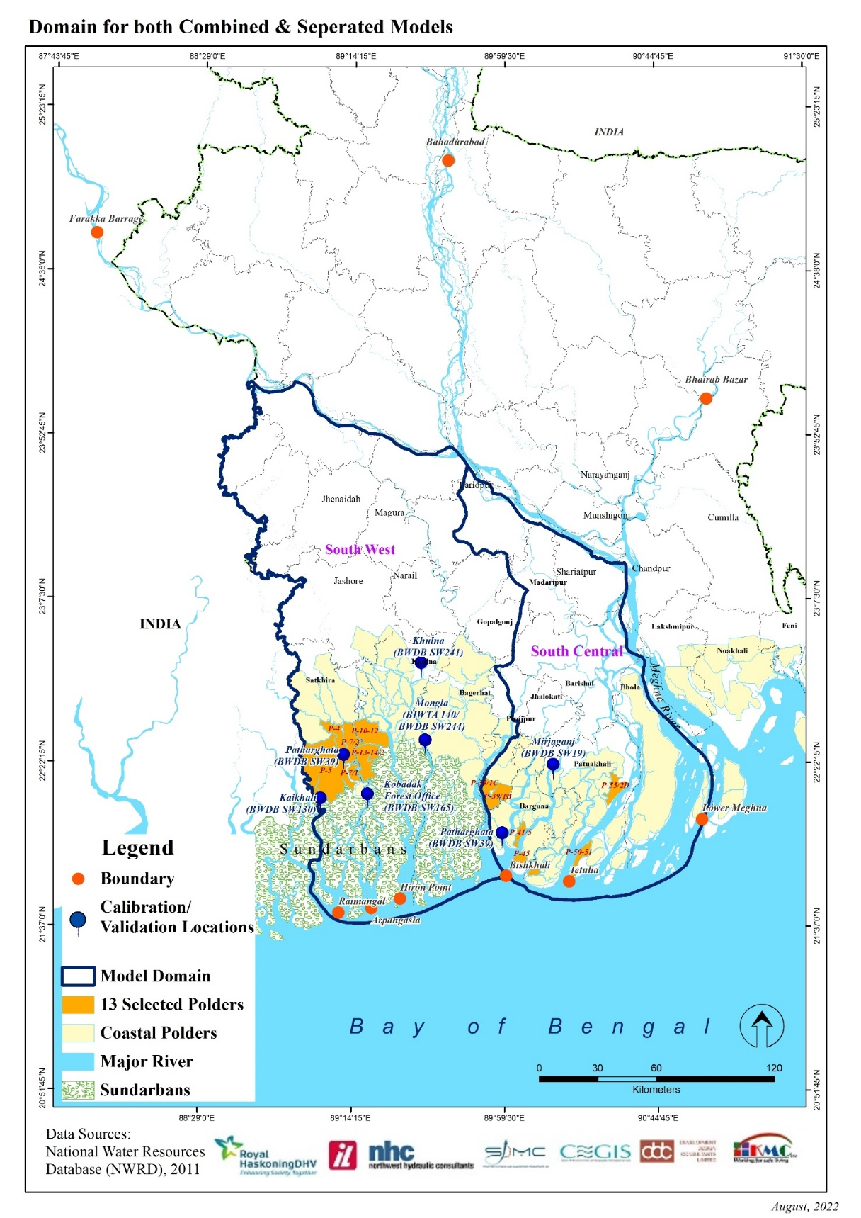

*Figure 8‑1: Domain for combined and separated models*

**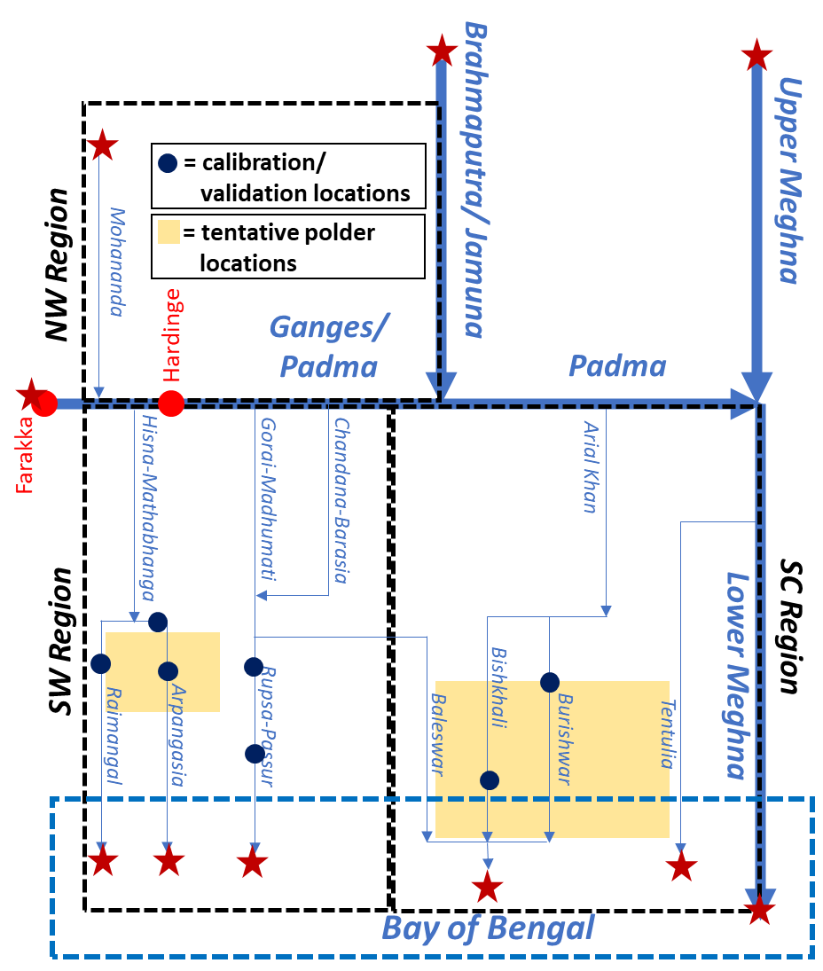**

*Figure 8‑2: Major river systems within model domains*

### Model Input Data

Data requirements concerned with model development includes data for assigning boundary conditions, model calibration/ validation and model schematization. Hydrological data such as discharge and water levels will be required for assigning the northern and southern model boundaries and subsequently for model calibration and validation for selected time periods. Bathymetry data such as river cross-sections as well as a varying degree of GIS layer data will be required for model schematization purposes. Table 8-3 lists the data requirements for model development.

Table 8‑3: Data Requirements for 1D Hydrodynamic Modeling

| Data | Type | Purpose | Source |
| --- | --- | --- | --- |
| Discharge | Hydrology | Boundary assign, model calibration/ validation | BWDB, BIWTA, Model |
| Water Level | Hydrology | Boundary assign, model calibration/ validation | BWDB, BIWTA, Field Survey, Model |
| Cross-section | Bathymetry | Model schematization | BWDB, CEGIS database, Field Survey, LTM |
| River system, location of hydrological stations, Hydrological Regions,  Cross-section locations | GIS | Model schematization | NWRD, Field Survey |

### Model Schematization

The schematized model domains are bounded to the north-northeast by the Ganges and the Padma, to the northeast-east by the lower Meghna, to the west by the Ichamati\_Kalindi-Raimangal system and to the south by the Bay of Bengal. The in-built NETTER GIS interface has been utilized to digitize the river systems and cross-sections within the model schematization. For the separated models, the combined model has been severed through appropriate locations along the middle portion to create two models for SW and SC regions. These separate models have been updated with polder specific data such as incorporation of peripheral rivers and khals, associated cross-sections etc. These two models have been separately checked for stability and have been separately calibrated and validated. Figure 8-3 illustrates the schematized model within the SOBEK NETTER interface.

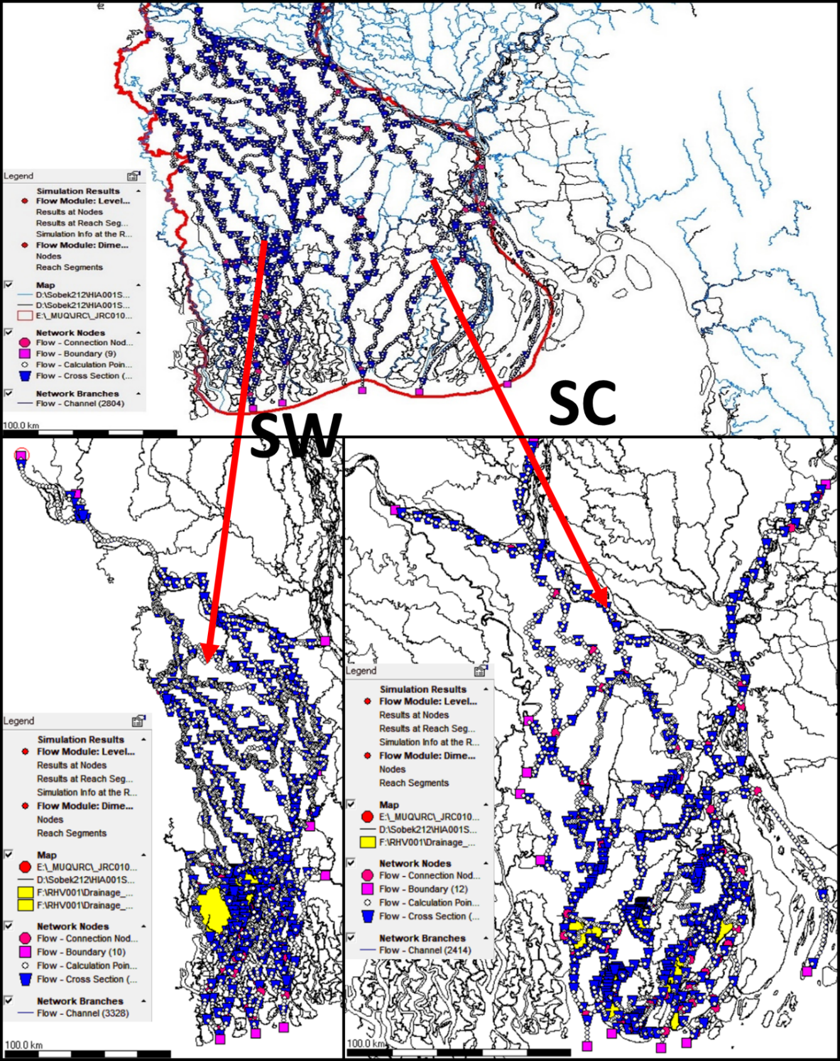

*Figure 8‑3: Model Schematization within SOBEK NETTER GIS Interface*

### Boundary Condition

At its present state, there are nine (9) boundary conditions defined within the combined model schematization. Of these, four (4) are upstream boundaries and five (5) are downstream boundaries. The upstream boundaries consist of daily discharge data for the Farakka point which is prepared from the available data, Chapai Nawabganj Station at Mohananda, Bahadurabad Station at Brahmaputra-Jamuna and Bhairab Bazar Station at Upper Meghna. Kazipur, Hardinge Bridge and Bahadurabad stations are at Mathabhanga, Ganges and Brahmaputra/ Jamuna Rivers respectively. Time periods for discharge data input is varied depending on the data availability but data from 1997-2019 i.e., for simulation period is kept common. Double staged rating curves have been generated to estimate daily discharge values using water level values for the same stations from the observed weekly discharge for the mentioned time periods. Downstream sea facing boundaries have been defined using global ocean model data collected/ generated from the Delft Dashboard interface. Initially, data for the period of 1990-2020 have been collected. The five boundaries include Arpangasia, Passur, Baleswar-Buriswar-Bishkhali, Tentulia and the lower Meghna. For Arpangasia and Passur, data adjacent to the location of the Hiron Point station have been collected. For the other three eastern locations namely the Baleswar-Buriswar-Bishkhali, Tentulia and the lower Meghna, BWDB observed data has been used. These data have then been corrected for phase, amplitude and datum with respect to relevant BWDB tidal water level data. Raimangal System has been added as an addition for the SW model. Interim model boundaries exist for the separated SW & SC models. Table 8-4 describes and illustrates the model boundary condition data.

Table 8‑4: Specified Boundary Conditions

| Boundary Locations | | | Date Type | Time Period |
| --- | --- | --- | --- | --- |
| River | Station | |
| Farakka  Ganges (SC)  Jamuna  Mohananda  Upper Meghna | * BWDB Observed Data * Combined Model Simulated Data | Source: BWDB; Model Data | Discharge | 1990-2020 |
| Ganges (SW)  Raimangal  Arpangasia  Passur  Baleswar-Buriswar-Bishkhali  Tentulia  Lower Meghna  Severance points (SW & SC Models) | * Global Model Data * BWDB Observed Data * Combined Model Simulated Data | Source: Observed data of BWDB;  Model Data | Water Level | 1990-2020 |

### Model Simulation

For fixing the crest height for Polders due to monsoon flooding, the separated regional models will be simulated with climate change considerations. The upstream discharges will be increased accordingly. In case of sea level rise the existing tidal water level at downstream boundaries have been increased by 0.65m considering SSP5-8.5 (2080) climate change scenario.

The model simulated a 30-year period of historic monsoon floods with climate change. The water level adjacent to polder periphery will be extracted from the model. The extraction points are the same points that were used in the storm surge model (Figure 7-4). A frequency analysis will be done to ascertain the 25-year return period water level unique to each extraction point in order to fix the crest height.

Table 8‑5: Simulation of the 1D Regional Model

|  |  |  |  |  |  |  |
| --- | --- | --- | --- | --- | --- | --- |
| Region |  | | Upstream boundary | Downstream Boundaries1 | | No. of Runs |
| Southwestern Model |  | | 30 years of historic discharge data (1990 – 2020) | 30 years of historic water levels including tidal forcing (1990 – 2020) | | 30 |
|  | | 30 years of historic discharge data (1990 – 2020) with climate change (increased upstream discharges) | 30 years of historic water levels including tidal forcing (1990 – 2020) with climate change (sea level +0.65 m) | | 30 |
| Southern Model |  | | 30 years of historic discharge data (1990 – 2020) | 30 years of historic water levels including tidal forcing (1990 – 2020) | | 30 |
|  | | 30 years of historic discharge data (1990 – 2020) with climate change (increased upstream discharges) | 30 years of historic water levels including tidal forcing (1990 – 2020) with climate change (sea level +0.65 m) | | 30 |
|  |  | |  |  | **Total** | **120** |
|  | |  | | | | |

### Model Calibration and Validation

Once the models were setup, they have been simulated for different time periods to assess model stability. Once stable, the model has been calibrated and validated against the observed data to determine its ability to reproduce the actual phenomena observed in the field. The resistance parameter is the major controlling calibration parameter for the hydrodynamic model. As such, Manning’s ‘n’ was chosen as a resistance parameter for the flow model and dispersion coefficient has been used for salinity model. After calibration, the model was validated both at other locations and with another set of observed data different from model calibration. Table 8-6 presents the calibration and validation location and other details. *Figure 8‑4* to *Figure 8‑10* presents the model calibration plots. *Figure 8‑11* to *Figure 8‑18* contains the model validation plots:

Table 8‑6: Calibration and Validation Locations

| **Parameter** | **Location/ Station** | **River/ System** | **Calib (Model & Year)** | **Valid (Model & Year)** |
| --- | --- | --- | --- | --- |
| Water Level | Protapnagar (SW26) | Betna-Kholpetua | Combined (2019); | Combined (2018); SW (2019) |
| Khulna (SW241) | Rupsa-Passur | Combined (2019) | SW (2019) |
| Mirjaganj (SW19) | Barisal-Buriswar | Combined (2019); SC (2019) | SC (2020) |
| Mongla (BIWTA 140 & BWDB SW244) | Rupsa-Passur | SW (2012) | Combined (2018) |
| Patharghata (SW39) | Bishkhali | SC (2019) | Combined (2018); SC (2020) |
| Kobodak Forest Station (SW165) | Kobodak | SW (2015) | - |
| Kaikhali (SW130) | Ichamati-Kalindi | SW (2019) | SW (2018) |

Calibration of the Combined Model

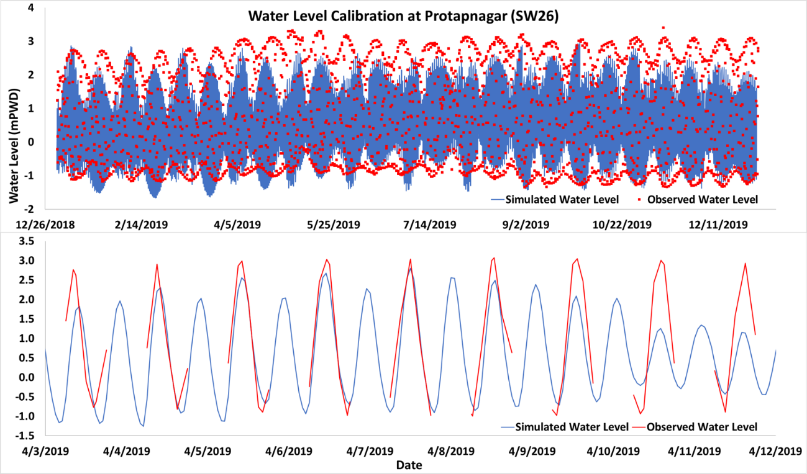

*Note – The break in observed data is due to the fact that no data is recorded during night time.*

*Figure 8‑4: Water Level Calibration at Protapnagar (SW26)*

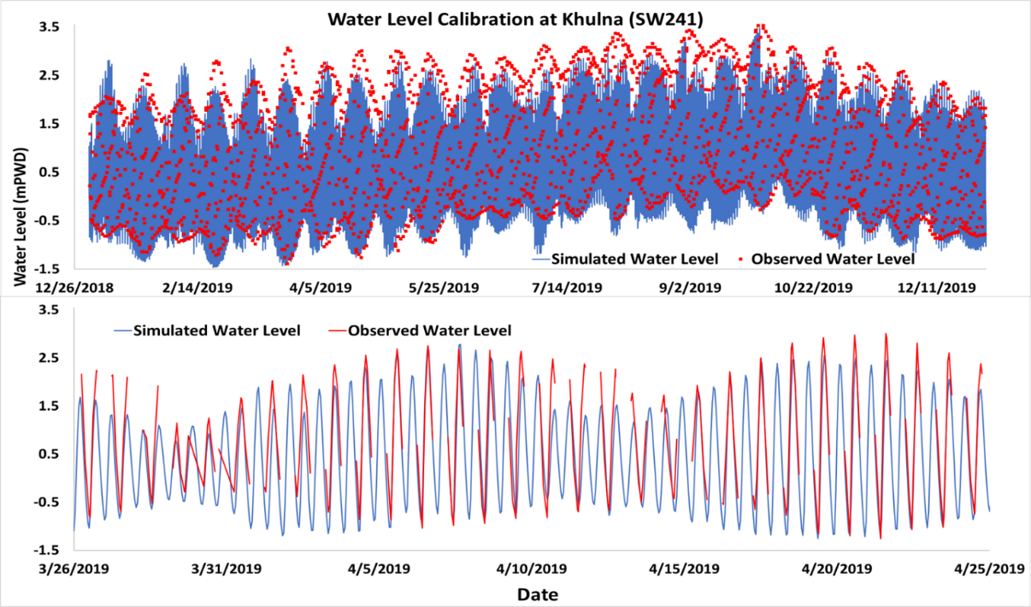

*Note – The break in observed data is due to the fact that no data is recorded during night time.*

*Figure 8‑5: Water Level Calibration at Khulna (SW241)*

Calibration of the South West Model

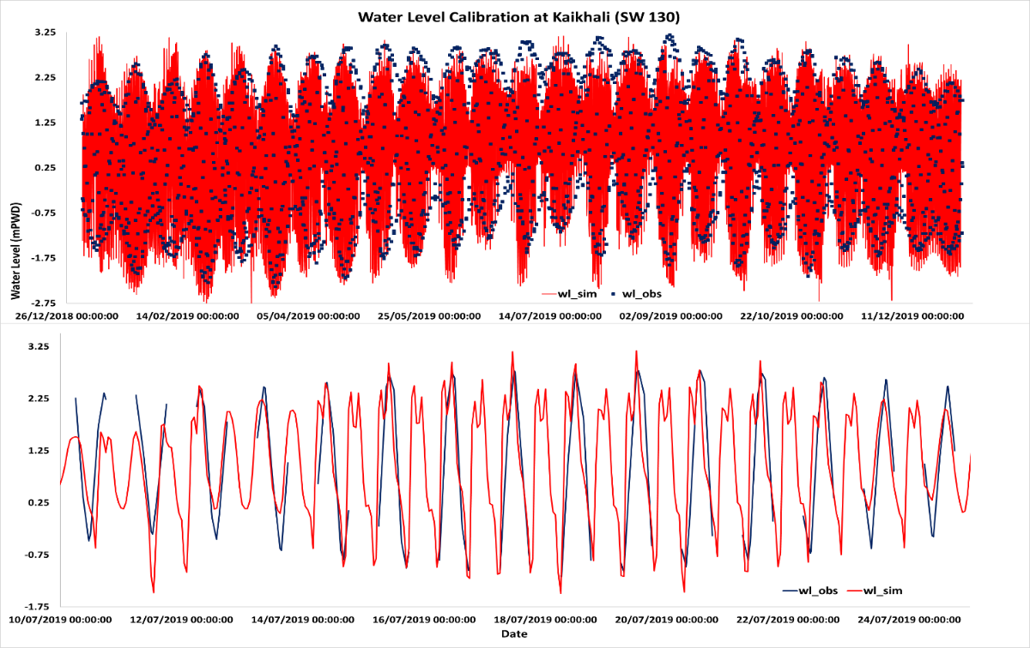

*Note – The break in observed data is due to the fact that no data is recorded during night time.*

*Figure 8‑6: Water Level Calibration at Kaikhali (SW130)*

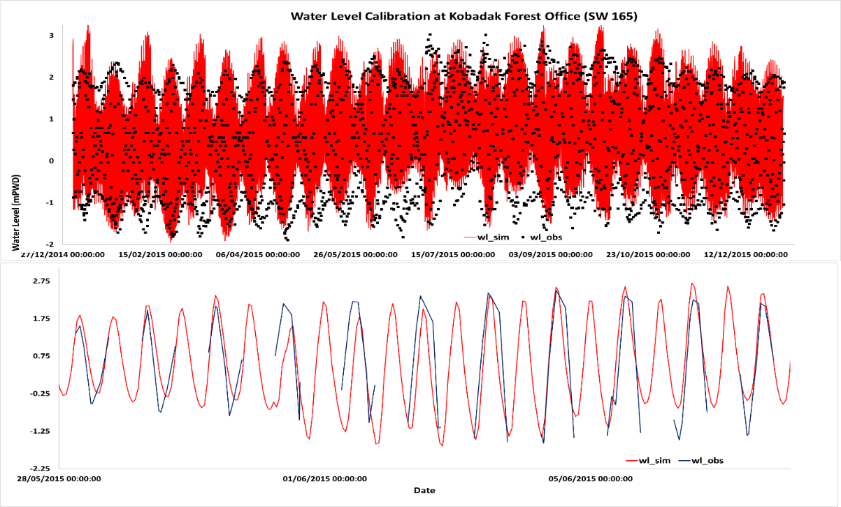

*Note – The break in observed data is due to the fact that no data is recorded during night time.*

*Figure 8‑7: Water Level Calibration at Kobadak Forest Office (SW165)*

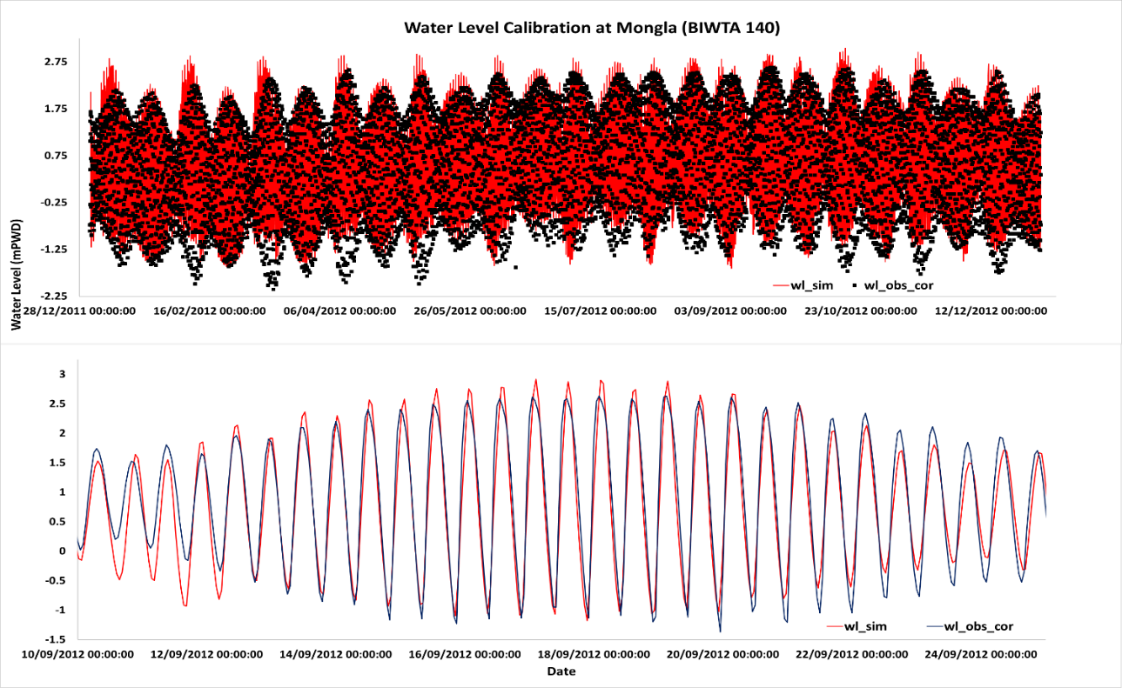

*Note – The break in observed data is due to the fact that no data is recorded during night time.*

*Figure 8‑8: Water Level Calibration at Mongla (SW140)*

Calibration of the South Central Model

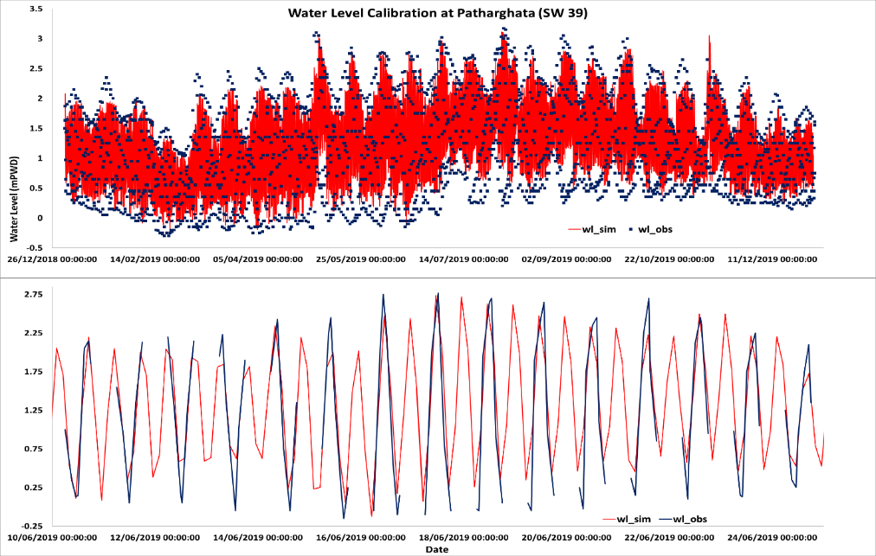

*Note – The break in observed data is due to the fact that no data is recorded during night time.*

*Figure 8‑9: Water Level Calibration at Patharghata (SW39)*

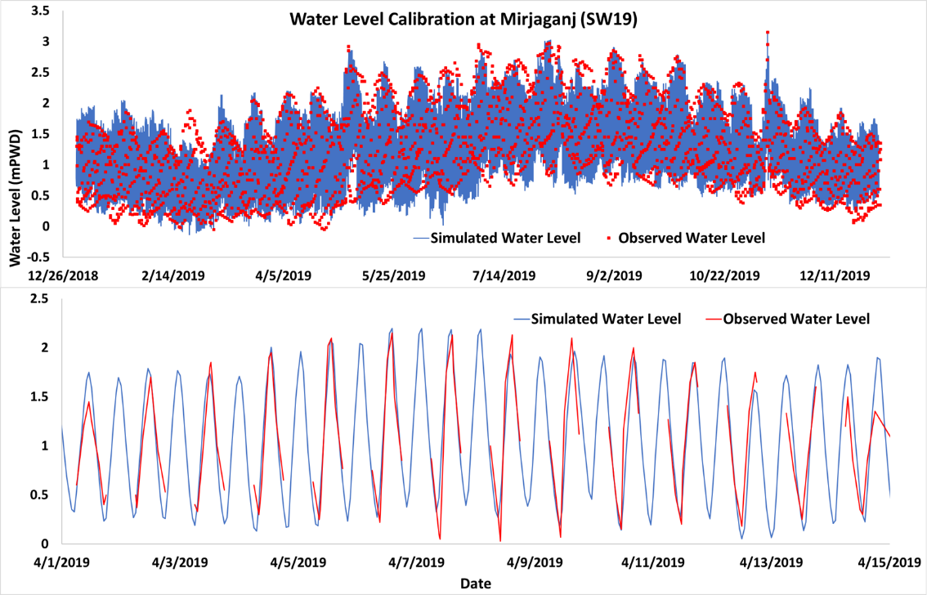

*Note – The break in observed data is due to the fact that no data is recorded during night time.*

*Figure 8‑10: Water Level Calibration at Mirjaganj (SW19)*

Validation of Combined Model

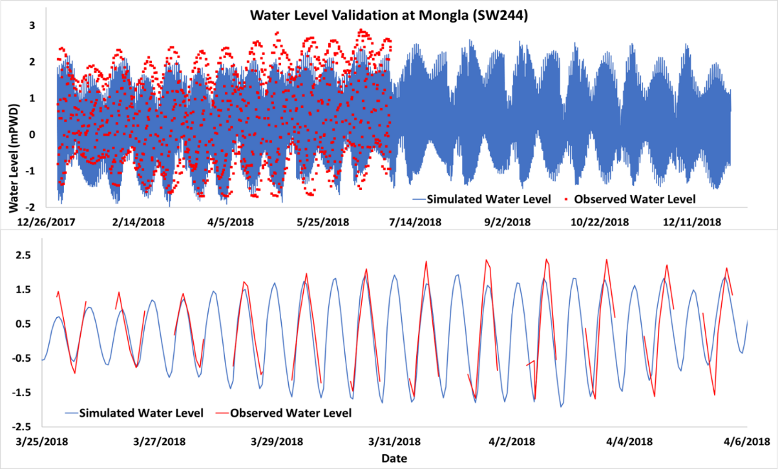

*Note – The break in observed data is due to the fact that no data is recorded during night time.*

*Figure 8‑11: Water Level Validation at Mongla (SW244)*

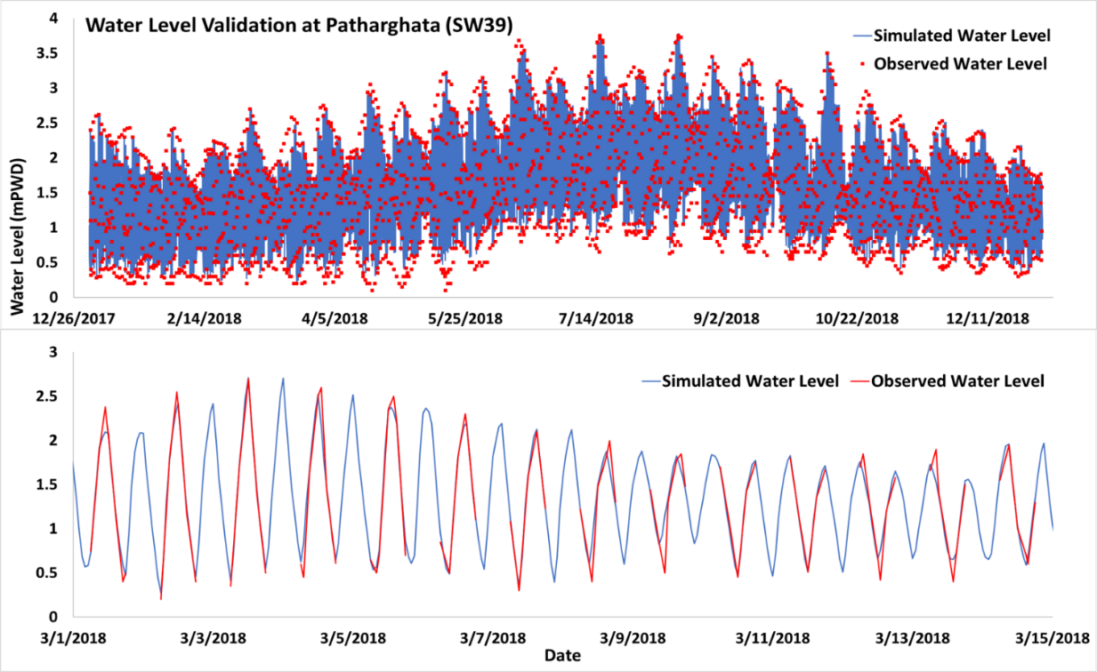

*Note – The break in observed data is due to the fact that no data is recorded during night time.*

*Figure 8‑12: Water Level Validation at Pathatghata (SW39)*

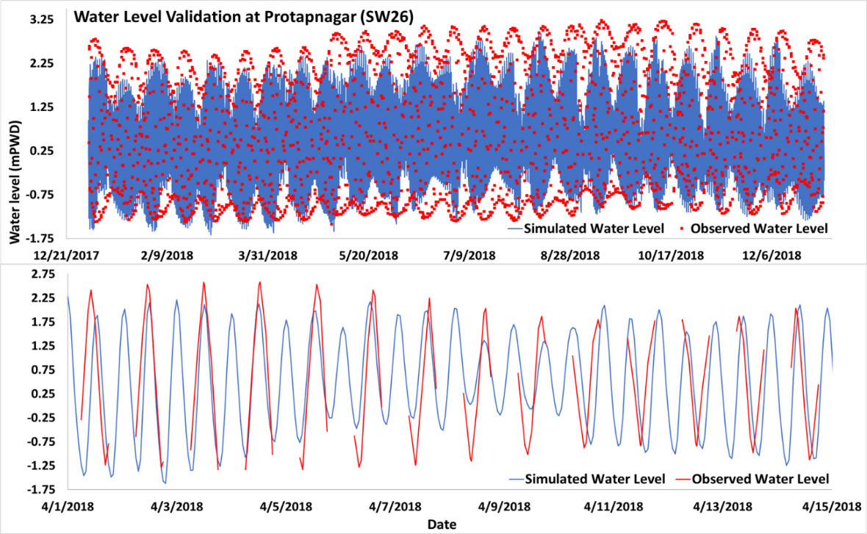

*Note – The break in observed data is due to the fact that no data is recorded during night time.*

*Figure 8‑13: Water Level Validation at Protapnagar (SW26)*

Validation of SW Model

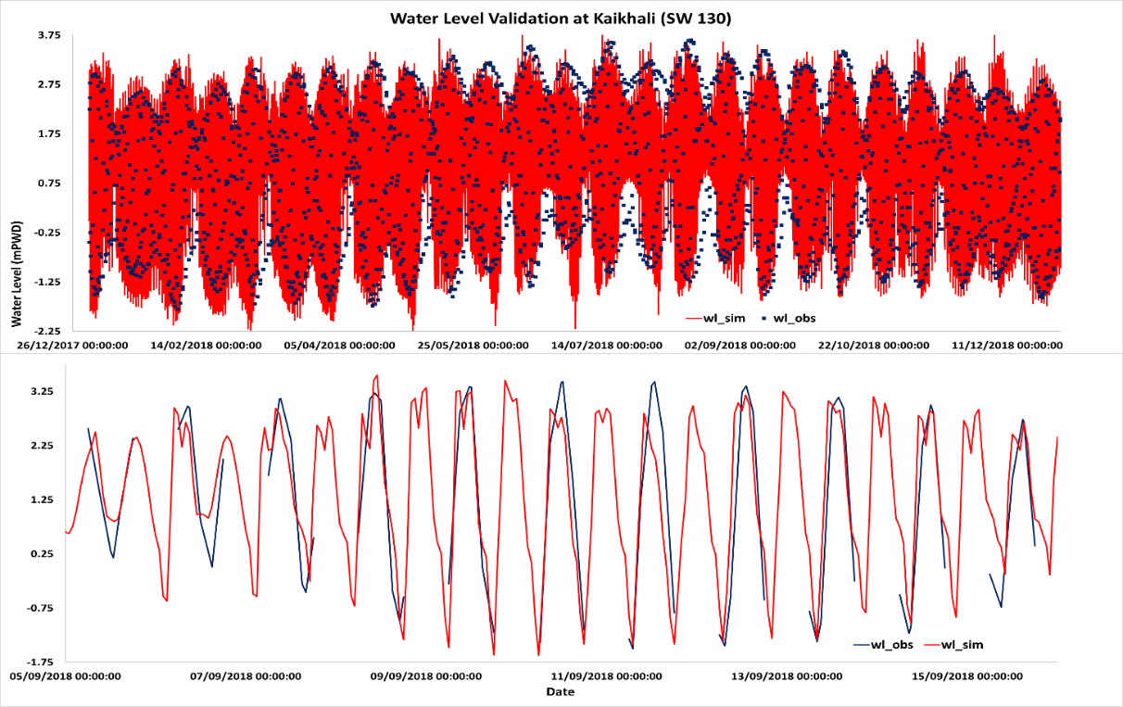

*Note – The break in observed data is due to the fact that no data is recorded during night time.*

*Figure 8‑14: Water Level Validation at Kaikhali (SW130)*

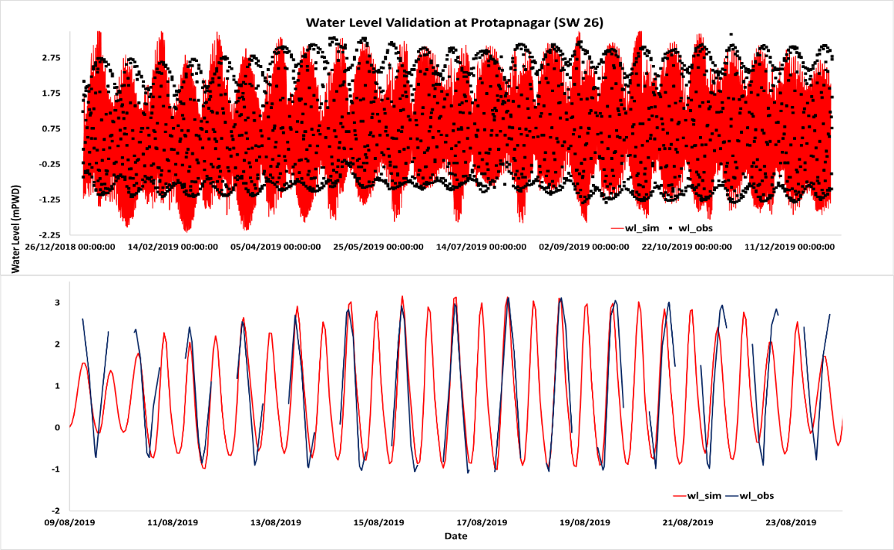

*Note – The break in observed data is due to the fact that no data is recorded during night time.*

*Figure 8‑15: Water Level Validation at Protapnagar (SW26)*

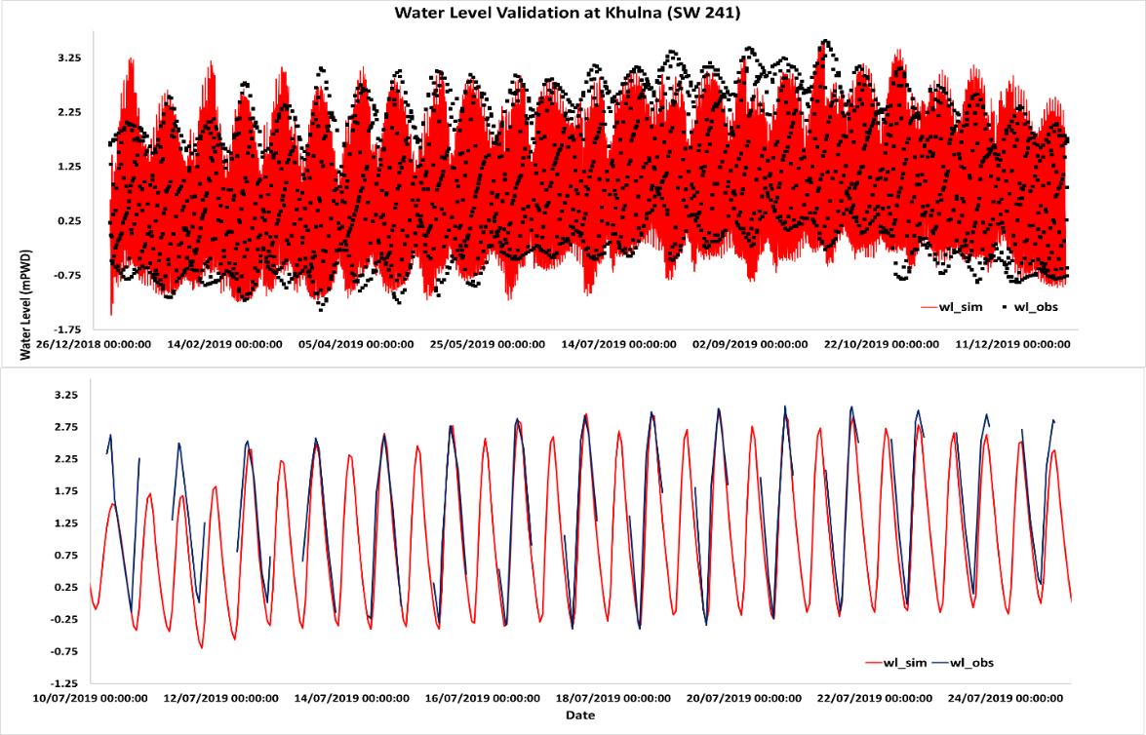

*Note – The break in observed data is due to the fact that no data is recorded during night time.*

*Figure 8‑16: Water Level Validation at Khulna (SW241)*

Validation of SC Model

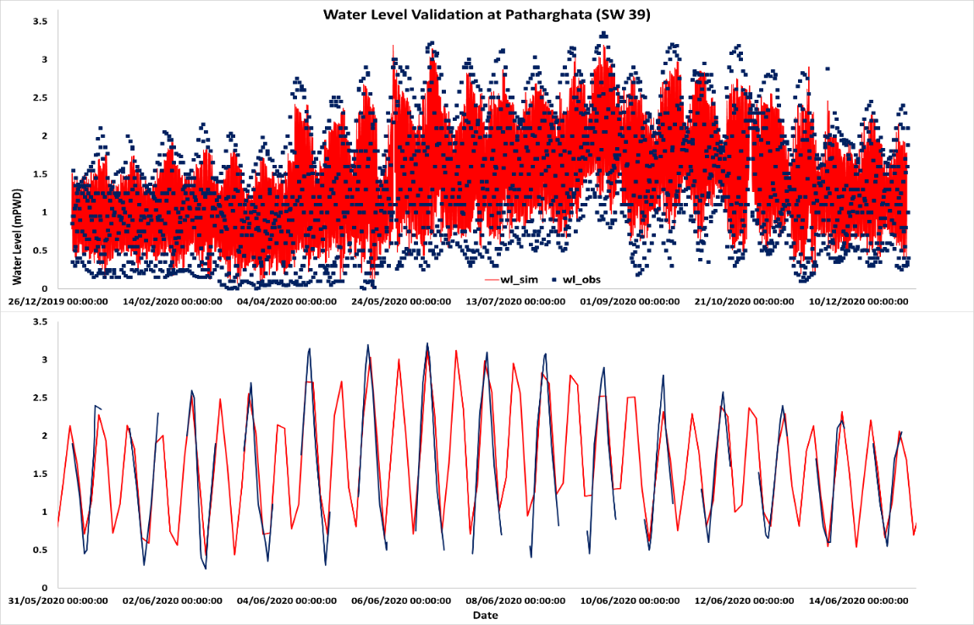

*Note – The break in observed data is due to the fact that no data is recorded during night time.*

*Figure 8‑17: Water Level Validation at Patharghata (SW39)*

**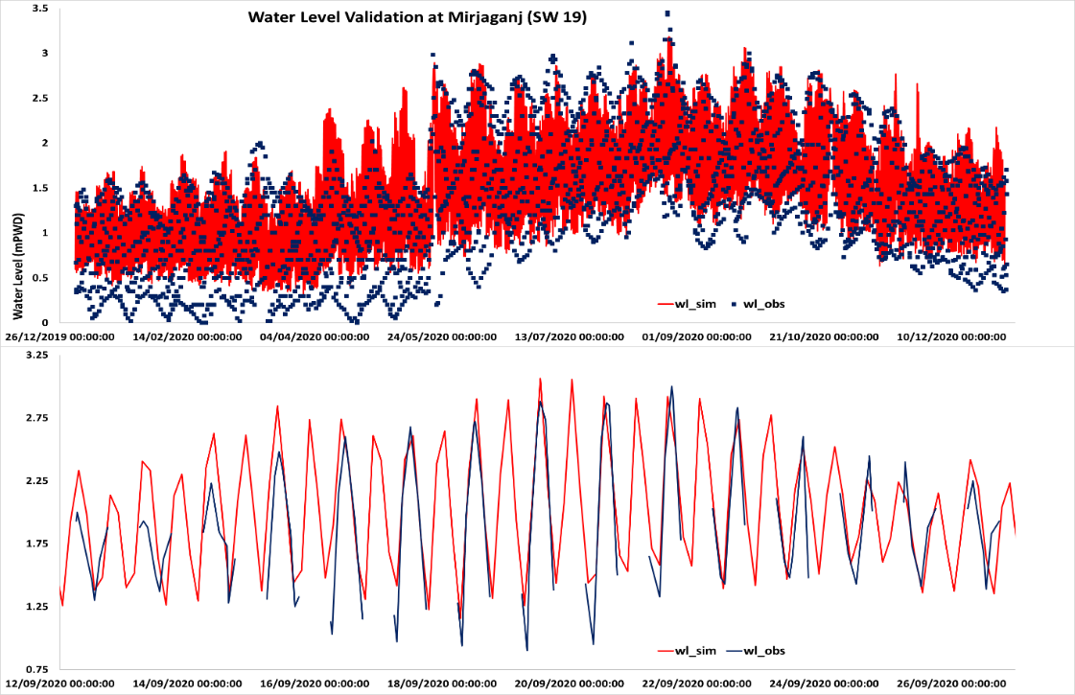**

*Note – The break in observed data is due to the fact that no data is recorded during night time.*

*Figure 8‑18: Water Level Validation at Mirjaganj (SW39)*

## Wave Height and Overtopping Calculations

### Wind Speed

In order to determine monsoon wave height monsoon wind is used. Frequency analysis of monsoon wind is carried out for the wind of Khulna Meteorological station. Annual maximum monsoon wind speed from 1990-2020 was analyzed for frequency distribution. Frequency distribution of monsoon wind considering climate change impacts has also been carried out.

Wind Speed Analysis of Patuakhali

Annual maximum monsoon wind speeds at Patuakhali station from 1990 to 2020 are given in Table 8-7.

Table 8‑7: Annual maximum Monsoon Wind Speed (m/s) at Patuakhali for different year

| **Year** | **Max wind speed (m\sec)** |
| --- | --- |
| 1990 | 9.3 |
| 1991 | 14.4 |
| 1992 | 10.3 |
| 1993 | 30.9 |
| 1994 | 10.3 |
| 1995 | 21.6 |
| 1996 | 10.8 |
| 1997 | 30.9 |
| 1998 | 22.6 |
| 1999 | 8.2 |
| 2000 | 20.6 |
| 2001 | 9.3 |
| 2002 | 11.8 |
| 2003 | 7.7 |
| 2004 | 9.3 |
| 2005 | 7.7 |
| 2006 | 11.3 |
| 2007 | 15.4 |
| 2008 | 12.9 |
| 2009 | 7.7 |
| 2010 | 11.3 |
| 2011 | 11.8 |
| 2012 | 13.4 |
| 2013 | 25.7 |
| 2014 | 5.1 |
| 2015 | 15.4 |
| 2016 | 14.0 |
| 2017 | 8.0 |
| 2018 | 10.0 |
| 2019 | 9.8 |
| 2020 | 11.0 |

Figure 8-19, shows the wind rose diagram, showing the governing direction of wind in Patuakhali with distribution of wind speed. The wind at this station has a tendency of blowing at North Direction.

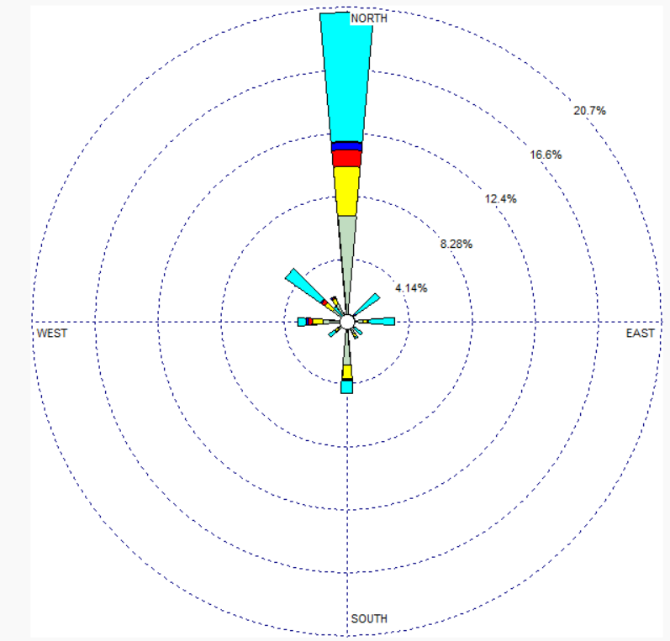

*Figure 8‑19: Wind Rose Diagram of Patuakhali*

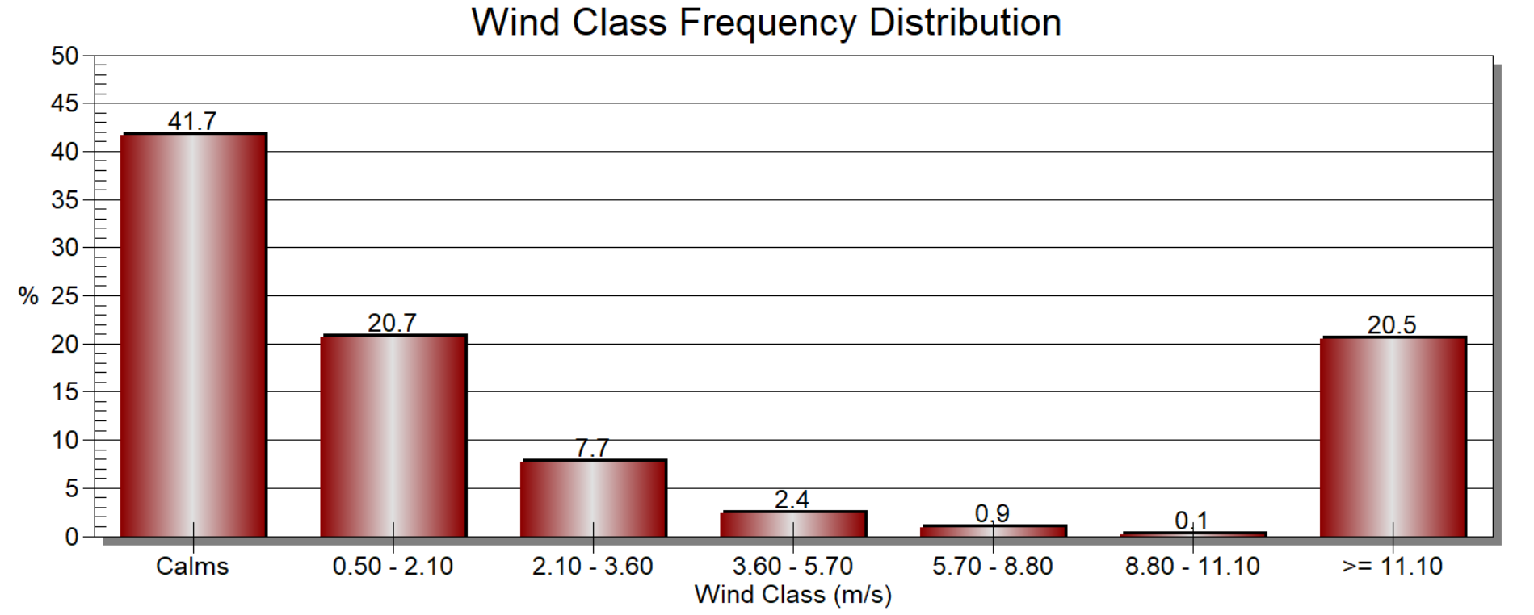

*Figure 8‑20: Wind Class Frequency Distribution of Patuakhali*

Monsoon wind speed for 10-, 25-, 50- and 100-year return period with and without climate change condition are shown in Table 8-8

Table 8‑8: Monsoon wind speed for different return period

| **Return Period (Years)** | **Monsoon Wind Speed (m/s)** | **Monsoon Wind Speed (m/s) with climate change + 8% increase** |
| --- | --- | --- |
| 10 | 21.3 | 23.0 |
| 25 | 26.1 | 28.2 |
| 50 | 29.8 | 32.2 |
| 100 | 33.5 | 36.2 |

Wind Speed Analysis of Shatkhira

Annual maximum monsoon wind speeds at Patuakhali station from 1990 to 2020 are given in Table 8-9:

Table 8‑9: Annual maximum monsoon wind speed at Patuakhali for different years

| **Year** | **Max wind speed (m\sec)** |
| --- | --- |
| 1990 | 12.9 |
| 1991 | 18.0 |
| 1992 | 10.3 |
| 1993 | 13.4 |
| 1994 | 15.4 |
| 1995 | 8.2 |
| 1996 | 7.2 |
| 1997 | 7.7 |
| 1998 | 9.3 |
| 1999 | 7.7 |
| 2000 | 14.4 |
| 2001 | 6.2 |
| 2002 | 6.2 |
| 2003 | 15.4 |
| 2004 | 8.2 |
| 2005 | 7.7 |
| 2006 | 5.1 |
| 2007 | 12.3 |
| 2008 | 8.2 |
| 2009 | 13.4 |
| 2010 | 5.1 |
| 2011 | 11.3 |
| 2012 | 6.7 |
| 2013 | 8.2 |
| 2014 | 5.1 |
| 2015 | 7.7 |
| 2016 | 7.0 |
| 2017 | 5.0 |
| 2018 | 12.9 |
| 2019 | 18.0 |
| 2020 | 12.9 |

Figure 8-21, shows the wind rose diagram, showing the governing direction of wind in Patuakhali with distribution of wind speed. The wind at this station has a tendency of blowing at North Direction

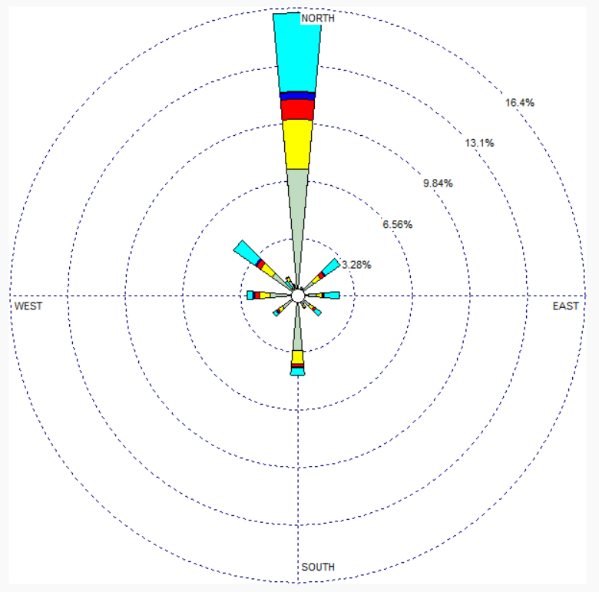

*Figure 8‑21: Wind Rose Diagram of Shatkhira*

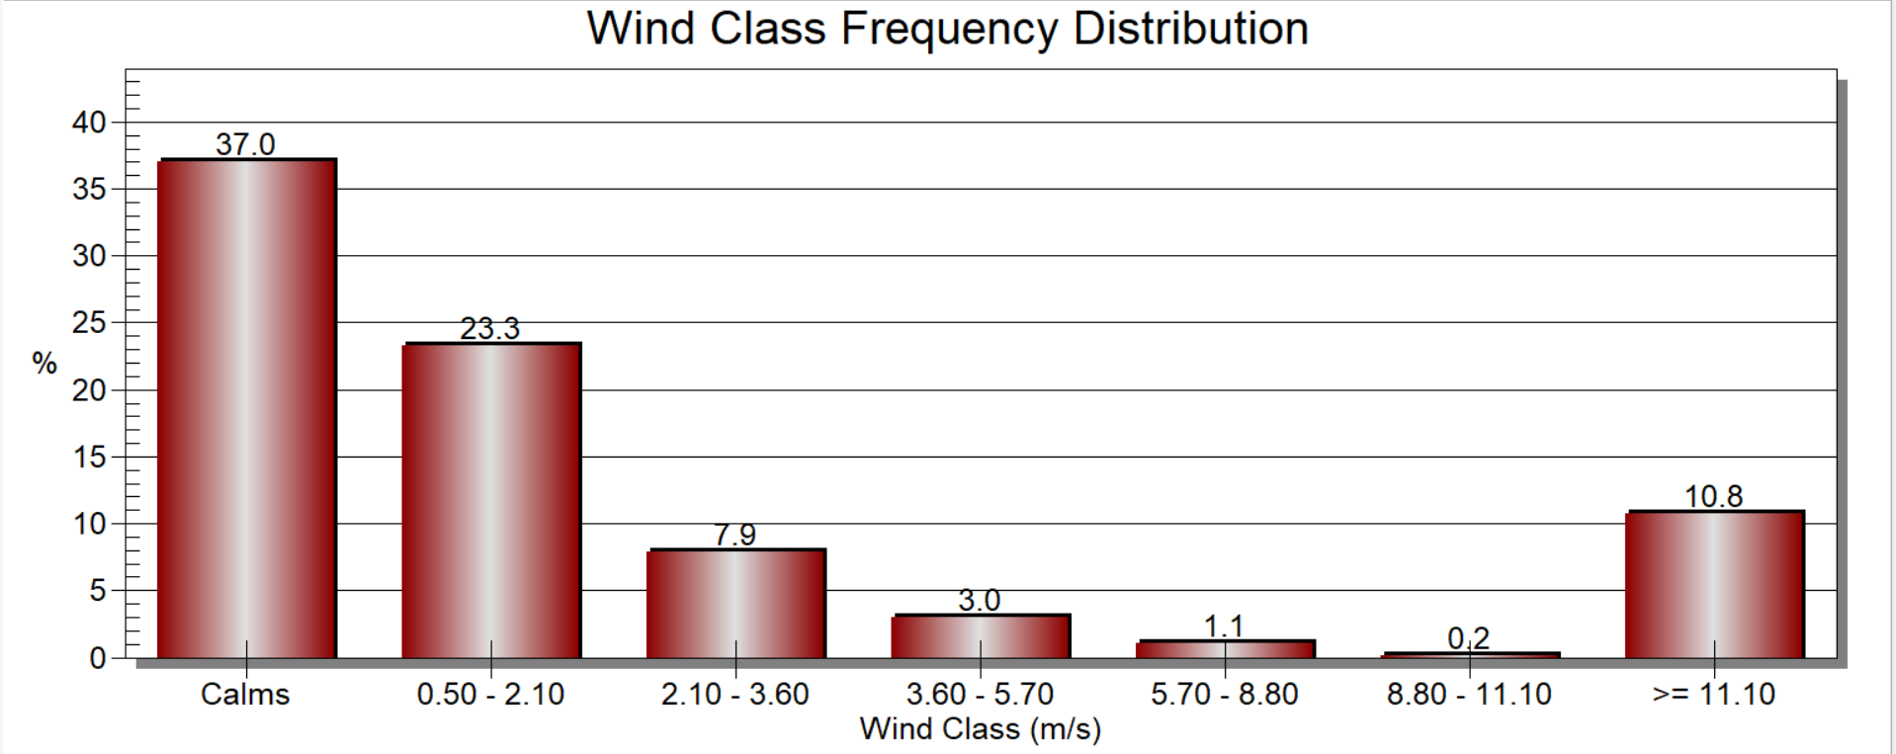

*Figure 8‑22: Wind Class Frequency Distribution of Shatkhira*

Monsoon wind speed for 10-, 25-, 50- and 100-year return period with and without climate change condition are shown in Table 8-10

Table 8‑10: Monsoon Wind Speed (m/s) for different return period (Shatkhira)

| **Return Period (Years)** | **Monsoon Wind Speed (m/s)** | **Monsoon Wind Speed (m/s) with climate change + 8% increase** |
| --- | --- | --- |
| 10 | 15.1 | 16.4 |
| 25 | 18.2 | 19.7 |
| 50 | 20.5 | 22.2 |
| 100 | 22.8 | 24.6 |

### Wave Height and Overtopping Calculations

Cyclone storms typically do not typically occur during the monsoon season (June to September) (*Figure 8‑23*). However, monsoon storms can still create strong winds and, consequently large waves. To determine the freeboard required for the embankments considering monsoon storms, a similar methodology was followed to the methodology presented in Section 7.6. However, the significant wave height was calculated analytically, rather than using the SWAN model, as the 2D wave model will be time consuming for simulating for a longer time period. The 25-year wind speed was determined by converting wind speed at z elevation to elevation at 10 m above the surface. For conversion wind speed of both base and climate change of Khulna and Shatkhira have been used. The below equation was applied for the conversion:

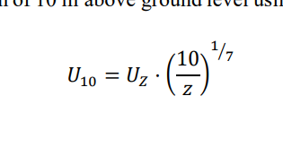

Here, U10= wind speed 10 m above the surface, Uz= wind speed z m above the surface, z= ground elevation. The average ground elevation (z) was calculated for each polder from the Digital Elevation Model prepared from the topographic survey data.

Next the significant wave height was calculated using the methodology presented by Mathiesen[[50]](#footnote-51).Using the methodology presented in Section 7.6, the required freeboard was calculated. This freeboard was added to the 25-year still water level, calculated from the monsoon modelling results.

|  |
| --- |
|  |
| *Figure 8‑23: Number of incidences of storm events in the North Indian Ocean[[51]](#footnote-52).* |

## Summary of Regional Assessment Results

The following table shows the results of the monsoon model assessment.

Table 8‑11: Results of the monsoon model; results include climate change

|  |  |  |  |  | Rough Embankment | | | Smooth Embankment | | |
| --- | --- | --- | --- | --- | --- | --- | --- | --- | --- | --- |
| Polder | Point | Recommended slope1 (1V:XH) | Design water elevation, SWL (m PWD) | Design wave height (m) | Calculated freeboard (m) | Recommended freeboard2 (m) | Crest elevation for monsoon floods3  (m PWD) | Calculated freeboard (m) | Recommended freeboard2 (m) | Crest Elevation for monsoon floods3  (m PWD) |
| 4 | 3 | 2 | 3.9 | 0.2 | 0.2 | 0.9 | 4.8 | 0.3 | 0.9 | 4.8 |
| 4 | 3 | 4.1 | 0.4 | 0.5 | 0.9 | 5.0 | 0.6 | 0.9 | 5.0 |
| 10 | 3 | 3.9 | 0.3 | 0.3 | 0.9 | 4.8 | 0.3 | 0.9 | 4.8 |
| 37 | 2 | 3.5 | 0.3 | 0.4 | 0.9 | 4.4 | 0.5 | 0.9 | 4.4 |
| 5 | 1 | 3 | 3.9 | 0.3 | 0.3 | 0.9 | 4.8 | 0.4 | 0.9 | 4.8 |
| 2 | 3 | 4.1 | 0.2 | 0.2 | 0.9 | 5.0 | 0.3 | 0.9 | 5.0 |
| 3 | 2 | 3.9 | 0.2 | 0.2 | 0.9 | 4.8 | 0.3 | 0.9 | 4.8 |
| 4 | 3 | 4.1 | 0.4 | 0.5 | 0.9 | 5.0 | 0.6 | 0.9 | 5.0 |
| 5 | 3 | 3.9 | 0.4 | 0.5 | 0.9 | 4.8 | 0.6 | 0.9 | 4.8 |
| 7 | 3 | 3.9 | 0.2 | 0.2 | 0.9 | 4.8 | 0.2 | 0.9 | 4.8 |
| 41 | 3 | 4.2 | 0.2 | 0.2 | 0.9 | 5.1 | 0.2 | 0.9 | 5.1 |
| 7/1 | 5 | 3 | 3.9 | 0.4 | 0.5 | 0.9 | 4.8 | 0.6 | 0.9 | 4.8 |
| 6 | 3 | 3.9 | 0.4 | 0.5 | 0.9 | 4.8 | 0.6 | 0.9 | 4.8 |
| 7/2 | 4 | 3 | 4.1 | 0.4 | 0.5 | 0.9 | 5.0 | 0.6 | 0.9 | 5.0 |
| 9 | 3 | 3.8 | 0.3 | 0.2 | 0.9 | 4.7 | 0.2 | 0.9 | 4.7 |
| 10 | 3 | 3.9 | 0.3 | 0.3 | 0.9 | 4.8 | 0.3 | 0.9 | 4.8 |
| 11 | 2 | 3.8 | 0.3 | 0.3 | 0.9 | 4.7 | 0.4 | 0.9 | 4.7 |
| 10-12 | 9 | 3 | 3.8 | 0.3 | 0.2 | 0.9 | 4.7 | 0.2 | 0.9 | 4.7 |
| 11 | 2 | 3.8 | 0.3 | 0.3 | 0.9 | 4.7 | 0.4 | 0.9 | 4.7 |
| 12 | 3 | 4.0 | 0.4 | 0.5 | 0.9 | 4.9 | 0.6 | 0.9 | 4.9 |
| 13 | 3 | 3.9 | 0.4 | 0.6 | 0.9 | 4.8 | 0.7 | 0.9 | 4.8 |
| 42 | 3 | 3.9 | 0.3 | 0.4 | 0.9 | 4.8 | 0.4 | 0.9 | 4.8 |
| 13-14/2 | 8 | 3 | 4.0 | 0.3 | 0.4 | 0.9 | 4.9 | 0.5 | 0.9 | 4.9 |
| 9 | 3 | 3.8 | 0.3 | 0.2 | 0.9 | 4.7 | 0.2 | 0.9 | 4.7 |
| 39/1B | 27 | 5 | 3.8 | 0.5 | 0.5 | 0.9 | 4.7 | 0.7 | 0.9 | 4.7 |
| 28 | 5 | 3.8 | 0.4 | 0.7 | 0.9 | 4.7 | 0.9 | 0.9 | 4.7 |
| 35 | 2 | 3.3 | 0.2 | 0.3 | 0.9 | 4.2 | 0.5 | 0.9 | 4.2 |
| 39/1C | 28 | 5 | 3.8 | 0.4 | 0.7 | 0.9 | 4.7 | 0.9 | 0.9 | 4.7 |
| 29 | 5 | 3.8 | 0.4 | 0.8 | 0.9 | 4.7 | 1.0 | 1.0 | 4.8 |
| 35 | 2 | 3.3 | 0.2 | 0.3 | 0.9 | 4.2 | 0.5 | 0.9 | 4.2 |
| 38 | 2 | 3.2 | 0.3 | 0.4 | 0.9 | 4.1 | 0.6 | 0.9 | 4.1 |
| 41/5 | 25 | Not extracted from monsoon model4 | | | | | | | | |
| 26 | 5 | 3.8 | 0.4 | 0.3 | 0.9 | 4.7 | 0.4 | 0.9 | 4.7 |
| 36 | 2 | 3.0 | 0.2 | 0.3 | 0.9 | 3.9 | 0.5 | 0.9 | 3.9 |
| 47/1 | 21 | 5 | 3.3 | 0.3 | 0.3 | 0.9 | 4.2 | 0.4 | 0.9 | 4.2 |
| 22 | Not extracted from monsoon model4 | | | | | | | | |
| 45 | 23 | Not extracted from monsoon model4 | | | | | | | | |
| 24 | Not extracted from monsoon model4 | | | | | | | | |
| 50-51 | 17 | Not extracted from monsoon model4 | | | | | | | | |
| 18 | 7 | 3.7 | 0.6 | 0.9 | 0.9 | 4.7 | 1.3 | 1.3 | 5.0 |
| 55/2D | 14 | 3 | 3.8 | 0.5 | 0.5 | 0.9 | 4.7 | 0.7 | 0.9 | 4.7 |
| 15 | 3 | 3.8 | 0.5 | 0.6 | 0.9 | 4.7 | 0.8 | 0.9 | 4.7 |
| 32 | 2 | 3.2 | 0.2 | 0.3 | 0.9 | 4.1 | 0.5 | 0.9 | 4.1 |
| 40 | 2 | 3.3 | 0.3 | 0.4 | 0.9 | 4.2 | 0.6 | 0.9 | 4.2 |

**Notes:**

1Riverside slope

2A minimum freeboard of 0.9 m is stipulated by the BWDB

3Crest elevation is equal to the design water elevation, SWL, plus the recommended freeboard; the results include subsidence

4Crest elevations will be governed by storm surge water levels

# Summary of Recommended Design Parameters

The following table provides a summary of the recommended crest elevation for all 13 polders. These recommended crest elevations are based on the critical event. The critical event is determined by whichever event results in higher water levels at the embankment, storm surge or monsoon floods.

Table 9‑1: Summary of recommended crest elevations; results include climate change

|  | | | |  | Rough Embankment | | Smooth Embankment | |
| --- | --- | --- | --- | --- | --- | --- | --- | --- |
| Polder | Point | Allowance for subsidence (m) | Recommended slope1 (1V:XH) | Critical event2 (monsoon / cyclone) | Recommended crest elevation 3  (m PWD) | Peak crest elevation allowing for subsidence 3  (m PWD) | Recommended crest elevation 3  (m PWD) | Peak crest elevation allowing for subsidence 3  (m PWD) |
| 4 | 3 | 0.15 | 2 | monsoon | 4.8 | 5.0 | 4.8 | 5.0 |
| 4 | 0.15 | 3 | monsoon | 5.0 | 5.2 | 5.0 | 5.2 |
| 10 | 0.15 | 3 | monsoon | 4.8 | 5.0 | 4.8 | 5.0 |
| 37 | 0.15 | 2 | monsoon |  | 0.2 | 4.4 | 4.6 |
| 5 | 1 | 0.15 | 3 | cyclone | 4.9 | 5.1 | 5.4 | 5.6 |
| 2 | 0.15 | 3 | monsoon | 5.0 | 5.2 | 5.0 | 5.2 |
| 3 | 0.15 | 2 | monsoon | 4.8 | 5.0 | 4.8 | 5.0 |
| 4 | 0.15 | 3 | monsoon | 5.0 | 5.2 | 5.0 | 5.2 |
| 5 | 0.15 | 3 | monsoon | 4.8 | 5.0 | 4.8 | 5.0 |
| 7 | 0.15 | 3 | monsoon | 4.8 | 5.0 | 4.8 | 5.0 |
| 41 | 0.15 | 3 | monsoon | 5.1 | 5.3 | 5.1 | 5.3 |
| 7/1 | 5 | 0.15 | 3 | monsoon | 4.8 | 5.0 | 4.8 | 5.0 |
| 6 | 0.15 | 3 | monsoon | 4.8 | 5.0 | 4.8 | 5.0 |
| 7/2 | 4 | 0.15 | 3 | monsoon | 5.0 | 5.2 | 5.0 | 5.2 |
| 9 | 0.15 | 3 | monsoon | 4.7 | 4.9 | 4.7 | 4.9 |
| 10 | 0.15 | 3 | monsoon | 4.8 | 5.0 | 4.8 | 5.0 |
| 11 | 0.15 | 2 | monsoon | 4.7 | 4.9 | 4.7 | 4.9 |
| 10-12 | 9 | 0.15 | 3 | monsoon | 4.7 | 4.9 | 4.7 | 4.9 |
| 11 | 0.15 | 2 | monsoon | 4.7 | 4.9 | 4.7 | 4.9 |
| 12 | 0.15 | 3 | monsoon | 4.9 | 5.1 | 4.9 | 5.1 |
| 13 | 0.15 | 3 | monsoon | 4.8 | 5.0 | 4.8 | 5.0 |
| 42 | 0.15 | 3 | monsoon | 4.8 | 5.0 | 4.8 | 5.0 |
| 13-14/2 | 8 | 0.15 | 3 | monsoon | 4.9 | 5.1 | 4.9 | 5.1 |
| 9 | 0.15 | 3 | monsoon | 4.7 | 4.9 | 4.7 | 4.9 |
| 39/1B | 27 | 0.30 | 5 | cyclone | 5.5 | 5.8 | 6.0 | 6.3 |
| 28 | 0.30 | 5 | cyclone | 5.1 | 5.4 | 5.7 | 6.0 |
| 35 | 0.30 | 2 | cyclone | 4.6 | 4.9 | 5.0 | 5.3 |
| 39/1C | 28 | 0.30 | 5 | cyclone | 5.1 | 5.4 | 5.7 | 6.0 |
| 29 | 0.30 | 5 | cyclone | 4.9 | 5.2 | 5.3 | 5.6 |
| 35 | 0.30 | 2 | cyclone | 4.6 | 4.9 | 5.0 | 5.3 |
| 38 | 0.30 | 2 | cyclone | 4.1 | 4.4 | 4.5 | 4.8 |
| 41/5 | 25 | 0.30 | 7 | cyclone | 5.8 | 6.1 | 6.3 | 6.6 |
| 26 | 0.30 | 5 | cyclone | 5.1 | 5.4 | 5.6 | 5.9 |
| 36 | 0.30 | 2 | cyclone | 4.5 | 4.8 | 5.0 | 5.3 |
| 47/1 | 21 | 0.30 | 5 | cyclone | 4.9 | 5.2 | 5.1 | 5.4 |
| 22 | 0.30 | 7 | cyclone | 6.2 | 6.5 | 6.7 | 7.0 |
| 45 | 23 | 0.30 | 7 | cyclone | 6.2 | 6.5 | 6.7 | 7.0 |
| 24 | 0.30 | 7 | cyclone | 5.8 | 6.1 | 6.3 | 6.6 |
| 50-51 | 17 | 0.30 | 7 | cyclone | 6.4 | 6.7 | 6.9 | 7.2 |
| 18 | 0.30 | 7 | cyclone | 5.6 | 5.9 | 6.3 | 6.6 |
| 55/2D | 14 | 0.30 | 3 | cyclone | 5.2 | 5.5 | 5.8 | 6.1 |
| 15 | 0.30 | 3 | cyclone | 4.8 | 5.1 | 5.2 | 5.5 |
| 32 | 0.30 | 2 | cyclone | 3.8 | 4.1 | 4.2 | 4.5 |
| 40 | 0.30 | 2 | cyclone | 3.6 | 3.9 | 4.0 | 4.3 |

**Notes:**

1Riverside slope

2 The recommended crest elevations are based on the critical event, which is the event that produces the highest 25-year water levels, either monsoon floods or storm surges

3 Includes the required freeboard, calculated from wave run up

1. Future Climate Change Analysis
   1. Future Climate Change Scenario

Assessment of future climate change is of great importance for a sustainable planning of water resources and disasters. Global climate change is impacting the temperature, rainfall and overall hydrologic cycle. So, the assessment of future climate change for water related hazards is essential for long term future planning.

The assessment of future climate change is done by IPCC through the Coupled Model Inter-comparison Project (CMIP). A set of Global Circulation Models (GCM) simulate plausible future climate conditions based of different scenarios. Recently, IPCC released its 6th Assessment Report that utilizes CMIP6 GCMs. In this report, IPCC has introduced the Shared Socioeconomic Pathways (SSPs) scenarios.

Shared Socioeconomic Pathways (SSPs) are scenarios of projected socioeconomic global changes up to 2100. The SSPs are based on five narratives describing broad socioeconomic trends that could shape future society. These are intended to span the range of plausible futures. They include: a world of sustainability-focused growth and equality (SSP1); a “middle of the road” world where trends broadly follow their historical patterns (SSP2); a fragmented world of “resurgent nationalism” (SSP3); a world of ever-increasing inequality (SSP4); and a world of rapid and unconstrained growth in economic output and energy use (SSP5).

These narratives describe alternative pathways for future society. They present baselines of how things would look in the absence of climate policy, and allow researchers to examine barriers and opportunities for climate mitigation and adaptation in each possible future world when combined with mitigation targets. SSP1 and SSP5 envision relatively optimistic trends for human development, with “substantial investments in education and health, rapid economic growth, and well-functioning institutions”. They differ in that SSP5 assumes this will be driven by an energy-intensive, fossil fuel-based economy, while in SSP1 there is an increasing shift toward sustainable practices.

For the present study, SSP5 based outputs will be used for future climate change assessment as this scenario represent the higher extreme of the future climate.

* + 1. Overall Methodology

The assessment of local climate change impact demands downscaling of General Circulation Model (GCM) data which are very coarse in resolution (approximately 100-300 km) to capture local phenomena. Two types of downscaling techniques are available i.e. dynamic downscaling and statistical downscaling, having pros and cons in both techniques. However, future projections through either dynamically or statistically downscaled GCM datasets have proven evidences to generate high resolution, dependable and appropriate local level climate change information.

Downscaling is the process through which finer resolution climate information is generated from GCM outputs, considering the dynamics of local physical processes. The following figure shows general approach of downscaling.

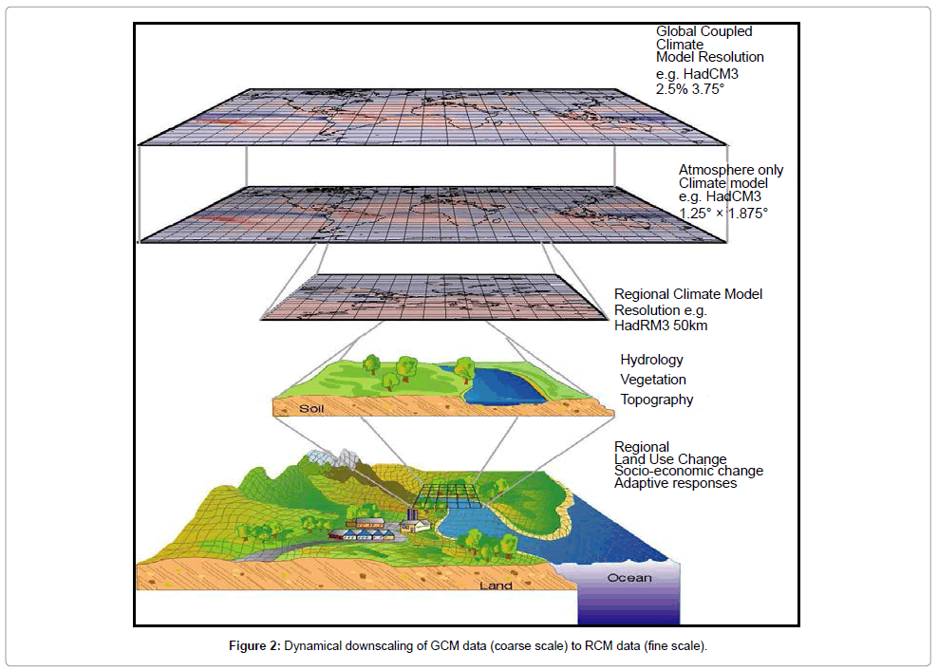

**Figure xx: General approach of downscaling**

The GCM and dynamically downscaled RCM outputs contain significant system biases with respect to the actual scenario during historical simulation. IPCC (2015) identified the significance of bias correction in regional climate projections and their use in impacts and risk analysis studies with possible guidelines to correct biases. There are many available bias correction methods particularly for correction of rainfall and temperature data, e.g., linear scaling, distribution-based scaling, quantile mapping, ISI-MIP, cumulative distribution function etc. Choice of methods varies with the purpose of bias correction and aim of the climate modelling output analysis.

The climate change assessment following the new SSP scenario based projection utilizes the CHELSA dataset. CHELSA is a mechanistical statistical downscaling of GCM data following Karger et al. (2021)[[52]](#footnote-53). The dataset utilizes Inter sectoral Impact Model Inter comparison Project (ISI-MIP) suggested trend-preserving bias correction method[[53]](#footnote-54). The downscaling exercises and future climate change anomalies assessment has been done for Temperature and Rainfall (precipitation) for SSP585 scenario of CMIP6 dataset for mid-century, i.e., 2050s (2035-2065) and end of century, i.e., 2085s (2071-2100). In accordance with IPCC practice, the base period for the climate change analysis has been considered from 1981 to 2010.

The future projection of sea level rise has been estimated based on IPCC AR6 GCM ensemble for the Bay of Bengal near Hiron Point, sea level rise estimates has been assessed for future climate change for SSP 585 during two time slices.

The future changes in wind speed has been estimated from the IPCC AR6 GCM ensemble data for the nearby locations of the study area (polders and surrounding rivers).

* 1. Future Climate Change Projection
     1. Temperature

The following tables present the plausible changes in Temperature during 2050s and 2085s in South West (SW) and South Central (SC) regions of Bangladesh. (DJF = December, January, February; MAM = March, April, May; JJAS = June, July, August, September; ON = October, November)

**Average Temperature during base period (1981-2010) °C**

|  |  |  |  |  |  |
| --- | --- | --- | --- | --- | --- |
| **Region** | **annual** | **DJF** | **MAM** | **JJAS** | **ON** |
| **South Central Zone** | 25.85 | 20.55 | 27.96 | 28.33 | 25.70 |
| **South West Zone** | 25.83 | 19.99 | 28.29 | 28.60 | 25.35 |

**Changes in Temperatures (0Celcius) for Future Climate Change (2050s)**

|  |  |  |  |  |  |
| --- | --- | --- | --- | --- | --- |
| **Region** | **SSP5-8.5(2050s)** | | | | |
| **annual** | **DJF** | **MAM** | **JJAS** | **ON** |
| **South Central Zone** | 1.86 | 2.00 | 1.70 | 1.75 | 2.11 |
| **South West Zone** | 1.89 | 2.07 | 1.76 | 1.77 | 2.06 |

**Changes in Temperatures (0Celcius) for Future Climate Change (2080s)**

|  |  |  |  |  |  |
| --- | --- | --- | --- | --- | --- |
| **Region** | **SSP5-8.5(2080s)** | | | | |
| **annual** | **DJF** | **MAM** | **JJAS** | **ON** |
| **South Central Zone** | 3.99 | 4.63 | 3.82 | 3.52 | 4.25 |
| **South West Zone** | 4.21 | 4.95 | 4.01 | 3.69 | 4.45 |

* + 1. Rainfall

The following tables present the plausible changes in rainfall during 2050s and 2085s in South West (SW) and South Central (SC) regions of Bangladesh . (DJF = December, January, February; MAM = March, April, May; JJAS = June, July, August, September; ON = October, November)

**Average Rainfall during base period (1981-2010) (mm)**

| **Region** | **annual** | **DJF** | **MAM** | **JJAS** | **ON** |
| --- | --- | --- | --- | --- | --- |
| **South Central Zone** | 2380 | 45 | 431 | 1670 | 235 |
| **South West Zone** | 1826 | 52 | 312 | 1286 | 177 |

**Percent Change in Rainfall for Future Climate Change (2050s)**

|  |  |  |  |  |  |
| --- | --- | --- | --- | --- | --- |
| **Region** | **SSP5-8.5(2050s)** | | | | |
| **annual** | **DJF** | **MAM** | **JJAS** | **ON** |
| **South Central Zone** | 3.12 | 0.30 | 3.05 | 4.49 | 4.73 |
| **South West Zone** | 3.95 | 0.53 | 4.92 | 4.37 | 6.79 |

**Percent Change in Rainfall for Future Climate Change (2080s)**

|  |  |  |  |  |  |
| --- | --- | --- | --- | --- | --- |
| **Region** | **SSP5-8.5(2080s)** | | | | |
| **annual** | **DJF** | **MAM** | **JJAS** | **ON** |
| **South Central Zone** | 6.70 | -1.10 | 4.52 | 14.71 | 5.66 |
| **South West Zone** | 5.85 | -1.09 | 6.55 | 10.52 | 5.89 |

* + 1. Wind Speed

Based on the IPCC AR6 GCM data for wind speed, in SSP 585 scenario, for end of century period, it was found that an average of 8% increase in monsoon wind speed is projected. This has been incorporated in the monsoon modelling.

In the North Indian basin, Mohapatra et al. (2015) find, based on observations over 1951-2010 (monsoon and post-monsoon seasons), that the probability of cyclonic disturbances intensifying into tropical cyclones has increased in the Arabian Sea in association with decreased vertical wind shear. They further report that the probability of tropical cyclones intensifying into severe tropical cyclones has increased over the Bay of Bengal in association with increased low-level cyclonic vorticity. For the Arabian Sea, model simulations suggest that recent increases in the occurrence of extremely severe tropical cyclones in the post-monsoon season are likely due in part to anthropogenic forcing (Murakami et al., 2017). For tropical cyclone intensity, a +2oC warming scenario is projected to yield a +5% (+1 to +10%) increase in maximum wind speed (Knutson et al., 2020), resulting in greater potential damage per storm.

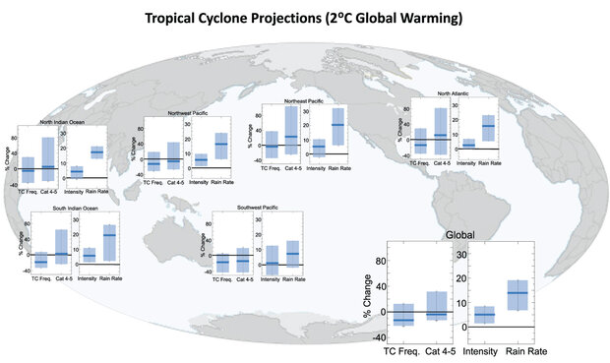

*Summary of projected regional and global changes in tropical cyclones (TC) assuming a 2° Celsius (3.6° Fahrenheit) global warming scenario*

For this study, in case of cyclone, a 10% increase in intensity has been considered as it is predicted that there may be increase of +40C temperature based on SSP8.5-5 scenario which is more than 20C.

* 1. Sea Level Rise

(IPCC) 6th Assessment Report estimates for the Bay of Bengal[[54]](#footnote-55). In this study, sea level rise scenario for the region was based on projections for Hiron Point, produced for the IPCC 6th Assessment Report (AR6). The geographically varying projections in the AR6 were created using an ensemble of 20 general circulation models from the Coupled Model Intercomparison Project Phase 6 (CMIP6), together with modelling of glaciers and ice sheets. The sea level rise projections include thermal expansion, the effect of atmospheric loading, sterodynamic sea level, glaciers, Greenland and Antarctica ice sheet, Land water storage and vertical land motion.

For SSP585, the median sea level change is 0.27 meter and 0.65 m for 2050s and 2080s relative to a 1995-2014 baseline. The sea level rise projections in the IPCC AR6 GCMs show quite some variations with a wide range of uncertainties. Under these circumstances, for the present study, SSP 5-8.5 (2080) projections for sea level rise has been utilized to ensure higher emission scenarios are covered. As there is also quite some variation among the GCMs for the SSP585, the present study uses the median projection values that is most plausible.

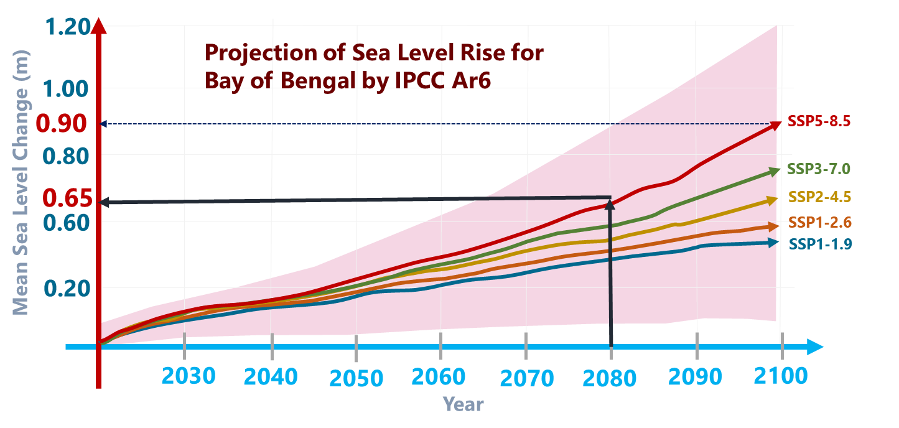

* 1. Increase in Upstream River Discharges

CEGIS has a basin model developed using ArcSWAT. SWAT is a physically based distributed hydrological model, which operates on a daily time step. It simulates hydrological processes at high spatial resolution by dividing the catchment into hydrological response unit (HRU) based on land use/cover, soil and slope.

|  |  |  |  |
| --- | --- | --- | --- |
| Climate Change Impact on the Percentage Change of Availability of Surface Water | | | |
| Basin | Annual Average Flow  (1981-2010) | SSP5-8.5 | |
| 2050s | 2085s |
| Ganges (average annual flow) | 11,928 | 28 | 55 |
| Brahmaputra (average annual flow) | 17,503 | 5 | 29 |
| Meghna (average annual flow) | 4,827 | 4 | 18 |

1. Data from LTM

This Appendix lists the data from the LTM available for the CEIP-2 Polder assessment.

| **Name** | **Data Type** | **Available Information** | **Co-ordinates** |
| --- | --- | --- | --- |
| **Bathymetric Survey Data** | | | |
| BoB Model Elevations | Point Shapefiles | Elevation of Deep Sea Part of IWM BoB Model in mPWD | WGS84 |
| BoB Model Contours | Contour Lines | Elevation of Deep Sea Part of IWM BoB Model in mPWD | WGS84 |
| Xsection\_River | Poly Lines Shapefiles | Baleswar River (Approx 5km from DS) | WGS84 |
| Bishkhali River (Approx 5km from DS) |
| Lohalia River (Beside Polder 55/1) |
| Bhola (Bagerhat) river (Beside Polder 35/1) |
| Pussur river (Beside Polder 35/2, 34/2) |
| Sibsa (Beside Polder 32, 31,23,9) |
| Chunkuri (Beside Polder 32,33) |
| Kurulia RIver (Beside Polder 23) |
| Teliganga/Ghengrail River (Beside Polder 17/1) |
| River parts besude polder 14/1 and 15 (Kobadak, Kholpetua) |
| Peripehral River of Polder 40/2, 40/1, 43/2C (Lohalia River) |
| **Soil Data** | | | |
| Soil Types and Class | Polygon Layers | Soil Types and Classes | WGS84 |
| Lithology | Point Shapefiles | Soil Depth | WGS84 |
| **Existing Structures** | | | |
| Hydraulic Structures | Point Shapefiles | General Information, No of Vent, Size of Vent, Vent Height & Width, Vent Diameter, Area, condition of structure  Collected in 2016 | WGS84 |
| Embankment Height | Point Shapefiles | Height of the Embankments in mPWD | WGS84 |
| Embankment | Shapefile (Polygon) | Polderwise Population, Land use Statistiscs, Socio Economic Statistics, Average, Maximum and Minimum Height of Embankment | WGS84 |
| Xsection\_Embankment | Poly Lines Shapefiles | Available for Polder 23, Polder 17/1, 18-19 (Partially), 15, 14/1, 35/1, 34/1 & 34/3  Only GIS layer is available | WGS84 |

1. Comparison of the CEIP-1 and CEIP-2 Storm Surge Modelling Approach

The current study has improved upon the CEIP-1 approach of the storm surge modelling. The differences between the CEIP-1 and CEIP-2 methodology are summarized in in the table below.

| **Parameters** | **CEIP-1** | **CEIP-2** |
| --- | --- | --- |
| Dimension | 2D | 2D |
| Software | MIKE 21M | Delft3D Flow 4.0 |
| Grid Type | Unstructured Curvilinear | Structured Curvilinear |
| Boundary Conditions | *Upstream (Time Series Discharge):*   1. Upper Meghna River at Bhairab 2. Padma River at Baruria   *Downstream (Global Tide Model):*   1. Southern Bay of Bengal | *Upstream (Time Series Discharge):*   1. Upper Meghna River at Bhairab 2. Padma River at Hardinge 3. Brahmaputra at Bahadurabad   *Downstream (TPXO 8.0 Global Inverse Tide Model):*   1. Southern Bay of Bengal |
| Boundary for Cyclones | Parameters related to pressure field imposed on water surface:   1. Radius of maximum winds 2. Maximum wind speed 3. Cyclone track location and direction 4. Central Pressure 5. Neutral Pressure 6. Holland Parameters | Parameters related to pressure field imposed on water surface:   1. Radius of maximum winds (calculated by model during creation of spiderweb) 2. Maximum wind speed (Input) 3. Cyclone track location and direction (Input) 4. Central Pressure (Input) 5. Neutral Pressure (Input) 6. Holland Parameters (Equation is there in the Model)   Cyclone is generated using spiderweb generation tool in the model. |
| Climate Change Scenario Considered | 50 cm Sea Level Rise: According to RCP 8.5m, Global MSL by 2100 is 0.52 to 0.98m.  Increase in maximum wind speed of cyclone by 8%. | Based on latest IPCC Ar6 Report and the latest Shared Socioeconomic Pathways (SSPs) scenarios will be considered. The scenario which has been planned to considered is SSP5-8.5 (2050) , SSP5-8.5 (2080).  Sea level at Hiron Point of Bay of Bengal is projected to increase 0.25m [0.05-0.5m] by 2050, 0.65m [0.1-0.9m] by 2080 and 0.90m [0.15-1.2 m] by 2100. 0.65m considered for this study.  Maximum wind speed increase by 10%. |
| Approach of the Overall Model | 1. Model updating using recent bathymetry 2. Base model simulation 3. Model calibration and validation 4. Simulation of total 19 cyclones; each cyclone was modelled twice, once for the original tidal phase and once for the opposite tidal phase from base scenario (historic cyclone data collected between 1960-2009, 51 years) 5. Statistical analysis of surge levels for different return period with and without climate change 6. Statistical analysis of wind speed for different return period with and without climate change 7. Statistical analysis of wave height for different return period with and without climate change 8. Embankment crest height was determined by adding the maximum storm surge level with the maximum wave height for the required return period. | 1. Model updated using recent bathymetry 2. Base model simulation 3. Model calibration and validation 4. Simulation for total 33 cyclones for original tidal phase with and without the effect of climate change (historic cyclone data collected between 1960-2021, 61 years) 5. In parallel to step 4, run wave model 6. Surge Height, Surge Level, Significant Wave Height, Wave Period as outcomee of the model 7. Calculate the additional freeboard required from wave run up 8. Identification of maximum crest level required for each storm at each location, considering the joint occurance of waves and storm surge 9. Statistical analysis of required crest levels with and without climate change 10. Identification of the return period for the design. |

**Comparison of methodology with and without joint probability:** The results of Point 17 have been used to test the effects of the joint probability methodology on the recommended crest elevations. The below table shows the results for a rough embankment with an assumed wave period of 6 seconds. The joint probability methodology reduces the height of the embankment at this location by 1.3 m.

|  |  |  |
| --- | --- | --- |
|  | Without Joint Probability | With Joint Probability |
| 25-year significant wave height (m) | 4.3 | Not directly calculated |
| 25-year freeboard (m) | 3.4 | Not directly calculated |
| 25-year storm surge height (m) | 5.6 | Not directly calculated |
| Recommended crest height (m) | 9.0 | 7.7 |

1. Cyclone Data

The following cyclones have been simulated. The cyclone data has been collected from the Indian Meteorological Department (IMD), Joint Typhoon Warning Center (JTWC) and the Bangladesh Meteorological Department (BMD), based on availability.

| SL no. | Date of Occurrence | Name1 | Nature of Phenomenon | Landfall Area | Maximum wind speed (km/hr) | Direction of the Max. Wind Speed | Tidal Surge Height (ft) | Central Pressure (mbs) |
| --- | --- | --- | --- | --- | --- | --- | --- | --- |
| 1 | 11.10.60 |  | Severe Cyclonic Storm | Chittagong | 160 | SE | 6 | - |
| 2 | 31.10.60 |  | Severe Cyclonic Storm | Chittagong | 193 | SE | 15 | - |
| 3 | 09.05.61 |  | Severe Cyclonic Storm | Chittagong | 160 | SE | 20 | - |
| 4 | 30.05.61 |  | Severe Cyclonic Storm | Chittagong (Near Feni) | 160 | SSE | 8-10 | - |
| 5 | 28.05.63 |  | Severe Cyclonic Storm | Chittagong- Cox's Bazar | 209 | SE | 6-15 | - |
| 6 | 11.05.65 |  | Severe Cyclonic Storm | Chittagong-Barisal Coast | 160 | SSE | 8-12 | - |
| 7 | 05.11.65 |  | Severe Cyclonic Storm | Chittagong | 160 | SE | 12 | - |
| 8 | 15.12.65 |  | Severe Cyclonic Storm | Cox's Bazar | 210 | SE | 8-12 | - |
| 9 | 01.11.66 |  | Severe Cyclonic Storm | Chittagong | 120 | SE | 8-10 | - |
| 10 | 23.10.70 |  | Severe Cyclonic Storm of Hurricane intensity | Khulna-Barisal | 163 | SW | 20-22 | - |
| 11 | 12.11.70 |  | Severe Cyclonic Storm with a core of hurricane wind | Chittagong | 224 | SE | - | - |
| 12 | 28.11.74 |  | Severe Cyclonic Storm | Cox's Bazar | 163 | SE | 10-33 | - |
| 13 | 10.12.81 |  | Cyclonic Storm | Khulna | 120 | SW | 9-17 | 989 |
| 14 | 09.11.83 |  | Severe Cyclonic Storm | Cox’s Bazar | 136 | SE | - | 986 |
| 15 | 24.05.85 |  | Severe Cyclonic Storm | Chittagong | 154 | SE | 5 | 982 |
| 16 | 29.11.88 |  | Severe Cyclonic Storm with a core of hurricane wind | Khulna | 160 | SW | 15 | 983 |
| 17 | 18.12.90 |  | Cyclonic Storm (crossed as a depression) | Cox's Bazar Coast | 115 | SE | 2-14.5 | 995 |
| 18 | 29.04.91 |  | Severe Cyclonic Storm with a core of hurricane wind | Chittagong | 225 | SE | 5-7 | 940 |
| 19 | 02.05.94 |  | Severe Cyclonic Storm with a core of hurricane wind | Cox's Bazar-Teknaf Coast | 220 | SE | 12-22 | 948 |
| 20 | 25.11.95 |  | Severe Cyclonic Storm | Cox's Bazar | 140 | SE | 5-6 | 998 |
| 21 | 19.05.97 |  | Severe Cyclonic Storm with a core of hurricane wind | Sitakundu | 232 | SE | 10 | 965 |
| 22 | 27.09.97 |  | Severe Cyclonic Storm with a core of hurricane wind | Sitakundu | 150 | SSE | 15 | - |
| 23 | 20.05.98 |  | Severe Cyclonic Storm with core of hurricane winds | Chittagong Coast near Sitakunda | 173 | SSE | 10-15 |  |
| 24 | 15.11.07 | SIDR | Severe Cyclonic Storm with core of hurricane winds (SIDR) | Khulna-Barisal Coast near Baleshwar river | 223 | SW | 9.8 | 942 |
| 25 | 16.05.13 | MAHSEN | Cyclonic Storm (Mahasen) | Noakhali-Chittagong Coast | 100 | SSE | 6.6 | - |
| 26 | 21.05.16 | ROANU | Cyclonic Storm (Roanu) | Barisal-Chittagong Coast near Patenga | 128 | WSW | 7 | 992 |
| 27 | 30.05.17 | MORA | Severe Cyclonic Storm (Mora) | Chittagong-Cox’s Bazar Coast near Kutubdia | 146 | SE | 4 to 5 | 998 |
| 28 | 08.10.2018 | Titli 2018 | Very Severe Cyclonic Strom | Khulna-Satkhira | 148 | SE | 3.3 | 1004 |
| 29 | 05.11.2019 | Bulbul 2019 | Very Severe Cyclonic Strom | Khulna\_Barishal area | 139 | SE | 5-7 | 1004 |
| 30 | 26.04.2020 | Fani 2020 | Extremely Severe Cyclonic Strom | Khulna area | 213 | SSW | 5 | 1000 |
| 31 | 16.05.2020 | May 2020 | Super Cyclonic Strom | Khulna area | 241 | SSW | - | 1002 |
| 32 | 22.11.2020 | Nivar 2020 | Very Severe Cyclonic Strom |  | 120 |  | 5 | 1002 |
| 33 | 23.05.2021 | Yaas 2021 | Very Severe Cyclonic Strom | Khulna area | 139 | SE/SW | 20 | 996 |

Notes: 1Before 2004 cyclones were not named.

1. Klaver, E. N., 2005. *Probabilistic analysis of typhoon induced hydraulic boundary conditions for Suo-nada Bay*, MSc Thesis, Delft University of Technology, Faculty of Civil Engineering and Geosciences. [↑](#footnote-ref-2)
2. The largest tidal range is along the Noakhali coast, immediately east of the Lower Meghna estuary. The tidal range declines to the east and west. [↑](#footnote-ref-3)
3. Haque, A., Nicholls, R. J., 2018. *Floods and the Ganges-Brahmaputra-Meghna Delta*. In: Nicholls, R., Hutton, C., Adger, W., Hanson, S., Rahman, M., Salehin, M. (eds) Ecosystem Services for Well-Being in Deltas. Palgrave Macmillan, Cham. https://doi.org/10.1007/978-3-319-71093-8\_8 [↑](#footnote-ref-4)
4. LTM, 2020a*. Interim Report on the Effect of human interventions on tidal and sediment dynamics in the Pussur-Sibsa basin*. Report prepared by DHI and Deltares in association with IWM and University of Colorado for the Bangladesh Water Development Board. [↑](#footnote-ref-5)
5. Haque, A., Nicholls, R. J., 2018. *Floods and the Ganges-Brahmaputra-Meghna Delta*. In: Nicholls, R., Hutton, C., Adger, W., Hanson, S., Rahman, M., Salehin, M. (eds) Ecosystem Services for Well-Being in Deltas. Palgrave Macmillan, Cham. https://doi.org/10.1007/978-3-319-71093-8\_8 [↑](#footnote-ref-6)
6. The Padma River is downstream of the confluence of the Ganges and Brahmaputra Rivers. [↑](#footnote-ref-7)
7. Islam, M. S., Alam, R., Khan, M. Z. H., Khan, M. N. A. A., Nur-A-Jahan, I., 2013. *Methodology of Crest Level Design of Coastal Polders in Bangladesh*, 4th International Conference of Water & Flood Management ICWFM [↑](#footnote-ref-8)
8. Basson, G., Bosman, E., 2011. *Guidelines on Freeboard for Dams 2011 Volume I Literature Review and Case Studies*, Stellenbosch University. [↑](#footnote-ref-9)
9. Marche, C., 2005. *Embankment dam overtopping and collapse: an innovative approach to predict the breach outflow hydrograph*. WIT Transactions on The Built Environment, Vol 84. [www.witpress.com](http://www.witpress.com) ISSN 1743-3509 [↑](#footnote-ref-10)
10. Bangladesh Water Development Board (BWDB), 1983. *Design Manual Procedures for Designs of Polders in Tidal Areas in Bangladesh*, Md. Abdul Quassem, P.F. Raijmakers, J. Burger, Delta Development Project. [↑](#footnote-ref-11)
11. FRERMIP, 2019*. Feasibility Study for Tranch-2*. Prepared by Institutional Strengthening (ISPMC) and Project Management Consultant for the Bangladesh Water Development Board. August 2019 [↑](#footnote-ref-12)
12. Linde, A. H. and Aerts, J. C. J. H., 2008. *Simulating flood-peak probability in the Rhine basin and the effect of climate change*, Conference Flood Risk 2008, Oxford, UK, 30 September – 2 October, 2008 [↑](#footnote-ref-13)
13. Department of Transport and Main Roads (DoTMR), 2020. *Geotechnical Design Standard – Minimum Requirements*. The State of Queensland, Australia. [↑](#footnote-ref-14)
14. Department of Environment, Land, Water and Planning (DELWP), 2015. *Levee Management Guidelines*. The State of Victoria, Australia. [↑](#footnote-ref-15)
15. Dyhouse, 1995. *Effects of Federal Levees and Reservoirs on 1993 Flood Stages in St. Louis*, http://onlinepubs.trb.org/Onlinepubs/trr/1995/1483/1483-002.pdf [↑](#footnote-ref-16)
16. FEMA, 2007. *Risk Management Series Design Guide for Improving Critical Facility Safety*, https://www.fema.gov/sites/default/files/2020-08/fema543\_design\_guide\_complete.pdf, FEMA 543, January 2007 [↑](#footnote-ref-17)
17. Overeem, I., 2022. *Basin Responses to Human Action and Climate*. International Workshop for the Long Term Monitoring, Research and Analysis of Bangladesh Coastal Zone, 11-12 June 2022 [↑](#footnote-ref-18)
18. IPCC, 2021*. Climate Change 2021: The Physical Science Basis. Contribution of Working Group I to the Sixth Assessment Report of the Intergovernmental Panel on Climate Change* [Masson-Delmotte, V., P. Zhai, A. Pirani, S.L. Connors, C. Péan, S. Berger, N. Caud, Y. Chen, L. Goldfarb, M.I. Gomis, M. Huang, K. Leitzell, E. Lonnoy, J.B.R. Matthews, T.K. Maycock, T. Waterfield, O. Yelekçi, R. Yu, and B. Zhou (eds.)]. Cambridge University Press, Cambridge, United Kingdom and New York, NY, USA, In press, doi:10.1017/9781009157896. [↑](#footnote-ref-19)
19. SSP5-8.5 represents thehigh end of the range of future pathways, corresponding to RCP8.5.SSP stands for Shared Socio-Economic Pathway and RCP stands for Representative Concentration Pathway. [↑](#footnote-ref-20)
20. IWM, 2017. *Technical Report on Water Modelling and Climate Resilient Planning for Improvement of Polders,* Prepared for the Bangladesh Water Development Board. 3 February 2017 [↑](#footnote-ref-21)
21. CEIP-1, 2021. *Climate Change Scenarios: Deliverable 4c*, Long Term Monitoring, Research and Analysis of Bangladesh Coastal Zone (Sustainable Polders Adapted to Coastal Dynamics), Prepared for the Bangladesh Water development Board. June 2021 [↑](#footnote-ref-22)
22. IPCC, 2013. *Climate Change 2013: The Physical Science Bases. Contribution of Working Group I to the Fifth Assessment Report of the Intergovernmental Panel on Climate Change Stocker*. Cambridge University Press, Cambridge, United Kingdom and New York, NY, USA, 1535 pp. [↑](#footnote-ref-23)
23. General Economic Division (GED), 2018. *Bangladesh Delta Plan 2100*. [↑](#footnote-ref-24)
24. FRERMIP, 2021. *Climate Risk and Vulnerability Assessment and Geological Hazard Risk Assessment Final Report*, Prepared by Institutional Strengthening and Project Management Consultant (ISPMC) for the Bangladesh Water Development Board. May 2021 [↑](#footnote-ref-25)
25. ADB, 2021. *Climate Risk and Adaption Assessment (CRA) Draft Final Report*, ADB Project 53237, Prepared by Northwest Hydraulic Consultants Ltd. and Resource Planning and Management Consultants Ltd for the Bangladesh Government (Local Government Engineering Department). August 5 [↑](#footnote-ref-26)
26. IPCC, 2021. *Climate Change 2021: The Physical Science Basis. Contribution of Working Group I to the Sixth Assessment Report of the Intergovernmental Panel on Climate Change* [Masson-Delmotte, V., P. Zhai, A. Pirani, S.L. Connors, C. Péan, S. Berger, N. Caud, Y. Chen, L. Goldfarb, M.I. Gomis, M. Huang, K. Leitzell, E. Lonnoy, J.B.R. Matthews, T.K. Maycock, T. Waterfield, O. Yelekçi, R. Yu, and B. Zhou (eds.)]. Cambridge University Press, Cambridge, United Kingdom and New York, NY, USA, In press, doi:10.1017/9781009157896. [↑](#footnote-ref-27)
27. Knutson, T., Camargo, S. J., Chan, J. C. L., Emanuel, K., Ho, C.-H., Kossin, J., et al., 2020. Tropical Cyclones and 56 Climate Change Assessment: Part II. Projected Response to Anthropogenic Warming. Bull. Am. Meteorol. Soc. 57 101, E303–E322. doi:10.1175/BAMS-D-18-0194.1. [↑](#footnote-ref-28)
28. Knutson, T., Camargo, S. J., Chan, J. C. L., Emanuel, K., Ho, C.-H., Kossin, J., et al., 2020. *Tropical Cyclones and 56 Climate Change Assessment: Part II. Projected Response to Anthropogenic Warming*, Bull. Am. Meteorol. Soc. 57 101, E303–E322. doi:10.1175/BAMS-D-18-0194.1. [↑](#footnote-ref-29)
29. LTM, 2020a. *Interim Report on the Effect of human interventions on tidal and sediment dynamics in the Pussur-Sibsa basin*, Report prepared by DHI and Deltares in association with IWM and University of Colorado for the Bangladesh Water Development Board. [↑](#footnote-ref-30)
30. Pickering, M. D., Horsburgh, K. J., Blundell, J. R., Hirschi, J. J.-M., Nicholls, R. J., Verlaan, M., Wells, N. C., 2017. *The impact of future sea-level rise on the global tides*, Continental Shelf Research, Volume 142, 2017, Pages 50-68, ISSN 0278-4343, https://doi.org/10.1016/j.csr.2017.02.004. [↑](#footnote-ref-31)
31. Sarker, M. H., Aketer, J., Ferdous, M. R., Noor, F., 2009. *Sediment dispersal processes and management in coping climate change in the Meghna Estuary, Bangladesh,* Sediment Problems and Sediment Management in Asian River Basin, Workshop held at Hyderbad, India, September 2009, IAHS Publ. 349. [↑](#footnote-ref-32)
32. LTM, 2020b. *Interim Subsidence Report*. Report prepared by DHI and Deltares in association with IWM and University of Colorado for the Bangladesh Water Development Board. [↑](#footnote-ref-33)
33. Sarker, M. H. S., Choudhury, G. A., Akter, J., Kumar, Hore A. K., 2012. *Bengal Delta is not Sinking at a Very High Rate as Indicated by Recent Research: A Pragmatic Assessment based on Archaeological Monuments.* Daily Star, 23 December 2012. https://www.thedailystar.net/news-detail-262153. Accessed 1 April 2019. [↑](#footnote-ref-34)
34. Becker, M., Papab, F., Karpytcheva, M., Delebecqueb, C., Kriend, Y., Khan, J.U., Ballua, V., Durandb, F., Le Cozannet, G, Islam, A.K.M.S., Calmantb, S., and Shum, C.K., 2019. *Water level changes, subsidence, and sea level rise in the Ganges–Brahmaputra–Meghna delta*. www.pnas.org/cgi/doi/10.1073/pnas.1912921117. Pp 10. [↑](#footnote-ref-35)
35. Sarker, M. H. S., Choudhury, G. A., Akter, J., Kumar, Hore A. K., 2012. *Bengal Delta is not Sinking at a Very High Rate as Indicated by Recent Research: A Pragmatic Assessment based on Archaeological Monuments.* Daily Star, 23 December 2012. https://www.thedailystar.net/news-detail-262153. Accessed 1 April 2019. [↑](#footnote-ref-36)
36. Brown, S., Nicholls, R. J., 2015. *Subsidence and human influences in Mega deltas: The case of the Ganges-Brahmaputra-Meghna*, Science of the Total Environment, Science of the Total Environment 527–528, 362–374 [↑](#footnote-ref-37)
37. Jakter, J., Sarker, M. H., Popescu, I., Roelvink, D., 2016. *Evolution of the Bengal delta and its prevailing processes*. J. Coast. Res. 321, 1212–1226. [↑](#footnote-ref-38)
38. Becker, M., Papab, F., Karpytcheva, M., Delebecqueb, C., Kriend, Y., Khan, J.U., Ballua, V., Durandb, F., Le Cozannet, G, Islam, A.K.M.S., Calmantb, S., and Shum, C.K., 2019. *Water level changes, subsidence, and sea level rise in the Ganges–Brahmaputra–Meghna delta*. www.pnas.org/cgi/doi/10.1073/pnas.1912921117. Pp 10. [↑](#footnote-ref-39)
39. LTM, 2020. *Interim Subsidence Report*. Report prepared by DHI and Deltares in association with IWM and University of Colorado for the Bangladesh Water Development Board. [↑](#footnote-ref-40)
40. Grall, C., Steckler, M. S., Pickering, J. L., Goodbred, S., Sincavage, R., Paola, C., Akhter, S. H., and Spiess, V., 2018. *A base-level stratigraphic approach to determining Holocene subsidence of the Ganges–Meghna–Brahmaputra Delta plain.* Earth Planet. Sci. Lett., 499 (2018), pp. 23-36, 10.1016/j.epsl.2018.07.008 [↑](#footnote-ref-41)
41. The LTM research was not complete at the time of this study, November 2021 [↑](#footnote-ref-42)
42. Becker, M., Papab, F., Karpytcheva, M., Delebecqueb, C., Kriend, Y., Khan, J.U., Ballua, V., Durandb, F., Le Cozannet, G, Islam, A.K.M.S., Calmantb, S., and Shum, C.K., 2019. *Water level changes, subsidence, and sea level rise in the Ganges–Brahmaputra–Meghna delta*. www.pnas.org/cgi/doi/10.1073/pnas.1912921117. Pp 10. [↑](#footnote-ref-43)
43. Steckler, M. S., Oryan, B., Wilson, C. A., Grall, C., Nooner, A., L., Mondal, D. R., Akhter, S., H., DeWolf, S., and Goodbred, S. L., 2022 *Synthesis of the Distribution of Subsidence of the Lower Ganges-Brahmaputra Delta*, Bangladesh, Earth-Science Reviews Volume 224, https://doi.org/10.1016/j.earscirev.2021.103887 [↑](#footnote-ref-44)
44. LTM, 2020. *Interim Subsidence Report*. Report prepared by DHI and Deltares in association with IWM and University of Colorado for the Bangladesh Water Development Board. [↑](#footnote-ref-45)
45. SWAN is an acronym for Simulating WAves Nearshore [↑](#footnote-ref-46)
46. Delft3D-WAVE, 2014. *Simulations of short-created waves with SWAN*, User Manual. [↑](#footnote-ref-47)
47. Singh, 2007. *Long-term trends in the frequency of severe cyclones of Bay of Bengal: Observations and simulations*, Mausam, 58, 1, January 2007, 59-66 [↑](#footnote-ref-48)
48. Eurotop, 2018. Manual on wave overtopping of sea defences and related structures. An overtopping manual largely based on European research, but for worldwide application, Volume 2. Van der Meer, J.W., Allsop, N.W.H., Bruce, T., De Rouck, J., Kortenhaus, A., Pullen, T., Schüttrumpf, H., Troch, P. and Zanuttigh, B., www.overtopping-manual.com. [↑](#footnote-ref-49)
49. Eurotop, 2007. Wave Overtopping of Sea Defenses and Related Structures: Assessment Manual. Die Küste, 1-178 [↑](#footnote-ref-50)
50. Mathiesen, J. 2022. *Wave Forecasting on the Big Rivers of Bangladesh*. Master of Science from the Technische Universitat Braumschweig. [↑](#footnote-ref-51)
51. data source: https://en.wikipedia.org/wiki/North\_Indian\_Ocean\_tropical\_cyclone [↑](#footnote-ref-52)
52. Karger, D.N., Wilson, A.M., Mahony, C., Zimmermann, N.E., Jetz, W. (2021): Global daily 1km land surface precipitation based on cloud cover-informed downscaling. Scientific Data. doi.org/10.1038/s41597-021-01084-6. [↑](#footnote-ref-53)
53. Lange, S. (2019): Trend-preserving bias adjustment and statistical downscaling with ISIMIP3BASD (v1.0), Geosci. Model Dev., 12, 3055–3070, https://doi.org/10.5194/gmd-12-3055-2019. [↑](#footnote-ref-54)
54. IPCC, 2021. *Climate Change 2021: The Physical Science Basis. Contribution of Working Group I to the Sixth Assessment Report of the Intergovernmental Panel on Climate Change* [Masson-Delmotte, V., P. Zhai, A. Pirani, S.L. Connors, C. Péan, S. Berger, N. Caud, Y. Chen, L. Goldfarb, M.I. Gomis, M. Huang, K. Leitzell, E. Lonnoy, J.B.R. Matthews, T.K. Maycock, T. Waterfield, O. Yelekçi, R. Yu, and B. Zhou (eds.)]. Cambridge University Press, Cambridge, United Kingdom and New York, NY, USA, In press, doi:10.1017/9781009157896. [↑](#footnote-ref-55)